Supplier User Manual
Variations Online (VOL)

Contents
Copying Agreement Variation Request 2
View Agreement Variation Request History 2
How can I view my AVR history? 2
How do I copy an AVR? 7
How can I copy my active AVR? 7
How can I copy my processed AVR? 10

Copying Agreement Variation Request

View Agreement Variation Request History
As an AVR progresses through its lifecycle, there are numerous notifications that are generated automatically or manually (by the Department). If, for any reason, you wish to go back and view each step of a specific AVR, you can do that by viewing the AVR history.
The AVR history begins after the AVR has been lodged. You will not be able to see the history while the AVR is in draft.

How can I view my AVR history?
Follow the instructions provided below to view the history of your AVR.

Step | Action
1. | Identify the corresponding Agreement of the AVR you wish to view. You can identify the Agreement by the Agreement Number.  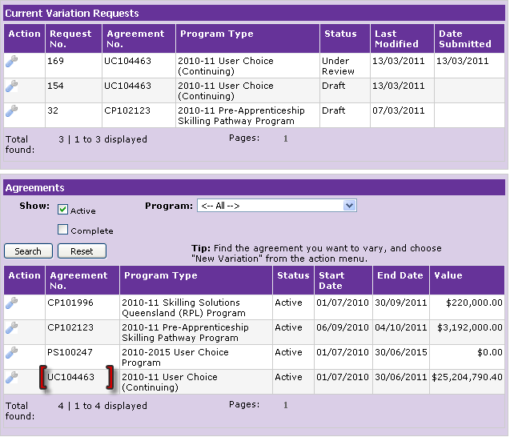

Step | Action
2. | In the column named “Action”, point your mouse over the “spanner” image. Click “Variations History” to view details of the AVR.  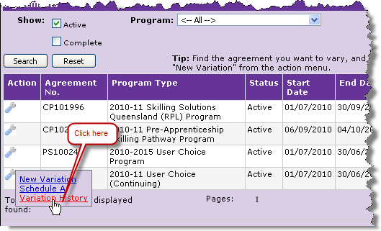
3. | Variation Request History page is displayed.  Ensure the Agreement is the intended Agreement for which the AVR history is required to be viewed. You can verify the correct Agreement by the Agreement Number and Name in the Variation Request History page header.  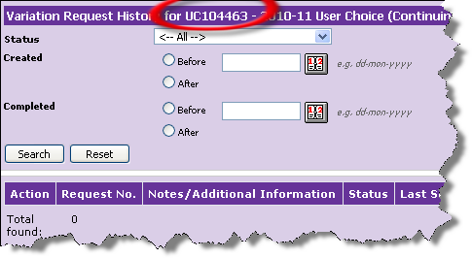

Step | Action
4. | Search for the specific AVR Agreement by:  - Status  - Created status  - Completed dates  Or you can simply “Click” the search button to display all AVRs created against the specific Agreement.  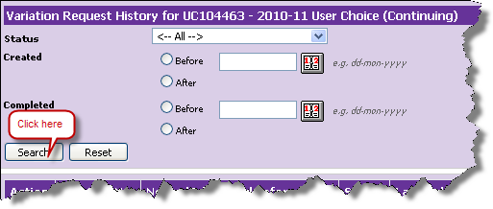
5. | Identify the AVR for which you wish to view the history.  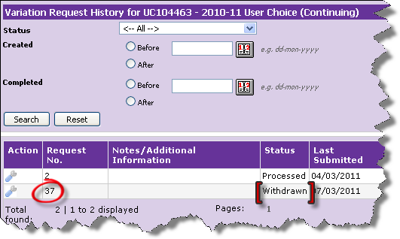

Step | Action
6. | In the column named “Action”, point your mouse over the “spanner” image and click “Open” to view details of the AVR.  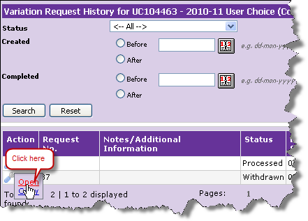

Step | Action
7. | “Review and Confirm Variation Request Details” page is displayed.  Look in the Notifications section identify the Notification you wish to view.  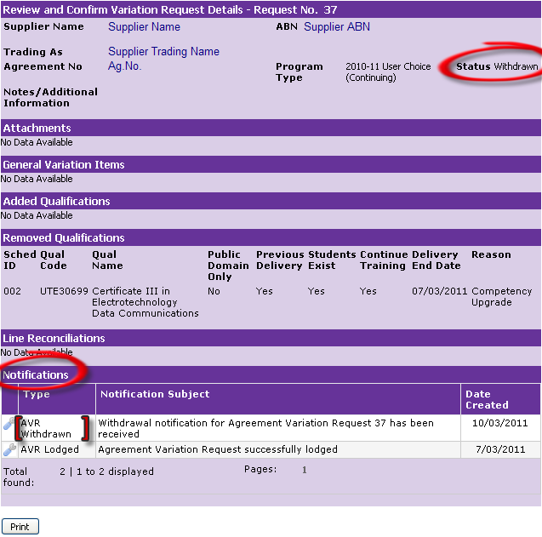
8. | In the column named “Action”, click the “spanner” image to view details of the selected notification.  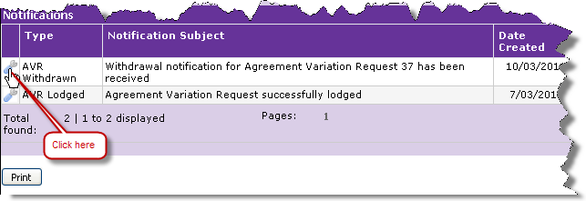

Step | Action
9. | The Notification Details page is displayed. Once you have read the information, to close the notifications details page “Click” the “Close” button.  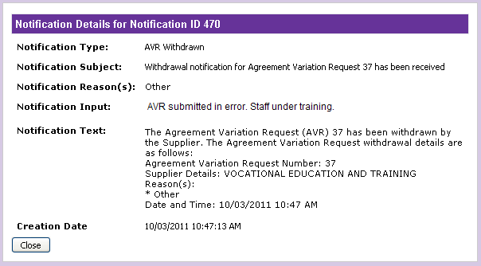

How do I copy an AVR?
The copy feature allows easy creation of an AVR that contains similar details to a past AVR. Copying an old AVR means less data entry, however, you will still have to exercise due care before submitting a copied AVR. For example, new errors may be generated on the copied AVR because the Agreement changed after the original AVR was processed.
You are able to copy Agreement Variation Requests that are currently active or completed. Click “Copy Active AVR” to learn more on how to copy an active AVR and “Copy completed AVR” for instructions on how to copy an AVR that has been completed.

How can I copy my active AVR?
All the active AVRs will be available under the Current Variation Requests section on the main Variations OnLine page. Follow the steps identified below to copy an active AVR.

Step | Action
1. | On the main Variations OnLine page, under Current Variation Requests, identify the active AVR you wish to copy. You can identify the AVR by the Request Number.  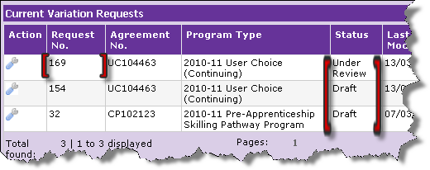
2. | In the column named “Action”, point your mouse over the “spanner” image and click “Copy” to copy the current AVR.  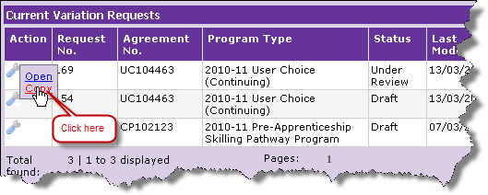

Step | Action
3. | Variations Request Details page with the new AVR is displayed.  Note the Request Number on the Variation Request Details page.  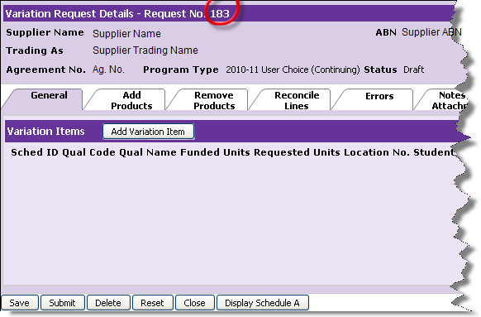
4. | Continue to add any variation elements. Once completed, save or submit the newly copied AVR.
5. | On the main Variations OnLine page, under Current Variation Requests section, you will be able to see your new AVR with status of Draft.  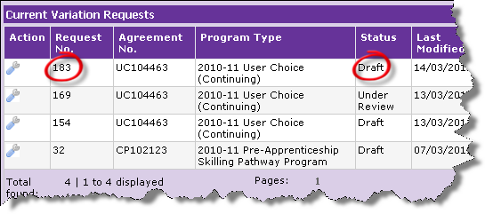

How can I copy my processed AVR?
All the processed AVRs will be available under the Current Variation Requests section on the main Variations OnLine page. Follow the instructions provided below to copy an active AVR.

Step | Action
1. | Identify the corresponding Agreement of the AVR you wish to copy. You can identify the Agreement by the Agreement Number.

Step | Action
2. | In the column named “Action”, point your mouse over the “spanner” image and click “Variations History” to view details of the AVR.  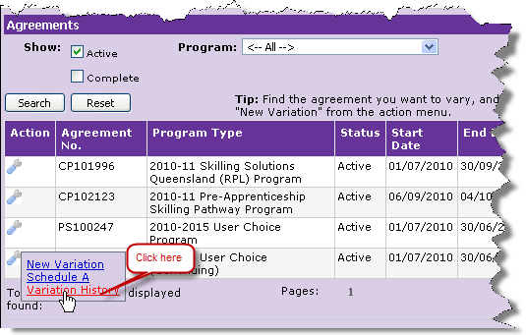
3. | Variations Request History page is displayed.  Ensure the Agreement is the intended Agreement for which the AVR history is required. You can verify the correct Agreement by the Agreement Number and Name in the Variation Request History page header.

Step | Action
4. | Search for the specific AVR for the Agreement. You can search for an AVR by:  - Status  - Created dates  - Completed dates  Or you can simply “Click” on search button to display all the AVRs created against the specific Agreement.
5. | Identify the AVR you wish to view the history for.  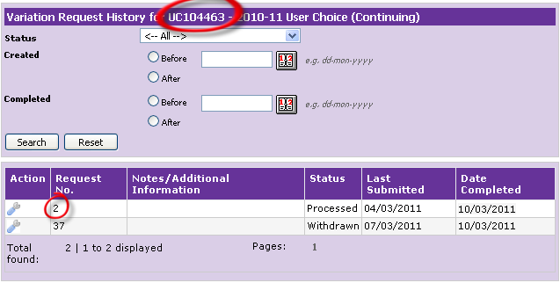

Step | Action
6. | In the column named “Action”, point your mouse over the “spanner” image and click “Copy” to make a clone of the processed AVR.  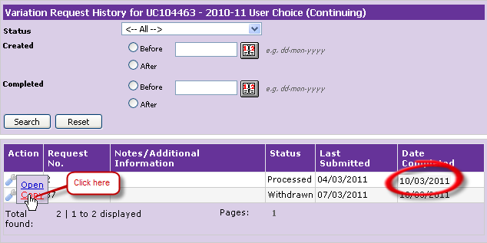
7. | Variations Request Details page with the new AVR is displayed.  Note the Request Number on the Variation Request Details page.  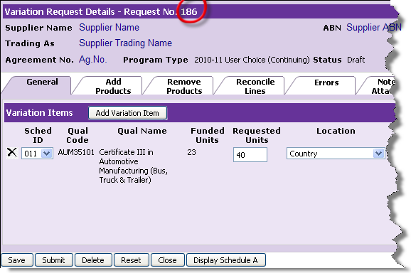
8. | Continue to add any variation elements. Once completed, save or submit the newly copied AVR.

Step | Action
9. | On the main Variations OnLine page, under Current Variation Requests section, you will be able to see your new AVR with status of Draft.  