Supplier User Manual
Variations Online (VOL)

Introduction

What is an Agreement Variation Request?
The Department is continuously endeavouring to improve relationships with stakeholders by encouraging transparency, supporting flexibility and thereby promoting a healthy working relationship. The Department understands there may be circumstances that may warrant changes to be made to an existing Agreement. Agreement Variation Request comes into play where you, the Supplier, have identified the need to request changes to be made to the existing Agreement.
There are two types of Agreement Variation Requests –
- Supplier Initiated
- Department Initiated.
For the purpose of this document, we are using the AVRs that are initiated by the Supplier (or a representative of the Supplier).

When can I create an Agreement Variation Request?
An Agreement Variation Request can only be created for active Agreements. You cannot create an AVR for Agreements that have been completed or where the Agreement End Date for which you are intending to create a variation, is within next 30 days. You can check the current Status of the Agreement and the Agreement End Date under the Agreement section of the Variations OnLine main page.

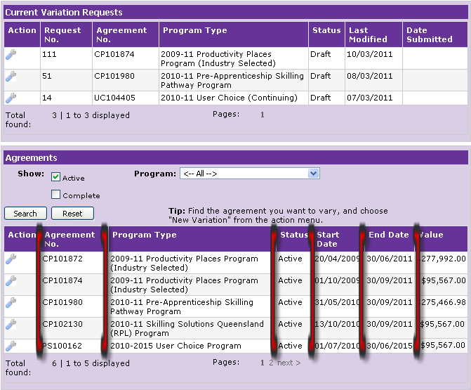

Is it too late to create an Agreement Variation Request?
All Agreement Variation Requests for an active Agreement must be made with 30 days of the Agreement End Date. You will not be able to create an AVR for an Agreement where an Agreement End Date falls within the 30 days.

What happens after I have created an Agreement Variation Request?
An Agreement Variation Request comes into existence only after being lodged. If an AVR exists prior to lodgement, the status would be either Draft or Awaiting Confirmation and therefore not acknowledged as active.
The AVR has the status of Draft once the process of creating is initiated. The Draft AVR must be submitted for validation and then, after successful validation, the AVR can be lodged.
When a Draft AVR has been created the following occurs:
- the Draft AVR is allocated a unique number
- the Draft AVR appears under the Current Variation Requests section of the Variations OnLine main page
- the status of the Draft AVR is Draft and the Last Modified date gets populated.
A variety of things happen after an AVR is submitted or lodged. To find out more read: “What happens after I have submitted an Agreement Variation Request?” and “What happens after I have lodged an Agreement Variation Request?”

