Probation order

What is a probation order?
 |  | It is a court order that you got after you went to court for your offence.
 |  | It is a way to help you stop offending.
 |  | It means a YJ officer will supervise you during this order.
 | At your 1st meeting with YJ
 |  | Your parents or carers may be invited.
 |  | The YJ officer will talk to you about:
 |  | - your order
 |  | - why you did the offence
 |  | - the days you need to see the YJ officer
 |  | - how they can help you stick to your order
 |  | - what you want to do with your life.
 | Rules
You need to follow the rules.
You must:
 |  |  |  | - not break the law
 |  |  |  | - go to programs
 |  |  |  | - report to your YJ officer
 |  |  |  | - let your YJ officer visit you.
 |  |  | You must tell your YJ officer within 2 days if you:
- move house
- change schools
 |  |  | - change jobs.
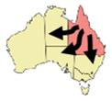 |  |  | You must tell and give lots of time to the YJ officer if you want to leave Queensland.
 |  |  | Your YJ officer needs to say ‘yes’.
 |  |  | Court can give you extra things for you to do on your order. Extra things like:
 |  |  | - help to get off drugs and alcohol
 |  |  | - mental health help.

What if I break the rules
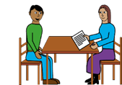 |  |  | Your YJ officer will tell you what happens if you break the rules.
 |  |  | If you break a rule, your YJ officer will give you a warning letter.
 |  |  | If you keep breaking the rules, you will go back to court.
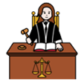 |  |  | The court will decide if you will stay on a probation order or a different order.
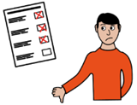 |  |  | If you offend again, the court may decide you have breached your order.  This means the court gave you rules but you did not follow the rules.
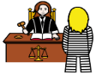 |  |  | The court may give you more punishment.

My order
Number of months ______________________________
My 1st meeting with my YJ officer
Date _________________________________________
Time _________________________________________

Who do I talk to in YJ?
Ask for the intake officer.
Where _______________________________________
Phone _______________________________________
Email ________________________________________
The material presented in this publication is distributed by the Queensland Government for information only and is subject to change without notice. The Queensland Government disclaims all responsibility and liability (including liability in negligence) for all expenses, losses, damages and costs incurred as a result of the information being inaccurate or incomplete in any way and for any reason. © State of Queensland (Department of Youth Justice, Employment, Small Business and Training) 2023.

