Supplier User Manual
Variations Online (VOL)

Contents
Lapsed Agreement Variation Request 2
Why has my Agreement Variation Request lapsed? 2
How can I view Lapse warning notifications for my Agreement Variation Request? 2
How can I determine if my Agreement Variation Request has lapsed? 2
How can I find my lapsed AVR? 3
How can I request that my AVR be unlapsed? 8
What does Lapse Warning Notification mean? 8
How can I confirm the Deed of Variation? 10

Lapsed Agreement Variation Request

Why has my Agreement Variation Request lapsed?
AVRs are lapsed automatically if events are not actioned within the prescribed timeframe.
The Department, in the process of reviewing the Agreement Variation Request may request the corresponding Supplier to provide specific information that may assist in conducting the review of the variation.
An Agreement Variation Request may Lapse when the Department has requested certain information or action from you, the Supplier, and the Department has not received a response within the stipulated time period. This time period is specified on the notification that was sent along with the Departmental request. Likewise, where the Supplier has failed to return / confirm the Deed of Variation within the specified time period, the status of the corresponding AVR will be progressed to “Lapsed”. The Supplier will be sent reminder notifications (two) before the AVR is lapsed.
When you see a Lapsed AVR, you can also see the reason why it has lapsed. The following describes the reasons for an AVR lapse:
  - Lapse (information requested): Where an AVR lapsed because the information requested by the Department was not provided within specified time period.
  - Lapse (confirm DoV): Where an AVR lapsed because the Department requested confirmation of DoV and the DoV was not confirmed within specified time period.
  - Lapse (DoV not returned): Where an AVR lapsed because the signed physical copies of the DoV were not returned to the Department within specified time period.

How can I view Lapse warning notifications for my Agreement Variation Request?
For any AVR, all the notifications sent by the Department are viewable at any time when the AVR is active and also after the AVR has been processed.
To view the notifications against a processed (Withdrawn, Lapsed or Processed) AVR, click “How can I view my variation history”.

How can I determine if my Agreement Variation Request has lapsed?
Before an AVR lapses, you will receive two warning notifications advising you of possible lapse actions. If the Supplier has not actioned the Department’s request after the warning notifications, then the AVR will be lapsed. It is advisable that you provide the necessary actions within the specified timeframe to avoid lapsed AVR’s.
All the lapsed AVRs are considered to be inactive and as a result are taken off from the Current Variation Requests list. So, if you are unable to see your AVR in the Current Variation Requests list and you are confident that your AVR has not yet been processed, then you will find your AVR has lapsed and as a result it forms part of Agreement Variations history.

How can I find my lapsed AVR?
All the lapsed AVRs are considered to be inactive and as a result are taken off from the Current Variation Requests list. All lapsed AVRs can be found in Variations History for the corresponding Agreement.
Follow the instructions provided below to learn how to find your lapsed AVR

Step | Action
1. | Identify the corresponding Agreement of the AVR you wish to view the Variations history. You can identify the Agreement by the Agreement Number.  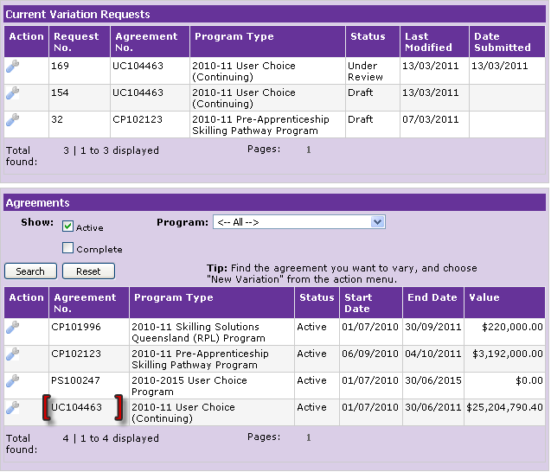

Step | Action
2. | In the column named “Action”, point your mouse over the “spanner” image. Click “Variations History” to view details of the AVR.  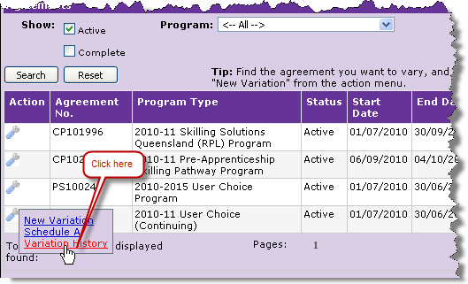
3. | The Variations Request History page is displayed.  Ensure the Agreement is the intended Agreement for which the AVR history is required to be viewed. You can verify the correct Agreement by the Agreement Number and Name in the Variation Request History page header.  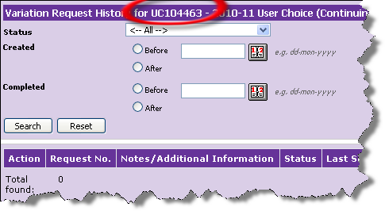

Step | Action
4. | Search for the specific AVR from amongst all the AVRs that ever existed for the Agreement. You can search for an AVR by:  - Status  - Created status  - Completed dates  Or you can simply “Click” the search button to display all AVRs that were ever created against the specific Agreement.  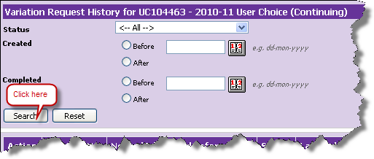
5. | Identify the AVR you wish to view the history for.  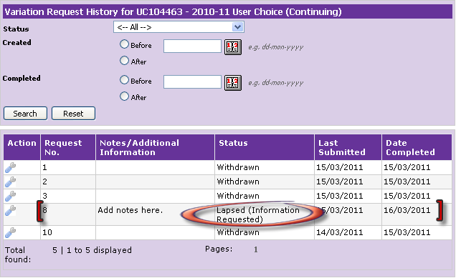

Step | Action
6. | In the column named “Action”, point your mouse over the “spanner” image and click “Open” to view details of the AVR.  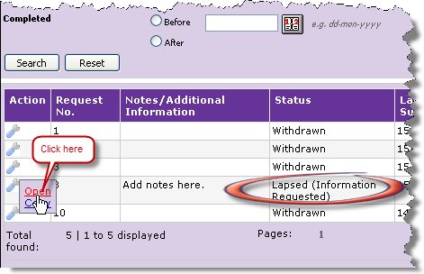

Step | Action
7. | “Review and Confirm Variation Request Details” page is displayed.  Look in the Notifications section on the “Review and Confirm Variation Request Details” page.  Identify the Notification that you want to view. You can easily identify the notification by its type along with the notification subject and the date it was created.  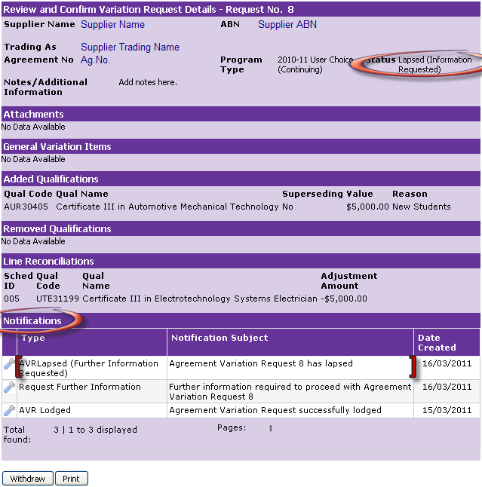
8. | In the column named “Action”, point your mouse over the “spanner” image and click on the spanner to view details of the AVR.  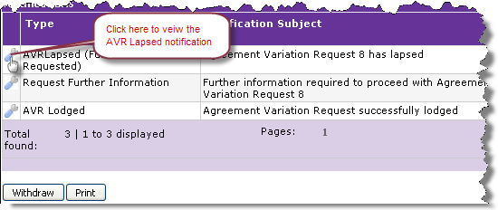

Step | Action
9. | The notification details page is displayed. To close the notifications details page “Click” on the “Close” button.  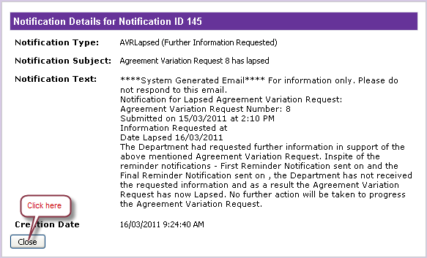

How can I request that my AVR be unlapsed?
The Department under special circumstances may return the status of a Lapsed AVR to the state it was in before it lapsed. You can make a request to unlapse an AVR by way of an email to the VOL Administrator with the subject as identified below:
VOL Administrator email address: vol.administrator@deta.qld.gov.au.
Subject: Unlapse – AVR <Variation Request Number> for Agreement <Contract number>

What does Lapse Warning Notification mean?
Lapse warning notification is a reminder notification for you to action your AVR failing which the AVR will lapse. When the Department requests further information for an AVR, you are required to provide the Department with the requested information to enable the Departmental Officer proceed with the AVR. If the Department does not receive a response within the prescribed timeframe, you are sent two warnings and if these warnings are not actioned your AVR will be lapsed.
Follow the instructions below to learn how to identify the lapse warning notifications.

Step | Action
1. | On the Variation Request Details page for your AVR, click “Notifications” to view all the notifications for your AVR.  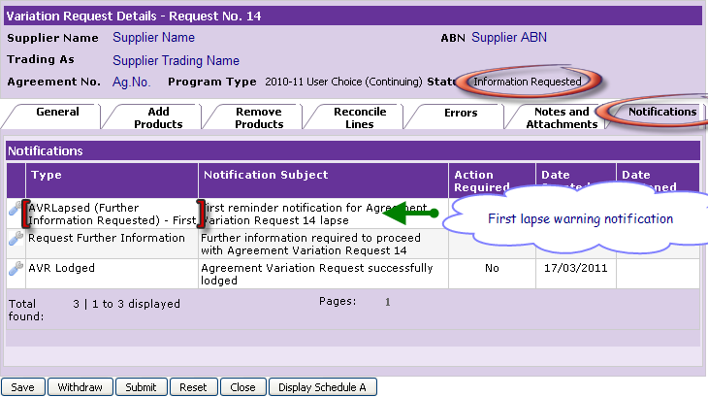
2. | Point your mouse over the “spanner” image. Click to view the AVR.  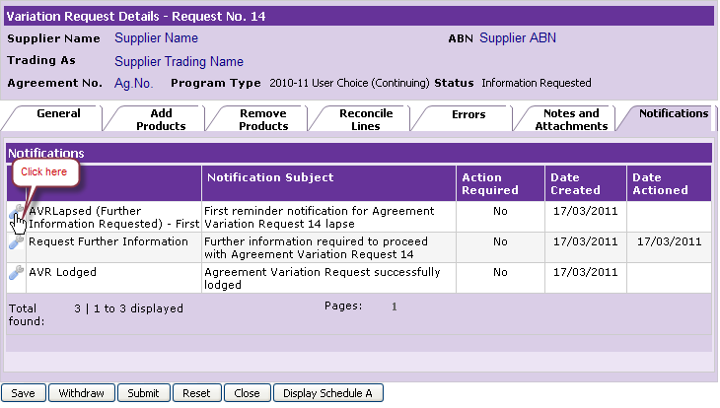

Step | Action
3. | View the contents of the lapse warning notification.  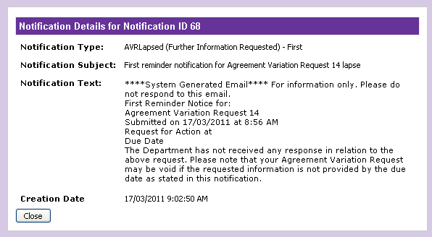

How can I confirm the Deed of Variation?
There may be an Agreement Variation Request that requires you to confirm the Deed of Variation incorporating the changes that will be made to your Agreement once your variation request has been fully processed.
The Department will send you a notification advising you to confirm the deed of variation for the AVR. If you view the Review and Confirm Variation Request Details page for the AVR you will be able to open and view the Deed of Variation.
You will be required to print out two Deeds of Variation, execute two originals that are signed by the authorised representative of your organisation, witnessed and dated. Post two originals to the Department.
The status of your AVR will be “Awaiting Deed of Variation Confirmation” when you are required to confirm the Deed of Variation. The status of the AVR upon your confirmation is updated to “Under Review”.
Important – You must confirm the Deed of Variation within the time period specified in the Confirm Deed of Variation notification to avoid lapsing of the AVR.
Please Note: Services must not be provided until the Deed of Variation has been signed by both parties and an approved Schedule A has been issued to your organisation.
Follow the instructions below to learn how to confirm Deed of Variation for your AVR.

Step | Action
1. | Identify the AVR for which you want to confirm the Deed of Variation.  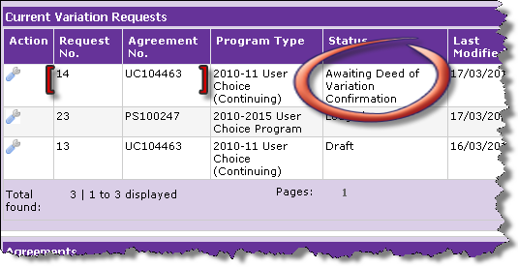
2. | In the column named “Action”, point your mouse over the “spanner” image. Click “Open” to view the AVR.  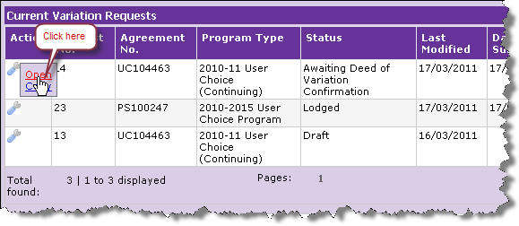

Step | Action
3. | The Review and Confirm Variation Request Details page is displayed. Note Deed of Variation document appears in the “Attachments” section. Confirm the correct Agreement and the correct AVR by the Agreement Number and Request Number respectively. Click “Confirm Deed of Variation” to confirm your acceptance to the Department.  Please note: This action does not mean that Services requested in the AVR can commence as the variation process is not finalised at this point. It is an acknowledgement from the Supplier that the terms of the variation has been accepted and the Deeds of Variation will be executed and posted to the Department.  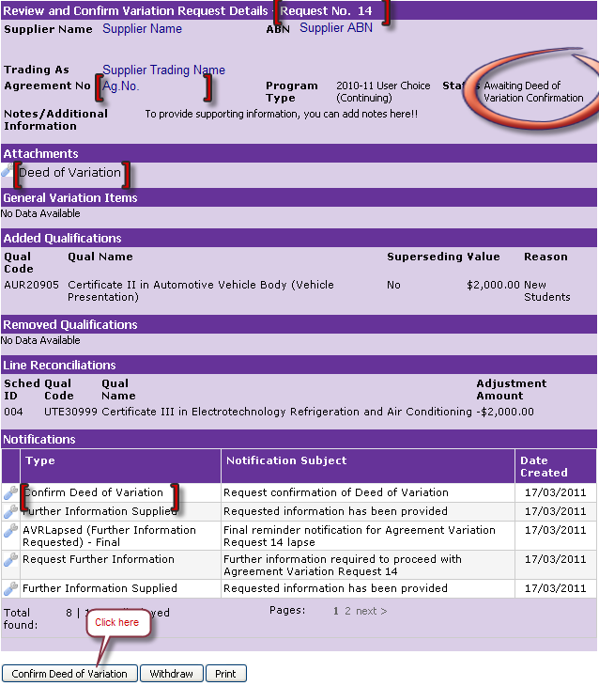

Step | Action
4. | A pop up message is displayed. Make some time to read the message and click “Ok” to send the confirmed Deed of Variation to the Department.  Remember: You have to print two Deeds of Variation.  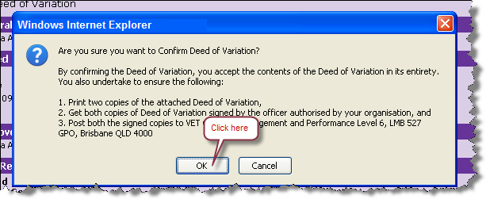
5. | You have now confirmed the Deed of Variation for your AVR. The status of your AVR has been progressed from “Awaiting Deed of Variation Confirmation” to “Under Review”.  