Supplier User Manual
Variations Online (VOL)

Contents
Request for Further Information 2
What is Request for further information? 2
When can you provide requested information? 2
Is it too late to provide requested information? 2
What happens after I have provided the requested information? 3
Who can provide further information? 3
How can I check if further information has been requested for my AVR? 3
How can I provide the requested information? 3
How can I check if I have supplied the information? 9
Can I amend my response to further information after confirming my response? 9
How can I review the information provided for an AVR? 9

Request for Further Information

What is Request for further information?
Further Information on the Agreement Variation Request may be requested by the Department to assist in the Review and/or the Assessment of the Agreement Variation Request. The request for Further Information is sent by the Department to the respective Supplier who initiated the Agreement Variation Request.
When the Department requests further information, the status of your AVR is progressed from “Under Review” to “Information Requested”. Depending on the information requested by the Department, you can provide information by way of attaching Supporting Documentation, and providing textual information by way of Notes.
When further information is requested against an AVR, all activity against the AVR ceases until such time when the requested information has been provided. The Departmental Officer, in the request for further notification, identifies the time period within which you must respond to the requested information. If you fail to provide the requested information with the specified time period, your AVR will Lapse. Click “My AVR has lapsed” to learn more about Lapsed AVRs.
Upon submission of the Requested Information by the Supplier, the Departmental Officer responsible for initiating the request for further information will be notified of your submission. You will also be notified of successful submission of the requested information. The status of the Agreement Variation Request upon submission of the requested information will be “Under Review”.
It is pertinent to note that since an AVR can only be approved in its entirety, the Departmental Officer may request through the “further information” facility that your lodged AVR needs to be amended to include those variation elements that can be considered without delay. For the variation elements that cannot be approved without delay, you can add them to a new AVR at a later date.

When can you provide requested information?
You can provide further information only once it has been requested by the Departmental Officer. When the Departmental Officer has made a request for further information, you will be notified by an email. You can also check the status of your AVRs on the main Variation OnLine page for all the AVRs initiated by your organisation.

Is it too late to provide requested information?
When the Departmental Officer requests further information, all activity by the Department against the specific AVR ceases until the information being requested is received by the Department. It is therefore in your interest to provide the requested information as soon as possible.
Whenever further information is requested by the Departmental Officer, you are notified by an email. When you check the notification against the corresponding AVR, you can identify the exact information that has been requested as well as the timeframe within which you are expected to respond. If you fail to provide the response within the specified timeframe, your AVR will lapse.
Click “My AVR has lapsed” to learn more about Lapsed AVRs. Once an AVR is lapsed, the only way it can be reactivated or unlapsed is by way of a Unlapse request to the Departmental Officer.
Click “Unlapse my AVR” to learn more about requesting the Department to Unlapse a Lapsed AVR.

What happens after I have provided the requested information?
Upon submission of the Requested Information by the Supplier, the Departmental Officer responsible for initiating the request for further information will be notified of your submission. You will also be notified of successful submission of the requested information. The status of the Agreement Variation Request upon submission of the requested information will revert back from “Information Requested” to “Under Review” and the AVR will be considered.

Who can provide further information?
Where further information is requested for a supplier initiated AVR, only the Supplier or a representative of the Supplier can provide the requested information through their Purchasing Online Account.

How can I check if further information has been requested for my AVR?
Follow the instructions provided below to provide further information for an AVR.

How can I provide the requested information?
Follow the instructions provided below to provide further information for an AVR.

Step | Action
1. | On the main Variations OnLine page, under Current Variation Requests section, you can find the AVR for which further information has been requested. You can identify the specific AVR by looking at the status column.  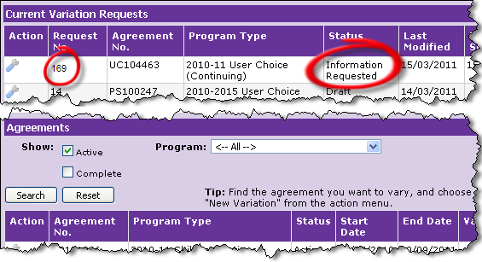
2. | In the column named “Action”, point your mouse over the “spanner” image. Click “open” to view details of the specific AVR.  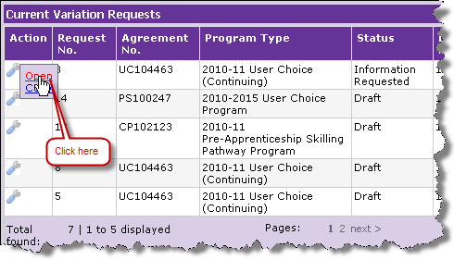

Step | Action
3. | Click the Notifications tab in the Variation. You will be able to find the content of the information that is being requested by the Department.  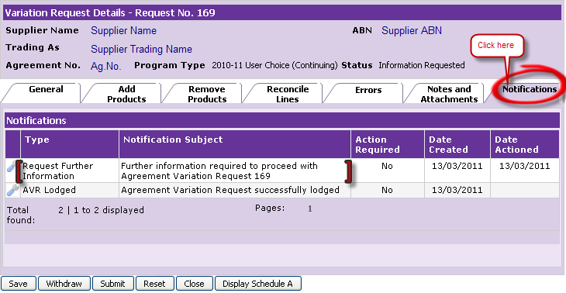
4. | In the column named “Action”, point your mouse over the “spanner” image. Click “open” to view details of the information requested for the specific AVR.  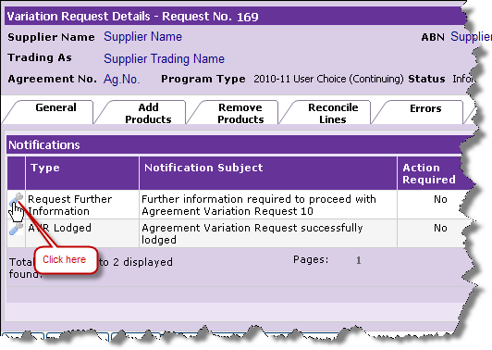

Step | Action
5. | The notification details page containing the specific information requested by the department is displayed.  Note the AVR number for which the information has been requested.  The information requested by the Departmental Officer can be found against Notification Reason(s) and Notification Input.  Note the timeframe within which you must respond. Also, you can identify the particulars of the Departmental Officer who has requested the information.  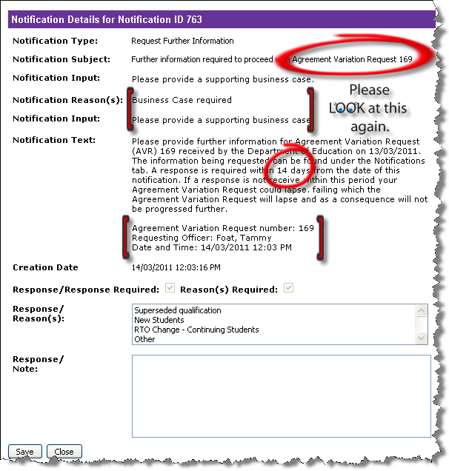
6. | Click on the most suitable Response/Reason(s) and provide response / notes. After you have provided the notes, click Save.  Note: If you fail to click Save, the information that you have provided will not be saved and the request for further information has not been addressed by the Supplier.  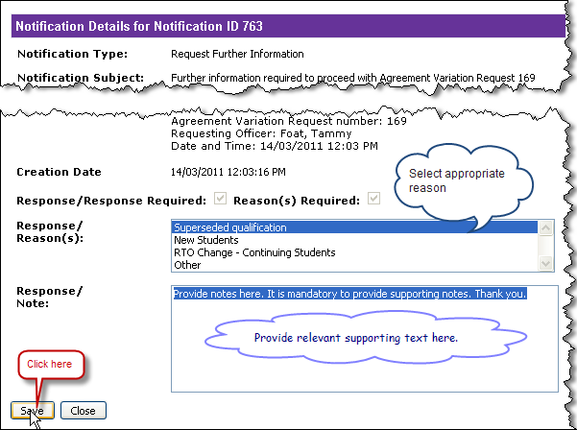

Step | Action
7. | The notification details page is displayed where you can view the reason(s) and the response notes. Click “close” to close the window.  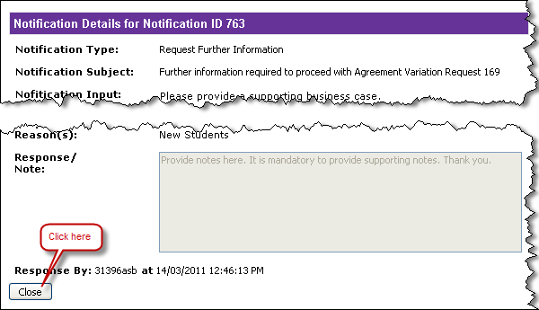
8. | The Variation Request Details page will be displayed with active Notifications tab.  Note under “Action Required” the text says “No” meaning that the Supplier has recorded information against the AVR.  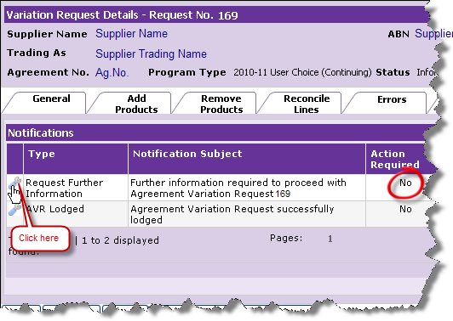

Step | Action
9. | To submit the AVR with your further information click “Submit” to validate the response to the requested information.  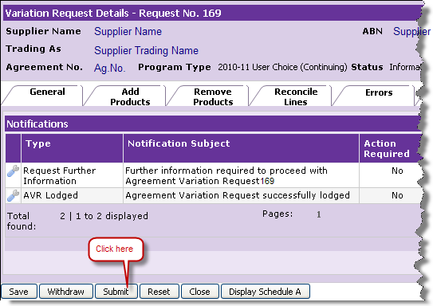
10. | The Review and Confirm Variation Request Details page is displayed. Click Confirm to send your validated response to the Department through POL.  Note the status of the AVR has been updated from “Information Requested” to “Information Provided”.  At this stage you can “Amend” your AVR by clicking on “Amend AVR” to learn more about how to amend your AVR.  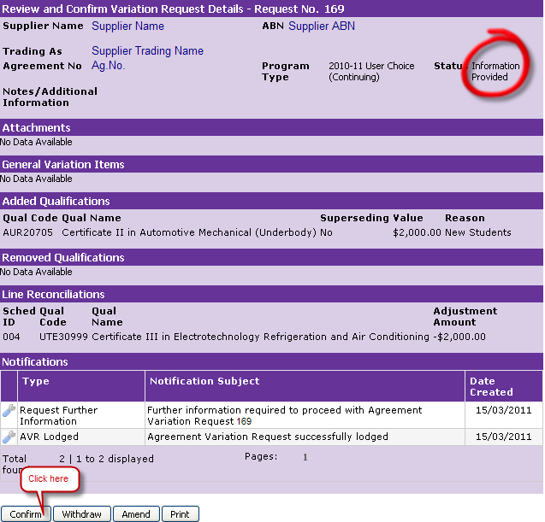

Step | Action
11. | You have now successfully sent your response for the information as requested by the Department for your AVR.  Note: Upon confirming the AVR, the status of the AVR is progressed from “Information Provided” to “Under Review”.  The Notifications section has been updated with your response. The next available options are restricted to “Withdraw” and “Print”.  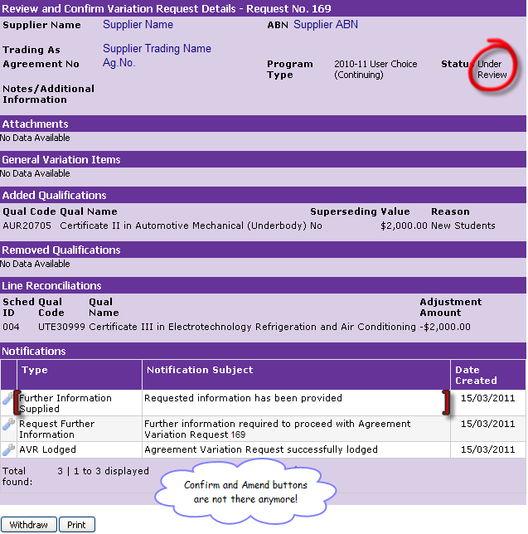

How can I check if I have supplied the information?
You can check successful submission of your response to the request for further information in the following ways:
- The status of the AVR is progressed to “Under Review”.
- On the Review and Confirm Variation Request Details page, under notifications section you will be able to see “Further information supplied”.

Can I amend my response to further information after confirming my response?
You will not be able to amend your response to further information upon submission.

How can I review the information provided for an AVR?
Follow the instructions provided below to view your response to further information for an AVR

Step | Action
1. | On the main Variations OnLine page, under Current Variation Requests section, identify the AVR for which you wish to review the response to further information. You can identify the specific AVR by looking at the status column.  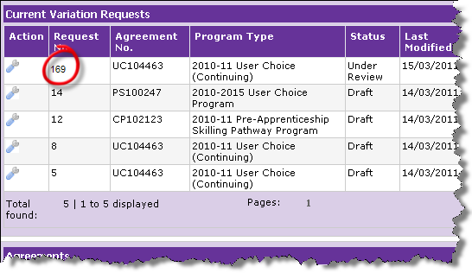
2. | In the column named “Action”, point your mouse over the “spanner” image. Click “open” to view details of the specific AVR.

Step | Action
3. | The Review and Confirmation Request Details page is displayed. Under the notifications section you can find your response to further information been recorded.  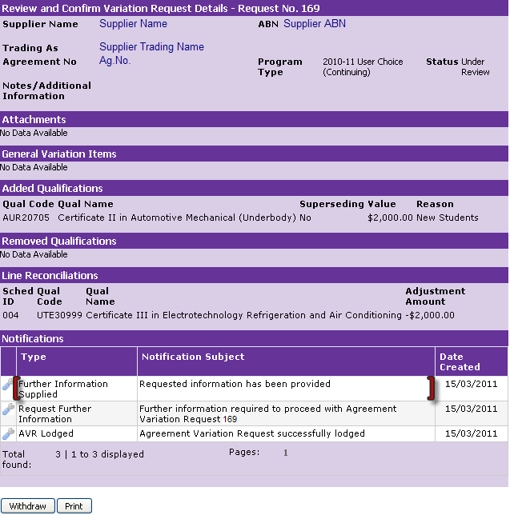
4. | Point your mouse over the “spanner” image. Click to view details of the further information supplier notification..  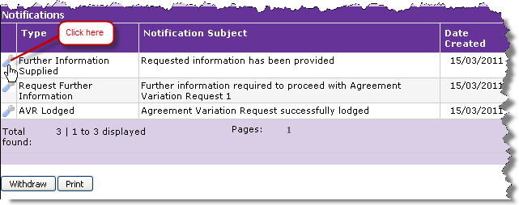
5. | The notification details page is displayed and you can view the information that was supplied for you against the request for further information.  