Community service order

What is a community service order?
It is unpaid work.
It helps your community.
 | The court tells you how many hours you need to do.
The court tells you how long you must do your hours. Like, in 6 months.
The work supervisor will count how many hours you did. They will tell your YJ officer.
 | Your YJ officer may ask a youth worker to help you get to the places.

What work will I do?
 | - mowing and landscaping
 | - painting
 | - making toys for charity
 | - making furniture for charity

What do I bring?
 | - your own food and drinks
 | - hat
 | - sunglasses
 | - sunscreen
Your boss or youth worker will tell you what to bring.
The work site may give you special clothing. They will tell you how to use it safely.

Do not bring
 | - alcohol
 | - drugs
 | - weapons, like a knife
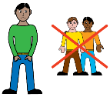 | - your friends
 | Your supervisor will tell you other things you cannot bring.

 | What if I cannot go that day?
 |  |  | You must have a very good reason to not go to community service.
 |  |  | You must call your YJ officer to tell them. You must do what your YJ officer says.
 |  |  | If you are sick, you need to go to a doctor to get a medical certificate.
 | Rules
You need to follow the rules.
You must:
 |  |  | - not break the law
 |  |  | - finish your hours
 | 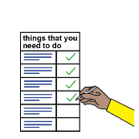 |  | - do what it says in your order.
 |  | You must tell your YJ officer within 2 days if you:
- move house
- change schools.
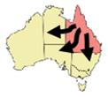 |  | You must tell and give lots of time to the YJ officer if you want to leave Queensland.
 |  | Your YJ officer needs to say ‘yes’.

What if I break the rules
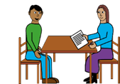 |  | Your YJ officer will tell you what happens if you break the rules.
 |  | If you break a rule, your YJ officer will give you a warning letter.
 |  | If you keep breaking the rules, you will go back to court.
 |  | The court will decide if you will stay on a community service order or a different order.
If you offend again, the court may decide you have breached your order.
This means the court gave you rules but you did not follow the rules.
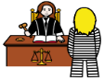 |  | The court may give you more punishment.

My order
Number of hours _______________________________
I finish my order on _____________________________

Who do I talk to in YJ?
Ask for the intake officer.
Where _______________________________________
Phone _______________________________________
Email ________________________________________
The material presented in this publication is distributed by the Queensland Government for information only and is subject to change without notice. The Queensland Government disclaims all responsibility and liability (including liability in negligence) for all expenses, losses, damages and costs incurred as a result of the information being inaccurate or incomplete in any way and for any reason. © State of Queensland (Department of Youth Justice, Employment, Small Business and Training) 2023.

