COVID-19 information for parents and carers
We are working closely with Queensland Health to limit the effect of COVID-19 on youth detention centres (YDCs). Our priority is the safety and wellbeing of young people, staff and the community.
We have strategies in place to stop the spread of COVID-19, including:
- COVID-19 health checks and vaccinations for young people
- mandatory COVID-19 vaccination for staff
- mask wearing (highly recommended if you are inside and not able to socially distance)
- increased cleaning and sanitising
- increased use of hand sanitisers and protective equipment
- extra staff training.
These strategies are reviewed daily. We encourage you to contact your child’s caseworker if you have any concerns.

Visiting a youth detention centre
It is important that young people continue to connect with their families, friends, legal contacts and service providers while in a YDC. Staff will work with you to ensure you can stay in contact with young people.
You no longer have to be vaccinated against COVID-19 to visit a YDC.
Mask wearing is highly recommended if you are inside and not able to socially distance.

General screening
You should not enter a YDC if you have:
- had contact with a confirmed case of COVID-19 in the past 14 days
- a fever or symptoms of acute respiratory infection (e.g. cough, sore throat, runny nose or shortness of breath)
- tested positive for COVID-19 in the past seven days.

During your visit
You must:
- ensure you keep 1.5 metres apart during your visit and use allocated seating
- follow visible floor directions
- minimise risk of contagion by not having physical contact (e.g. hand shaking or hugging).
Approved items may be brought into the visit as per the usual visit processes, however the sharing of food or other items with young people will continue to be done in a COVID safe way.

Health services for your child
All young people have access to health services while they are at a YDC. Eligible young people have access to COVID-19 vaccines as part of the onsite vaccination program led by Queensland Health. Young people can talk to nurses and doctors at the centre if they have concerns about their health.
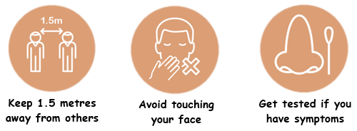
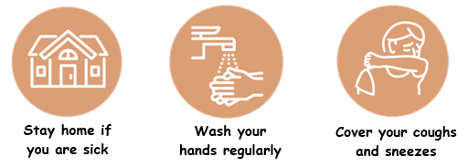
Thank you for your patience and cooperation. Please contact the relevant YDC if you need more information.

