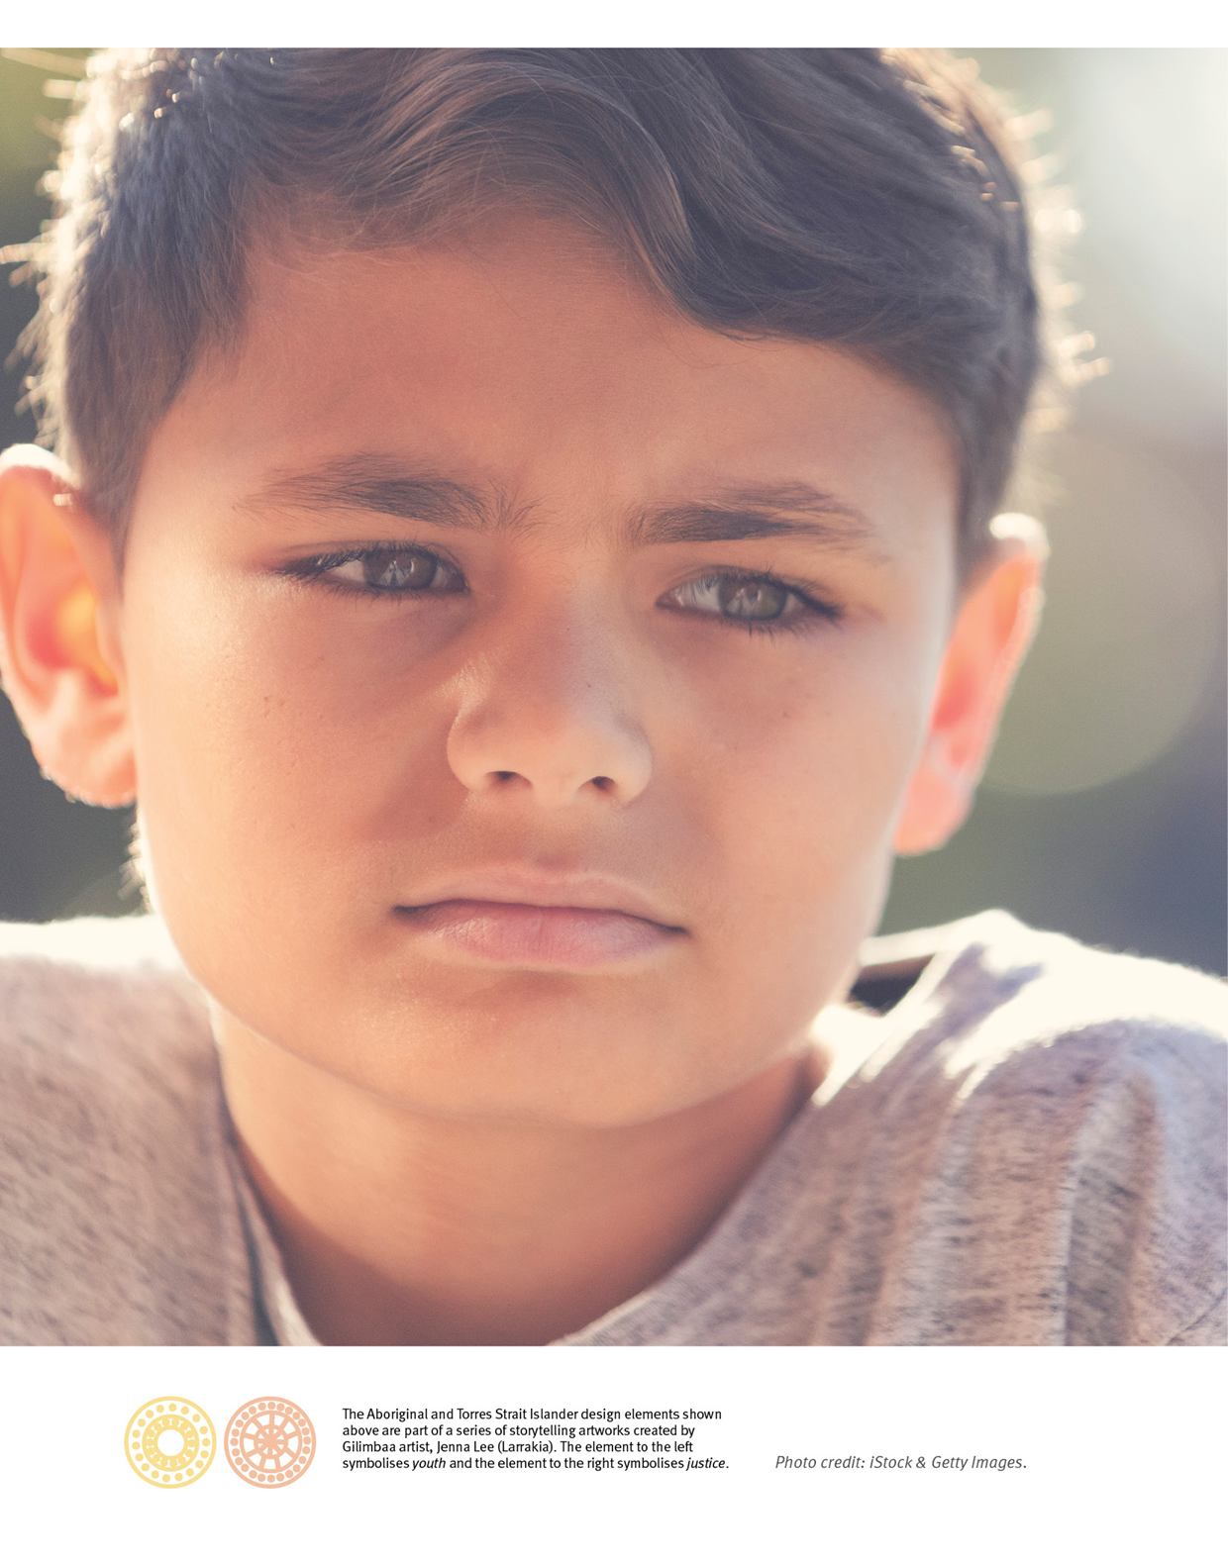

From the Minister
The Queensland Government is committed to reforming the youth justice system to make our communities safer, address the causes of offending and reduce youth crime in Queensland.
The Youth Justice Strategy Action Plan 2019-21 (the Action Plan) heralds a significant milestone in our youth justice reform agenda, which aims to reduce the number of children and young people offending and re-offending in Queensland.
The Action Plan sets out the practical steps to implement the Working Together Changing the Story: Youth Justice Strategy 2019-2023 (the Youth Justice Strategy) and builds on reforms introduced by the Queensland Government, including:
- reinstating court-ordered restorative justice conferencing
- implementing the findings of the Independent Review of Youth Detention
- ending the treatment of 17-year-olds as adults in Queensland’s criminal justice system
- responding to Mr Bob Atkinson’s Report on Youth Justice
- responding to recommendations from the report by Townsville Community Champion, retired Major-General Stuart Smith: Townsville’s Voice: local solutions to address youth crime.
Since the Youth Justice Strategy was launched in December 2018, there have been further reforms:
- $332.5 million of investment to tackle youth crime, announced in April 2019 - actions associated with this investment are prioritised in the Action Plan
- a new Department of Youth Justice, formed in May 2019
- new programs implemented to reduce the high number of children remanded in custody and ensure the safety and wellbeing of children currently held in police watchhouses
- proposed amendments to the Youth Justice Act 1992 to remove legislative barriers to children being granted bail.
Through this Action Plan, the Department of Youth Justice and its partner agencies will hold children and young people accountable for their criminal behaviour. These agencies will also address the causes of crime, and engage with families and communities to develop positive, sustainable and culturally appropriate solutions.
A key focus of our work will be to reduce the over-representation of Aboriginal and Torres Strait islander children and young people in the youth justice system. This Action Plan includes a range of actions that will help improve outcomes for Aboriginal and Torres Strait Islander children.
I am committed to reducing the use of watchhouses to accommodate children on remand. If children do need to be detained, we will do everything possible to keep them safe and address their needs. In order to maintain public expectations of community safety, it is necessary to build contemporary, secure accommodation that is safe and appropriate for serious or repeat offenders.
We are continuing to change the story for young people, but we cannot do this alone. It requires a fundamental shift in the way government, non-government, community organisations and businesses work together to support families, deter young people from committing crime and help them change their own story. This Action Plan is a key mechanism to deliver this change.

Di Farmer MP
Minister for Child Safety, Youth and Women
Minister for Prevention of Domestic and Family Violence

Youth Justice Strategy Action Plan 2019–2021
This Action Plan sets out the practical steps to implement the Youth Justice Strategy over the next two years.
The Action Plan was developed in consultation with Queensland Government agencies and the Youth Justice Strategy Reference Group, comprising community leaders, industry representatives and criminal justice experts.
It focuses on doing more of what we know works, working in partnership with communities, engaging differently with young people in trouble with the law, and delivering entirely new services and infrastructure.
The Action Plan supports the achievement of the Queensland Government’s Our Future State: Advancing Queensland Priorities to reduce the rate of youth re-offending and crime victimisation.
Initiatives and actions also deliver on the government’s responses to Mr Bob Atkinson’s Report on Youth Justice and Major-General Stuart Smith’s report Townsville’s Voice: local solutions to address youth crime. The Action Plan includes:
- new programs and approaches delivered through $332.5 million youth justice investment
- actions to build on and extend existing capacity
- important reforms which are already underway that need to be monitored to ensure they deliver change.
The tables in the following pages reflect the Strategy’s four pillars: Intervene early, Keep children out of court, Keep children out of custody, and Reduce re-offending. Some actions assist with more than one pillar, but for simplicity and readability, actions are listed under the most relevant pillar.
The Action Plan highlights three other areas of significant work, which are important to reforming the youth justice system:
- working with Aboriginal and Torres Strait Islander families and communities to address their children’s disproportionate representation in the criminal justice system
- responding to the different needs of girls and young women
- strengthening infrastructure and providing safe detention and watchhouse environments.
The majority of actions respond to findings or recommendations from recent youth justice-related reports. These are recorded in the following tables as:
- Atkinson Report on Youth Justice – AR
- Townsville’s Voice: local solutions to address youth crime - TV
- Adjust our Settings: A community approach to address cyberbullying among children and young people in Queensland (Report on Cyberbullying) - CB
A comprehensive list of actions is available on our website www.youthjustice.qld.gov.au
The Action Plan will be reviewed annually to ensure we are making genuine progress, and there will be opportunity for new actions to be added. Monitoring and evaluation will check that real change is being delivered and ensure we make good progress on implementing actions and initiatives.

Pillar 1: Intervene early

We will connect children, young people and families to services and supports so they can address their health, wellbeing, safety and education needs.
Preventing crime begins with making sure that children are born healthy and are brought up safe and well. Prevention and early intervention is a responsibility of the whole community as well as government. Actions focus on ensuring that when children and families start experiencing problems, they receive help as early as possible.
Actions | Report | Lead Agency
Aboriginal and Torre Strait Islander Family Wellbeing Services will be enhanced in 11 locations to provide family support to prevent children and young people's involvement in the youth justice system. | AR | Child Safety, Youth and Women (CSYW)
Implement the Queensland Youth Partnerships Initiative which engages corporate and community partners in initiatives supporting young people including youth crime prevention and crime responses. | AR | CSYW
Information sharing and collaboration will be enhanced through:  - Our Child IT platform providing real-time information sharing  - guidance for staff on approaches to information sharing  - embedding expectations of collaboration for contracted service providers. | AR | CSYW  Youth Justice
Implement a community-driven strategic Townsville Youth Development Strategic Plan. | TV, AR | Youth Justice
The Queensland Immunisation Strategy 2017-2022 aims to increase immunisation rates for Aboriginal and Torres Strait Islander children and children under State care. | AR | Health
Enhance engagement in education through:  - government commitments under the Statement of Commitment to Alternative Education (Youth Engagement Strategy 2019-22)  - resourcing for alternative schooling sites and programs for young people disengaged from education and at risk of justice system involvement. | AR | Education
Release a whole-of-government Early Years Plan, to support Queensland children’s early learning and development. | AR | Education
Family and Child Connect, Intensive Family Support and Aboriginal and Torres Strait Islander Family Wellbeing Services will identify and respond to children, young people and their families at risk of youth justice system involvement. | AR | CSYW
Reshape approaches to domestic and family violence to assist Aboriginal and Torres Strait Islander families and communities live free from violence. |  | CSYW
Continue to implement the Supporting Families Changing Futures child and family reforms to meet the health, wellbeing, safety and education needs of young people in care, and help reduce the number of young people in care coming into contact with the youth justice system. | AR | CSYW
Address cyberbullying through:  - a public awareness and education campaign co-designed with young people  - an online portal with information, accessible and inclusive for all  - grants for young people and youth and community organisations. | CB | CSYW
Address youth sexual violence through:  - three place-based early intervention trials, including a culturally-specific trial  - new sexual abuse and sexual assault counselling services and training to help organisations work with young people who have harmful sexual behaviours. | AR | CSYW

Pillar 2: Keep children out of court

Where possible, we will divert children from court, ensuring children and young people with early or low-level offending have positive family and community influences, are engaged in education, training and activities, and get support to address their behaviours.
There is consistent evidence that many children who offend for the first time will not re-offend and that providing support and diverting them away from court is the most effective and efficient response. These actions provide options for diversion with interventions suitable for children who are at higher risk of offending, including for Aboriginal and Torres Strait Islander children.
Actions | Report | Lead Agency
Place-based responses to address community concerns about youth crime through:  - new Community Youth Responses (including after-hours diversion and mentoring services) in Brisbane South/Logan, Ipswich and Cairns  - new and enhanced diversion services in Gold Coast and North Brisbane/Moreton Bay  - Townsville Community Youth Response – continue to deliver after-hours diversion and crisis accommodation, case management, transport, assessment and referral, service connection and follow up. | AR  TV | Youth Justice
Increase police diversion of young offenders by:  - police training and options to increase frontline police capability to utilise diversionary options  - delivering a Protected Admissions Scheme  - improving the referral database for diversionary options. | AR | Queensland Police Service
Youth Legal Advice Hot Line to respond to young people requiring bail after-hours. | AR | Youth Justice
Deliver new after-hours Diversion service in the Upper Ross (Townsville) and additional after-hours youth services, coordinated mentoring and employment partnerships and pathways between existing youth programs in Townsville. | TV  AR | Youth Justice
Trial a Youth Transitional Hub in Mount Isa to provide a safe place and assistance for children at risk of offending, particularly children on the streets at night. | AR | Youth Justice
Framing the Future mentoring and support to Project Booyah graduates. | AR | Queensland Police Service
Reduce preventable police call-outs to residential care services through the implementation of a new protocol between service providers, police and DCSYW. | AR | CSYW
Provide training and information about adolescent development and trauma-informed responses to support services so they can work more effectively with children in or at risk of involvement in the youth justice system. | AR | Youth Justice
Participate in the national review of the minimum age of criminal responsibility. | AR | Justice and Attorney-General

Pillar 3: Keep children out of custody

Children and young people who have offended need to have a safe place to live, be supervised and supported to repair harms, address behaviours and reconnect with families and communities.
Research shows that detention can be harmful to children and may increase offending. This is especially relevant for Aboriginal and Torres Strait Islander children. To keep children out of detention and the community safe, courts require a range of orders and interventions that decrease future offending. These actions mean that children who don’t need to be in custody are kept out of watchhouses and detention prior to, and following an appearance in court.
Actions | Report | Lead Agency
In Townsville, improve diversionary justice procedures in the High Risk Youth Court for persistent offenders, consider Elders’ involvement and review Community Justice Group resources. | AR  TV | Justice and Attorney-General
Continue Legal Advocacy and Bail Support Services, and improve by delivering training to stakeholders about the youth justice system and bail, and evaluating their effectiveness. | AR | Youth Justice
Trial a new Risk And Dynamic Assessment Register (RADAR) tool to advise courts on re-offending risks and available supports in the community as an alternative to remanding children in custody. | AR | Youth Justice
Continue and improve the Conditional Bail Program (CBP) to maximise children’s potential to remain in the community while they wait to be sentenced. | AR | Youth Justice
Trial Aboriginal and Torres Strait Islander Family Led Decision Making across four sites to increase cultural authority in the youth justice system. | AR | Youth Justice
Deliver the Education Justice Initiative in Brisbane and Townsville and evaluate to determine its effectiveness and potential for expansion. | AR | Education
Trial Intensive Community Supervision for children on bail which will link to Bail Support, youth justice, and Community Youth Response services. | AR | Queensland Police Service
Continue Restorative Justice Conferencing across Queensland. | AR | Youth Justice
Increase children’s engagement in education, training or employment through the Youth Engagement Strategy 2019-22, which includes Regional Youth Engagement Hubs, FlexiSpaces in schools pilot, and improving youth engagement capability. | AR | Education
Ensure that the Childrens Court has ongoing capacity to hear and determine matters expediently through:  - additional 255 Childrens Court sitting days  - a jurisdictional review to explore process and procedure improvements. | AR | Justice and Attorney-General
Ensure young people have safe places to live through:  - Youth and Families Head-leases for young people and their families  - Youth Connect Social Benefit Bond in Townsville, Logan and Ipswich  - Mobile support via the Sustaining Young Tenancies Project in Brisbane  - Youth Foyers in Logan, Gold Coast and Townsville  - Youth Housing and Reintegration Services.  Department of Youth Justice will work with other agencies to develop future actions to expand accommodation and placement options for children at risk of remand in custody. |  | Housing and Public Works  CSYW  Youth Justice
Deliver a Youth Justice Framework for Practice to strengthen staff skills and knowledge in youth justice supervision, support and custodial practice. | AR | Youth Justice
Implement proposed legislation to remove legislative barriers that may contribute to bail refusals, breach of bail conditions or remand in custody for long periods. (Youth Justice and Other Legislation Amendment Bill 2019). | AR | Youth Justice
Review impact of the amendments in the Youth Justice and Other Legislation Amendment Bill 2019 for police, courts and Aboriginal and Torres Strait Islander children. | AR | Youth Justice

Pillar 4: Reduce re-offending

To make our communities safer, children and young people who are repeat offenders must receive rehabilitation and support that stops re-offending and enables their successful reintegration with families, culture and communities.
The best way to reduce re-offending is by delivering evidence-based interventions that address the risks and needs of each child, and are delivered with the right intensity and frequency. These actions ensure that young people access programs to address their offending and personal circumstances, and they are supported to transition back into the community as law-abiding citizens.
Actions | Report | Lead Agency
Continue and expand T2S (Transition 2 Success) to assist young people to engage in education and training and transition away from the youth justice system. | AR | Youth Justice
Provide high quality assessments and interventions for children under youth justice supervision:  - Integrated Case Management for children most likely to re-offend  - risk and need assessment tools, including the Neuro-developmental Impairment Framework to guide interventions  - Risk-Need-Responsivity Framework to improve decisions and deliver only responses known to be effective at addressing young people's offending  - Youth Justice Framework for Practice to strengthen staff skills  - Townsville Flexible Learning Centre will be continued and enhanced to reconnect young people with education. | AR | Youth Justice
Navigate Your Health expanded to address the health needs of young people in the youth justice system in Brisbane and two new locations. | AR | Health and CSYW
Specialist Multi-Agency Response Teams (SMART) in eight locations to support the Childrens Court in assessing and addressing young people’s needs and factors that contribute to offending behaviour. | AR | Youth Justice
Offender accountability board in Townsville to identify visible and meaningful ways that children who commit offences can give back to the community. | TV | Youth Justice
Domestic and Family Violence programs designed for young people including adolescents using violence towards their mothers or towards their partner. |  | CSYW
To prevent suicide and support young people with mental health and substance misuse issues, develop knowledge and skills of the youth justice workforce. | AR | Youth Justice  Health
Assist children and young people with disability, challenging and harmful behaviours, mental health and substance misuse issues, including referral for eligible young people to access National Disability Insurance Scheme (NDIS) packages. | AR | Youth Justice
In planning for mental health, alcohol and other drug treatment services, take into account the needs of young people within the criminal justice system. | AR | Health
Increase community service opportunities for children and young people while on supervised orders and in detention. | AR  TV | Youth Justice
Improve transition from detention by strengthening rehabilitation services for young people when they move between detention and community. | TV  AR | Youth Justice
Raise awareness and increase use of Breakthrough for Families services (for families affected by Ice use), amongst police, courts, youth justice and other services. | AR | CSYW
Continue to implement the government response from the Independent Review into Youth Detention. |  | Youth Justice
Deliver YouthChoices social benefit bond with families to reduce re-offending. |  | Youth Justice

Aboriginal and Torres Strait Islander children and young people

We will work with and empower Aboriginal and Torres Strait Islander communities to deliver culturally-safe and responsive solutions that result in positive futures for their children and young people.
While the majority of Aboriginal and Torres Strait Islander children and young people live safely at home and have developed a clear identity linked to their communities and culture, a substantial number experience significant challenges and disadvantage.
Aboriginal and Torres Strait Islander children make up 78 per cent of children sentenced to detention, while only 8 per cent of children aged 10-17 in Queensland are Aboriginal or Torres Strait Islander. In 2017-18, Aboriginal and Torres Strait Islander young people were 29 times more likely to be held in custody on remand than were non-indigenous young people. These vulnerable young people experience a number of barriers and we need to change the way we do things to improve their life outcomes.
Elders and leaders within Aboriginal and Torres Strait Islander communities are powerful agents of change. As part of our reform, we are committed to working with Aboriginal and Torres Strait Islander people – elders, community leaders, and families of young people to prevent and deal with crime in their communities.
Actions | Report | Lead Agency
Aboriginal and Torres Strait Islander Family Led Decision Making Processes to increase cultural authority in the youth justice system. | AR | Youth Justice
Aboriginal and Torres Strait Islander Family Wellbeing Services will be enhanced in 11 locations to provide family support to prevent children and young people's involvement in the youth justice system. | AR | CSYW
Establish relationships and protocols between Youth Justice Service Centres and Family Support and Aboriginal and Torres Strait Islander Family Wellbeing Services to increase work with families of young people in the youth justice system. | AR | Youth Justice  CSYW
Work collaboratively with the Cherbourg community to address youth crime by:  - co-designing a Bail Support Service to respond to the needs of local young people and opportunities identified by the community  - implement Justice Reinvestment to provide opportunities for young people to be positively involved in their community, instead of turning to crime. | AR | Youth Justice  Aboriginal and Torres Strait Islander Partnerships
Ensure investments are relevant to Aboriginal and Torres Strait Islander young people by embedding cultural capability requirements in all tender processes and contracts. | AR | Youth Justice
Develop cultural information and resources to improve the cultural capability of youth justice staff as they work with Aboriginal and Torres Strait Islander young people, families and communities. | AR | Youth Justice
Provide training to staff of agencies who engage with young people in the youth justice system, to ensure a culturally-competent workforce. | AR | Youth Justice
Reshape approaches to domestic and family violence to assist Aboriginal and Torres Strait Islander families and communities live free from violence. |  | CSYW
Review impact of the amendments to the Youth Justice and Other Legislation Amendment Bill 2019 (if passed) on Aboriginal and Torres Strait Islander children. |  | Youth Justice
Monitoring and evaluation for the Youth Justice Strategy will include goals to reduce the rates of over-representation of Aboriginal and Torres Strait Islander young people in the youth justice system. | AR | Youth Justice

Responding to the different needs of girls and young women

We need to do things differently for girls and young women if they are to benefit from reforms to the youth justice system.
There is a growing number of girls and young women in the youth justice system and they often have very complex needs. Most of our responses in the youth justice system have been designed for boys, but we know that young women’s communication and relational styles are different to young men.
The problem behaviours of girls and young women are more closely linked to interpersonal relationships, trauma and abuse, mental health issues and developmental transitions.
We know that girls and young women are likely to have better outcomes when they have healthy and supportive family and peer relationships, develop empathy and learn ways of positive coping.
Actions | Report | Lead Agency
The needs and behaviours of girls and young women within the Queensland youth justice system will be better understood and met through a gender responsive approach in the Youth Justice Framework for Practice. | AR | Youth Justice
The capacity of Youth Justice to work effectively with girls and young women will be improved through the design and delivery of youth justice services and programs that effectively respond to the needs of girls and young women, such as Girls…Moving On and Black Chicks Talking. | AR | Youth Justice
A special gendered response will be funded in the Bail Support Program to target girls and young women and respond to their distinct needs. | AR | Youth Justice

Strengthened and safe infrastructure

Serious and repeat young offenders will be held accountable for their behaviour and will be supported to address the causes of their offending in secure, safe environments.
While the Queensland Government implements reforms in partnership with community to divert young people from the system and to reduce offending and re-offending rates, new infrastructure will ensure there are safer places than watchhouses to remand children. We will ensure no child is held in a watchhouse any longer than is necessary to process their charges.
Population growth also places pressures on the justice system—new infrastructure will keep pace with population growth. Building new detention facilities allows us to plan over the longer term and decommission or re-purpose our existing and aging infrastructure.
These actions will ensure that children and young people are safe and have their needs addressed while in watchhouses, and those requiring an extra level of supervision are safely accommodated and can address their offending behaviour in a secure environment.
Actions |  | Lead Agency
New youth detention centre at Wacol | A new youth detention centre at Wacol is planned for delivery in a 2 stage construction approach. The 32 beds, as part of Stage one, will become available to support the movement of young persons out of police watchhouses. | Youth Justice
Additional capacity at Brisbane Youth Detention Centre | A 16-bed accommodation block with associated modular ancillary services will be constructed within the current campus of the BYDC, allowing removal of 16 young people from police watchhouses. | Youth Justice
Resourcing watchhouses - interim measures | To ensure the safety of children and police, interim measures are in place to respond to the remand of children in police watchhouses:  - additional police staff  - additional Youth Justice staff (Watchhouse Response Team)  - non-government services at police watchhouses including cultural support.  These responses allow continued care, support and access to justice for a highly vulnerable group of children and young people. Measures ensure young people can make bail applications and, where necessary, facilitate their admission to youth detention centres. | Youth Justice

© The State of Queensland (Department of Youth Justice) 2019
Department of Youth Justice
Locked Bag 3405, Brisbane Qld 4001
www.youthjustice.qld.gov.au
This document is licensed by the State of Queensland (Department of Youth Justice) under a Creative Commons Attribution 4.0 International License.
In essence, you are free to copy, communicate and adapt this document, as long as you attribute the work to the State of Queensland (Department of Youth Justice).
To view a copy of the licence visit https://creativecommons.org/licenses/by/4.0.
Attribution
Content from this document should be attributed as: The State of Queensland (Department of Youth Justice) Youth Justice Strategy Action Plan 2019-2021.

