Supplier User Manual
Variations Online (VOL)

Contents
Withdraw Agreement Variation Request 2
Can I withdraw an Agreement Variation Request? 2
When can I withdraw an AVR? 2
Is it too late to withdraw an AVR? 3
What happens after I withdraw my AVR? 3
Who can withdraw AVR? 3
Why am I unable to withdraw my AVR? 3
How can I view my withdrawn AVR? 3
How can I check the current status of my AVR? 3
How can I withdraw my AVR? 4

Withdraw Agreement Variation Request

Can I withdraw an Agreement Variation Request?
After an Agreement Variation Request (AVR) has been lodged, there may be various scenarios where, due to changes in circumstances, continuation of the AVR may no longer be required. For example, the reason(s) that led to the AVR no longer exist, or another way has been found to counter the variation requested. The AVR should then be withdrawn as soon as possible.
An AVR can be withdrawn at any time before the AVR has been approved. Consent by the Department is not required, however a reason must be provided.
There may be times where Departmental staff may suggest that the AVR should be withdrawn, however; they will be unable to withdraw the AVR on your behalf.

When can I withdraw an AVR?
An AVR can be withdrawn any time after it has been lodged and before it has been approved. This includes AVRs that have lapsed. You must determine the current status of the AVR before you can withdraw. The green colour checked AVRs shown below are able to be withdrawn, the others are not.
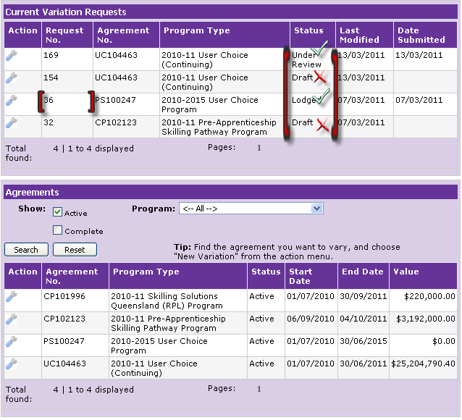

Is it too late to withdraw an AVR?
An AVR cannot be withdrawn if the current status is Draft, Approved, Refused or Lapsed. The Agreement is updated after approval to reflect the variation requested and therefore withdrawal is not possible. Another AVR will need to be submitted to request a reversal. The Department reserves the right to reject an AVR.

What happens after I withdraw my AVR?
The following occurs after withdrawal of an AVR:
- the current status of the AVR is updated to Withdrawn
- the withdrawal details of the AVR are recorded against the AVR and can also be found in the Variations History
- the Department is notified of the withdrawal
- the Department ceases to process the AVR

Who can withdraw AVR?
An AVR can only be withdrawn by you. Departmental staff may suggest withdrawal of an AVR but cannot withdraw the AVR on your behalf.

Why am I unable to withdraw my AVR?
You may not be able to withdraw an AVR if any of the following are true:
- Current status of the AVR is not Lodged, Information Requested, Awaiting Deed of Variation Confirmation or Under Review
- You have failed to provide the reason for withdrawal.
You have failed to provide the response/notes for the withdrawal of the AVR.

How can I view my withdrawn AVR?
You can view your withdrawn AVR at anytime after it has been successfully withdrawn. To view the withdrawn AVR refer to the Variation History.

How can I check the current status of my AVR?
You can check the current status of your AVR by referring to the “Status” column within the Current Variation Requests section. AVRs that have been processed or have lapsed do not appear in the Current Variation Requests section. To view lapsed or processed AVRs refer to Variation History for the specific Agreement. Refer to the screen print below for all active AVRs:
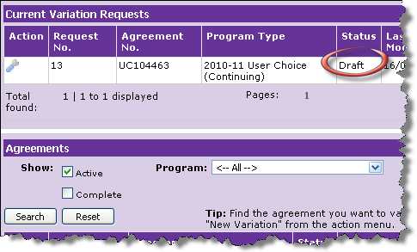

How can I withdraw my AVR?
Follow the instructions provided below to withdraw an AVR.

Step | Action
1. | Identify the AVR you wish to withdraw by its unique Request Number.  Check the current status of the AVR you wish to withdraw.  To be able to withdraw the AVR, the status of the AVR must be one of the following:  - Lodged  - Under Review  - Information Requested  - Awaiting Deed of Variation Confirmation.

Step | Action
2. | In the column named “Action”, point your mouse over the “spanner” image and click “Open” to view details of the AVR you wish to withdraw.  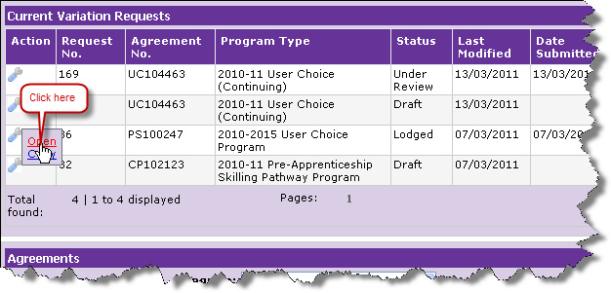
3. | Ensure the AVR is the intended AVR for withdrawal by verifying the Request Number and corresponding details.  Look for the button named “Withdraw” at the bottom of the page.  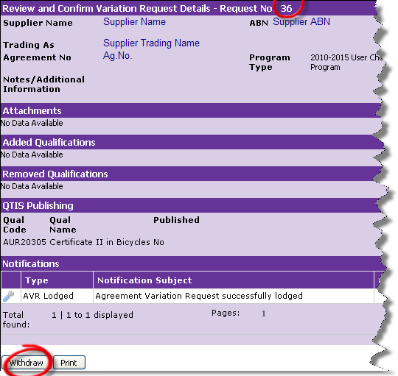

Step | Action
4. | Click “Withdraw” to withdraw the AVR.  A warning message is displayed to confirm your intention of withdrawing the AVR. You must choose OK to continue. Choosing Cancel will stop the withdrawal process from continuing.  Click “OK” to proceed with the withdrawal of AVR.  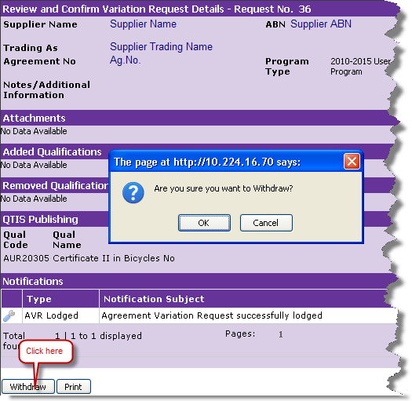

Step | Action
5. | A Notification – AVR withdrawn pop-up window appears. This is where you will provide the reason for withdrawal of the AVR. If you choose “other” as a reason for withdrawing the AVR, you can also provide additional information by way of text in the “Notes” section.  Provide additional information in support of the reason, in the Response / Notes section.  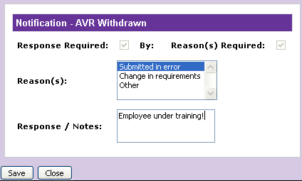
6. | Click the Save button to save the reason(s) and the notes. If you choose not to save and close the Notification – AVR Withdrawn popup window, your AVR will not be withdrawn.  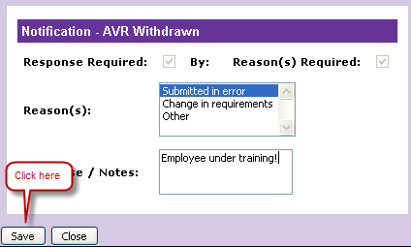

Step | Action
7. | “Review and Confirm Variation Request Details” page is displayed.  Note the following changes in this page:  - Change in status of the AVR to Withdrawn  - “Withdraw” button no longer appears at the bottom of the page  Notifications section is updated with a new notification of the type “AVR Withdrawn”.  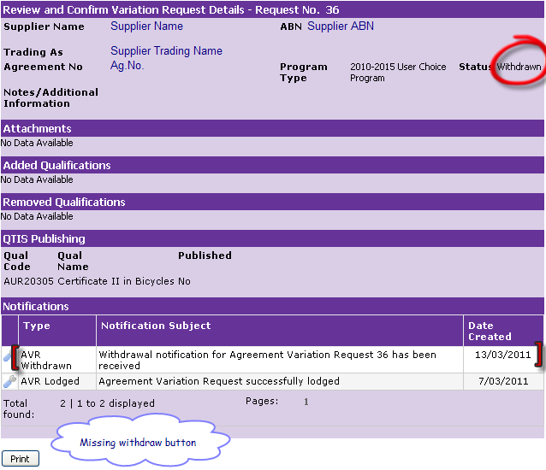
8. | If you wish, you can Print the withdrawn AVR for your records. Alternatively, you can view the withdrawn AVR at a later date by looking at the Variation History.

Step | Action
9. | If you return to the Current Variation Requests section by clicking the “Back” browser button or the Variations link in the POL left menu, the AVR will no longer appear in the list.  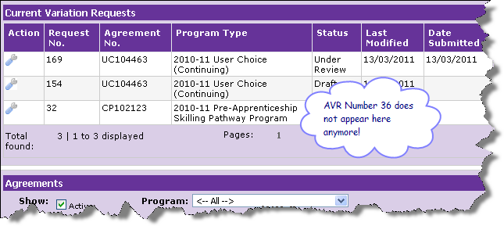
10. | To view the withdrawn AVR, or learn more about how to view past variations, refer to Variation History.

