Graffiti removal order

What is a graffiti removal order?
 | It is unpaid work to remove graffiti.
12+ | 12 years old and older.
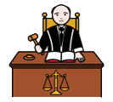 | You are guilty of doing graffiti.  You said you did graffiti  or  the court said you did graffiti.
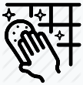 | You can fix the damage you did.
 | The court and YJ officer will tell you how many hours you need to do.
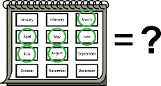 | The court tells you when you need to finish doing your hours. Like, in 6 months.

What work will I do?
You do this work in your spare time.
Your YJ officer will tell you where you will remove graffiti.
Your YJ officer may ask a youth worker to be there with you.
The graffiti supervisor will count how many hours you did. They will tell your YJ officer.

What do I bring?
- your own food and drinks
- hat
- sunglasses
- sunscreen
Your youth worker will tell you what to bring.
The work site may give you special clothing. They will tell you how to use it safely.

Do not bring
 | - alcohol
 | - drugs
 | - weapons, like a knife
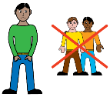 | - your friends
 | Your supervisor will tell you other things you cannot bring.

What if I cannot go that day?
 |  | You must have a very good reason to not go to graffiti removal.
 |  | You must call your YJ officer to tell them. You must do what your YJ officer says.
 |  | If you are sick, you need to go to a doctor to get a medical certificate.

 | Rules
 | 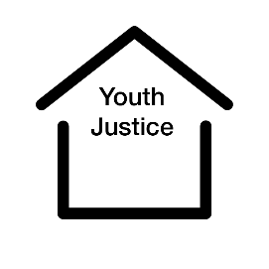 |  | 1 business day after court, you must see your YJ officer.  Like, if court gives you the order on Monday, you need to see the YJ officer on Tuesday.  Monday → Tuesday
You need to follow the rules.
You must:
 |  |  | - not break the law
 | 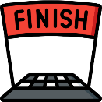 |  | - finish your hours
 | 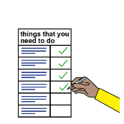 |  | - do what it says in your order.
 |  | You must tell your YJ officer within 2 days if you:
- move house
- change schools.

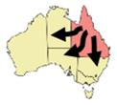 | You must tell and give lots of time to the YJ officer if you want to leave Queensland.
 | Your YJ officer needs to say ‘yes’.

What if I break the rules
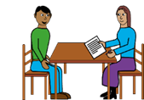 | Your YJ officer will tell you what happens if you break the rules.
 | If you break a rule, your YJ officer will give you a warning letter.
 | If you keep breaking the rules, you will go back to court.
 | The court will decide if you will stay on a graffiti removal order or a different order.
If you offend again, the court may decide you have breached your order.
This means the court gave you rules but you did not follow the rules.
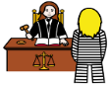 | The court may give you more punishment.

My order
Number of hours _______________________________
I finish my order on _____________________________

Who do I talk to in YJ?
Ask for the intake officer.
Where _______________________________________
Phone _______________________________________
Email ________________________________________
The material presented in this publication is distributed by the Queensland Government for information only and is subject to change without notice. The Queensland Government disclaims all responsibility and liability (including liability in negligence) for all expenses, losses, damages and costs incurred as a result of the information being inaccurate or incomplete in any way and for any reason. © State of Queensland (Department of Youth Justice, Employment, Small Business and Training) 2023.

