Supplier User Manual
Variations Online (VOL)

Contents
Submit and Lodge Agreement Variation Request 2
What is Submitting of an Agreement Variation Request? 2
When can I submit an Agreement Variation Request? 2
Is it too late to submit an Agreement Variation Request? 2
What happens after I submit an Agreement Variation Request? 2
Who can submit an Agreement Variation Request? 2
How do I submit my AVR? 2
How can I check if an Agreement Variation Request has been submitted? 6
What is meant by Agreement Variation Request - Awaiting Confirmation? 6
What is the difference between Submitting and Lodging an AVR? 7
What is lodgement of an Agreement Variation Request? 7
When can I lodge an Agreement Variation Request? 7
Is it too late to lodge an Agreement Variation Request? 8
What happens after I lodge an Agreement Variation Request? 8
Who can lodge an Agreement Variation Request? 8
How can I lodge my AVR? 8
How can I check if my Agreement Variation Request has been lodged? 12

Submit and Lodge Agreement Variation Request

What is Submitting of an Agreement Variation Request?
The purpose of submitting an AVR is to valid the request. The AVR status is in Draft until submitted. The system checks the AVR ensuring there are no errors before validation can be completed.
If no errors are found, the AVR summary page will be displayed and the status of the AVR will progress from Draft to Awaiting Confirmation. If errors have been identified during the validation, the AVR will not be lodged and the status of the AVR will remain in Draft. Errors will be identified in the errors tab, under Validation Request Details and will need to be rectified before re-submitting. All the errors that are identified during validation can be found in the Errors Tab located on the Variation Details Page. You must rectify all the errors before re-submitting the AVR.
Submitting an AVR is different from lodging an AVR. Click the following link to learn more about the difference between Submitting and Lodging of AVR.

When can I submit an Agreement Variation Request?
You can submit an Agreement Variation Request for an Active agreement at any time after the commencement of the Agreement and 30 days before the Agreement End Date. If errors are detected during the validation process of the AVR prior to submitting it to the Department, the system will identify the error/s to be rectified.
The status of the Agreement and the Agreement End Date must be checked before initiating any Agreement Variation Request for an Agreement.

Is it too late to submit an Agreement Variation Request?
Lodgement of an Agreement Variation Request is restricted to within 30 days of the Agreement End Date. This means that an AVR with the Last Modified date outside of the 30 day period will not be lodged and the system will return a validation error.

What happens after I submit an Agreement Variation Request?
The system will validate the AVR and if no errors are found, the AVR summary page will be displayed with the AVR status progressing from Draft to Awaiting Confirmation.

Who can submit an Agreement Variation Request?
A supplier initiated AVR can only be submitted by the Supplier or a representative of the Supplier.

How do I submit my AVR?
Once you have successfully added all the variation elements that you wanted, you can proceed to submit the AVR.

Note: When you submit the AVR, you are submitting it for validation only. Submitting an AVR is different from lodging an AVR. Click the following link to learn more about the difference between Submitting and Lodging of AVR. Validation of AVR ensures that the AVR is error free. Before the AVR is submitted, it has the status of draft.
Follow the instructions provided below to resume a Draft AVR.

Step | Action
1. | Skip to step 7 if you are on Variation Request Details page.
2. | On the main Variations Online page, under Current Variation Requests, identify the Draft AVR you wish to submit by the unique Request Number, corresponding Agreement Number and Program Type. If you are unable to identify the Draft AVR, please refer to “cannot find my Draft AVR” section.  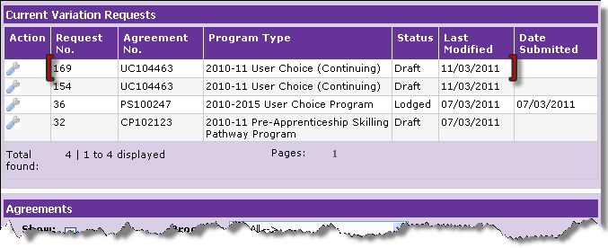
3. | In the column named “Action”, point your mouse over the “spanner” image. Click “open” to view details of the AVR you wish to submit.  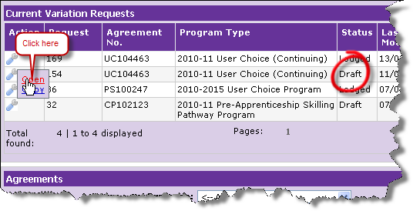

Step | Action
4. | Note the Request Number on the Variation Request Details page.  Ensure the Agreement is the intended Agreement for which the AVR is to be resumed. You can verify the correct Agreement by the Agreement Number and Program Type in the Variation Request Details page.  In this example we have assumed that you have requested a Qualification to be added.  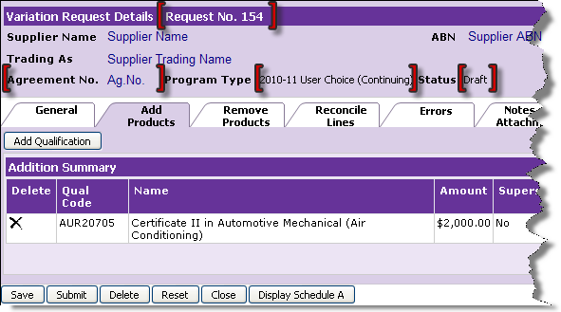
5. | Click on Submit to submit the AVR for validation.  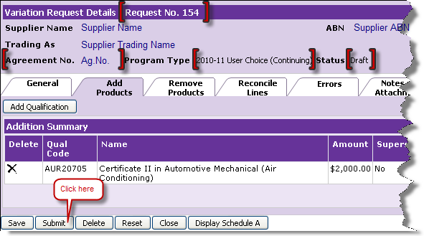

Step | Action
6. | Once the AVR is submitted, the system will validate the AVR for errors. Errors must be rectified before re-submitting. Click “I am getting error on submission” to learn more about error-handling.  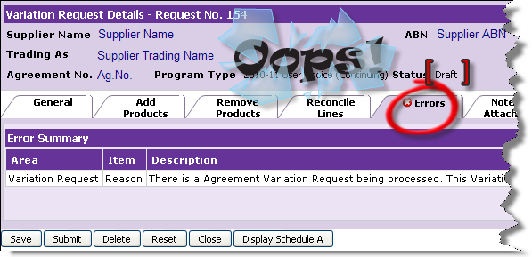
7. | When there are no errors identified during validation, the Review and Confirm Variation Request Details page will appear.  Note the status of the AVR now becomes Awaiting Confirmation. – this means the AVR is ready for lodgement. Click “how can I lodge my AVR” to learn more about AVR lodgement.  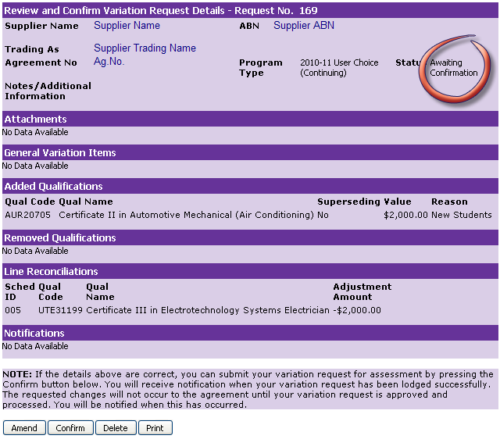
8. | You have now successfully submitted your AVR.

How can I check if an Agreement Variation Request has been submitted?
To confirm if the AVR has been submitted, go to the summary page. The status of the AVR should have progressed from Draft to Awaiting Confirmation.

What is meant by Agreement Variation Request - Awaiting Confirmation?
When an AVR has the status of Awaiting Confirmation, it means that the AVR is error free and is ready to be sent to the Department for their consideration.
Upon submission of AVR, the system validates the AVR to ensure there are no errors. The AVR does not achieve the status of Awaiting Confirmation until all errors have been rectified. When an AVR is Awaiting Confirmation, it provides the opportunity to review and amend the variations requested.
The AVR can then proceed to lodge. Click Lodge AVR to learn more about how to lodge an AVR.
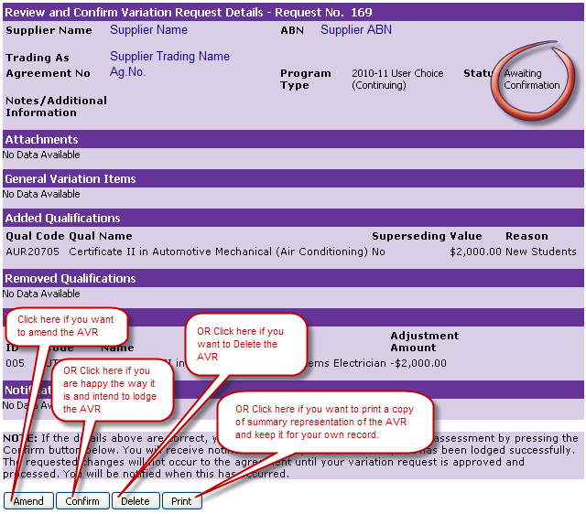

What is the difference between Submitting and Lodging an AVR?
The purpose of submitting an AVR is to valid the request. The AVR status is in Draft until submitted. The system then checks the AVR ensuring there are no errors before validation can be completed.
The purpose of lodging an AVR is to advise the Department of the variations requested as specified in the AVR.

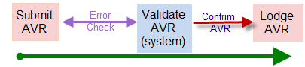

What is lodgement of an Agreement Variation Request?
Lodging an AVR is the same as making an application to vary an existing Agreement. It is the most important step when requesting the Department to consider the variation to an active Agreement. Variations should be reviewed prior to lodging the AVR by viewing the summary representation of all the variations specified on the Review and Confirm Variation Details page. Once lodged, the organisation acknowledges they have:
- reviewed and understand the contents of the AVR
- confirm the contents of the AVR form the intended request to vary the Agreement.

When can I lodge an Agreement Variation Request?
An Agreement Variation Request can only be lodged if all of the following conditions are met:
- the AVR is for an active Agreement
- the Agreement End Date for the corresponding Agreement does not fall within next 30 days
- no other AVR is active for the same agreement.
Where the system has returned an error on the “No other AVR is active for the same agreement”, then the active AVR must be finalised before attempting to lodge another AVR.

Is it too late to lodge an Agreement Variation Request?
Only if the Agreement Variation Request does not satisfy all of the following conditions:
- the AVR is for an active Agreement
- the Agreement End Date for the corresponding Agreement does not fall within next 30 days
- No other AVR is active for the same agreement.
Where the system has returned an error on the “No other AVR is active for the same agreement”, then the active AVR must be finalised before attempting to lodge another AVR.

What happens after I lodge an Agreement Variation Request?
Upon successful lodgement of an AVR the following will occur:
- notification of a successful submission
- the AVR will appear in the Current Variation Requests section on the Variations Online page with the status as Lodged
- notification of the type of AVR Lodged appears on the Review and Confirm Variation Details page
- the Department receives a notification of the submission of your AVR and proceeds to evaluate your request.
Once lodged, an AVR cannot be deleted but can be withdrawn.
You can now print the AVR for your records. To print at any time, go to the Notifications History of the respective AVR.

Who can lodge an Agreement Variation Request?
A supplier initiated AVR can only be lodged by the Supplier or a representative of the Supplier.

How can I lodge my AVR?
Follow the instructions provided below to lodge an AVR

Step | Action
1. | On the Review and Confirm Variation Request Details page, proceed to ensure the following are correct and intended:  - The Agreement Variation Request number  - The status of AVR is Awaiting Confirmation  - Review the variation elements.

Step |  | Action
2. | Click “Amend” if you want to change the variation elements or the contents of the variation elements.  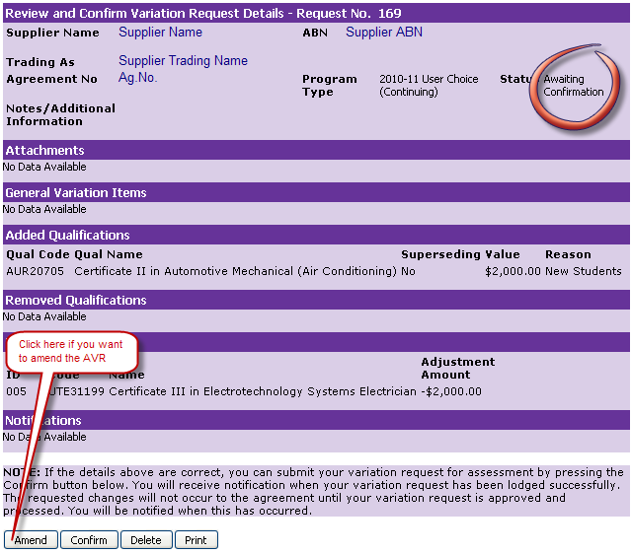

Step | Action
3. | Click “Confirm” if you are happy with the AVR as is and want to lodge the AVR.  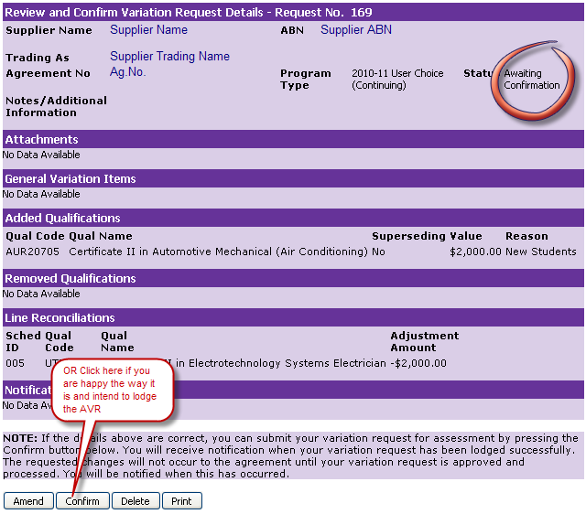  A notification confirming successful lodgement of the AVR is displayed.  Note the unique AVR number for future correspondence.  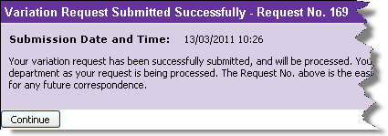
4. | You have successfully lodged the AVR.

How can I check if my Agreement Variation Request has been lodged?
The following are the ways to confirm successful lodgement of your AVR.

Step | Action
1. | Check if AVR appears in the Current Variation Requests section on Variations Online page with the status as Lodged.  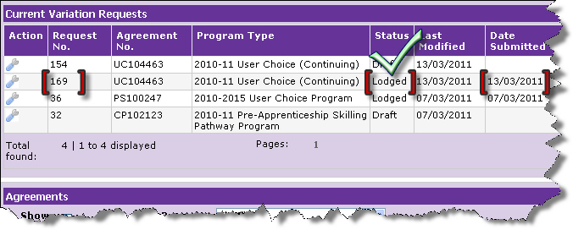

Step | Action
2. | Check for notification of the type AVR Lodged appears on the Review and Confirm Variation Details page.  Note: Only Withdraw and Print buttons are available now.  The Notification ID is not the same as your AVR number.  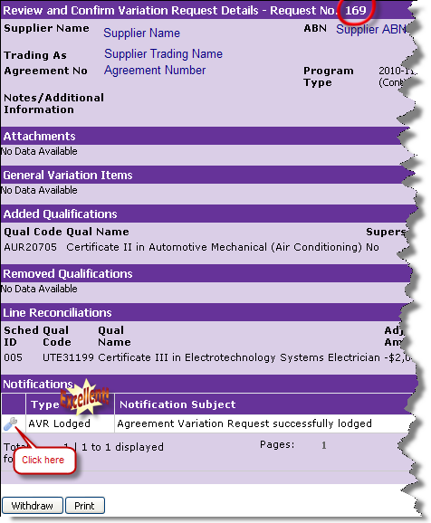
3. | 