Graffiti removal program – police referral

What is a graffiti removal program?
 | It is unpaid work to remove graffiti.
12+ | 12 years old and older.
 | You are guilty of doing graffiti.
 | You told the police you did graffiti.
 | You can fix the damage you did.
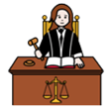 | You can avoid going to court.
 | You need to do 2 hours of work to remove graffiti. The 2 hours does not include your travel or safety training time.
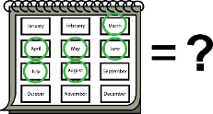 | The YJ officer tells you when you need to finish doing your hours.

What work will I do?
 | Your YJ officer will tell you where you will remove graffiti.
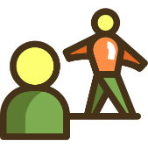 | Your YJ officer may ask a youth worker to be there with you.
 | The graffiti supervisor will count how many hours you did. They will tell your YJ officer.

What do I bring?
 | - your own food and drinks
 | - hat
 | - sunglasses
 | - sunscreen
Your youth worker will tell you what to bring.
The work site may give you special clothing. They will tell you how to use it safely.

Do not bring
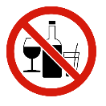 | - alcohol
 | - drugs
 | - weapons, like a knife
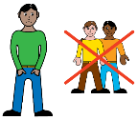 | - your friends
 | Your supervisor will tell you other things you cannot bring.

What if I cannot go that day?
 |  | You must have a very good reason to not go to your graffiti removal program.
 |  | You must call your YJ officer to tell them. You must do what your YJ officer says.
 |  | If you are sick, you need to go to a doctor to get a medical certificate.

 | Rules
 |  |  | The police will tell your YJ officer you must do the graffiti removal program.
 | 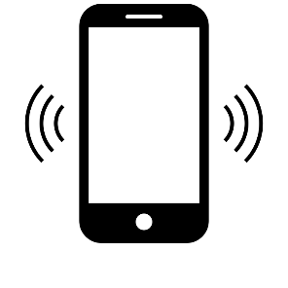  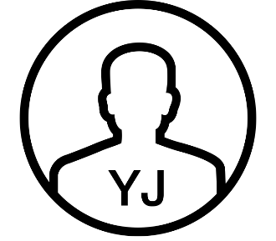 |  | Then your YJ officer will call you
 |  |  | You must call your YJ officer when they tell you.
You need to follow the rules.
You must:
 | 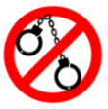 |  | - not break the law
 |  |  | - finish your hours.

What if I break the rules
 |  | You must complete your graffiti removal program or your YJ officer will tell the police.
The police will decide to give you another chance to do the program
or
send you to court.
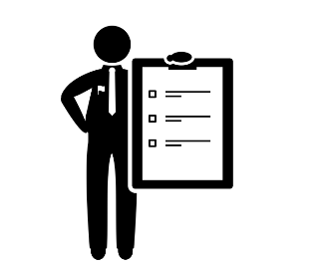 |  | The police could also charge you with another offence because you did not finish the program.

My program
I must do 2 hours by _____________________________
Time _________________________________________
Where ________________________________________

Who do I talk to in YJ?
Ask for the intake officer.
Where _______________________________________
Phone _______________________________________
The material presented in this publication is distributed by the Queensland Government for information only and is subject to change without notice. The Queensland Government disclaims all responsibility and liability (including liability in negligence) for all expenses, losses, damages and costs incurred as a result of the information being inaccurate or incomplete in any way and for any reason. © State of Queensland (Department of Youth Justice, Employment, Small Business and Training) 2023.

