COVID-19 visitor information
We are working with Queensland Health to stop the spread of COVID-19 at the youth detention centres.
We want young people, staff and others to be safe.
We are doing this to stop the spread of COVID-19:
- COVID-19 health checks and vaccinations for young people
- COVID-19 vaccinations for all staff
- increased cleaning
- increased use of hand sanitisers
- wearing masks (highly recommended if you are inside and not able to socially distance)
- extra staff training
Contact your child’s caseworker if you have any concerns.

Visiting a youth detention centre
We understand young people still need to connect with their families and friends while in a youth detention centre. Staff will help you to stay in contact with them.
You do not need to be vaccinated against COVID-19 to visit a youth detention centre.
Face masks are recommended in inside areas if you can’t socially distance from other people.

You should not enter if you have:
- had contact with a confirmed case of COVID-19 in the past 14 days
- a fever or symptoms of COVID-19
- tested positive to COVID-19 in the past 7 days

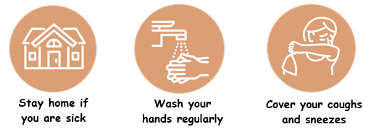
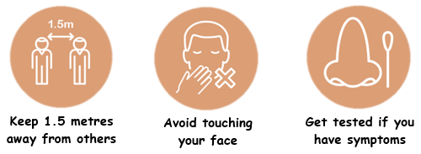
Please contact the youth detention centre if you need more information.

