Supplier User Manual
Variations Online (VOL)

Contents
Editing Agreement Variation Request – General 2
How do I resume a Draft (partially completed) Agreement Variation Request? 2
I cannot find my Agreement Variation Request? 4
Who changed my AVR? 5
How can I attach a document to my AVR? 5
How do I delete an attachment? 9
How can I delete my Agreement Variation Request? 12
How can I view the Schedule A for an Agreement? 14
Which variation elements can be included in an Agreement Variation Request? 15
How can I add notes to my AVR 16

Editing Agreement Variation Request – General

How do I resume a Draft (partially completed) Agreement Variation Request?
Depending on the complexity of the AVR, there may be instances where you are unable to create, submit and lodge the AVR in a single session. To help you engage in multiple sessions for a specific AVR, the system provides you with the functionality to resume from previously saved Draft AVR. You can choose to submit and lodge the AVR at a later date.
To ensure the system is free from redundant data, a Draft AVR will be automatically deleted if no activity has been detected for a period of 45 days.
Follow the instructions provided below to resume a Draft AVR.

Step | Action
1. | On the main Variations Online page, under Current Variation Requests section, identify the Draft AVR you wish to resume by its unique Request Number, corresponding Agreement Number and Program Type. If you are unable to identify the Draft AVR, please refer to “cannot find my Draft AVR” section.  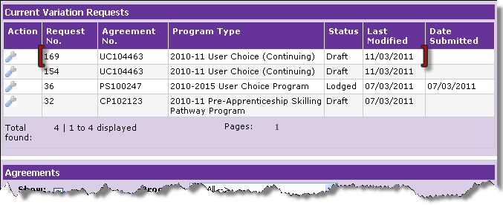
2. | In the column named “Action”, point your mouse over the “spanner” image. Click “open” to view details of the AVR you wish to resume.  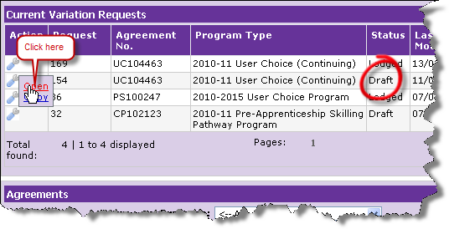
Step | Action
3. | Note the Request Number on the Variation Request Details page.  Ensure the Agreement is the intended Agreement for which the AVR is to be resumed. You can verify by the Agreement Number and Program Type in the Variation Request Details page.  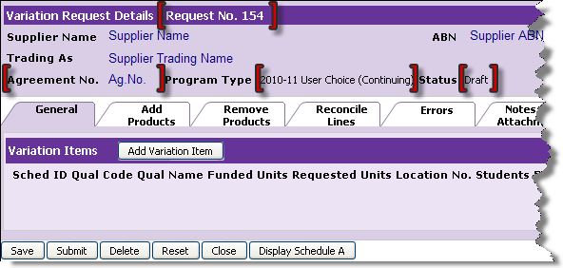
4. | Continue to add any variation elements. Click Add Variation Elements to learn more about adding the variation elements to your AVR. Once done, you can submit the AVR or save it for yet another session.  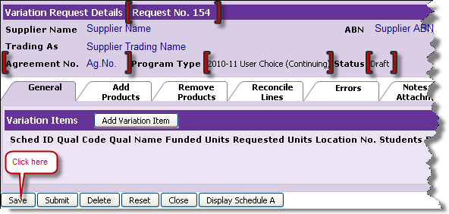
5. | If you have added the variation elements and are ready to submit the AVR, follow the instructions under “Submit AVR”.

Step | Action
6. | If you want to submit the AVR at a later date, you must save the AVR. The Current Variation Requests page will display the saved AVR in Draft status.  Note the Last Modified date is updated to “today’s date”.  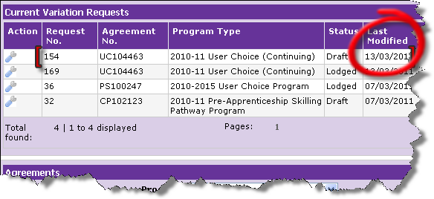

I cannot find my Agreement Variation Request?
All the active AVRs appear on the main Variations Online page under Current Variation Requests section. If the AVR is in any of the following status then you will not be able to find AVR under Current Variation Requests section:
- Deleted
- Lapsed
- Processed
All the lapsed AVRs are considered to be inactive and as a result are taken off from the Current Variation Requests list. An active AVR may lapse where the department has found it necessary to request further information from you to progress the AVR. If, for any reason, you have failed to provide the Department with the requested information within the specified time limit, the AVR will lapse.
A draft AVR is subject to automatic deletion when no activity has been detected against it for a period of 45 days continuously. It is important to note that the residual characteristics of the Agreement that supports the AVR are continuously changing.
These changes, by way of payment claims submissions, payments made to you, etc. continuously update the available Agreement allocation. These changes may make certain variation elements of an AVR void. This self cleaning mechanism helps to make sure that you don’t find yourself amid numerous draft AVRs that have over the period of time been created and not used.
The Department has undertaken measures to ensure that you receive relevant, accurate and current information. However, it is not possible to guarantee since there may be instances caused by system error.
If you feel your draft AVR should not have been deleted (because you are well within the 45 day time period), please inform the Department so that corrective steps can be taken. Click “Helpdesk” to learn more about system errors and report on abnormal system behaviour.

Who changed my AVR?
Only the person authorised by the organisation is able to make changes to the AVR. The Department will keep a record of who submitted the AVR on behalf of the organisation and cannot make changes to the AVR. The Department is unable to help identify the person making changes until the AVR is submitted.
It is important to note that some financial values forming part of the variation elements may change automatically. This is due to the residual characteristics of the Agreement that supports the AVR. Each time changes are made, the AVR (including draft AVR) is updated with the most up-to-date data.
These changes, by way of payment claim submissions, payments to organisations and RTOs continuously update the available Agreement allocation and may, in some circumstances, void certain variation elements of the AVR.
Before submitting an AVR that has been in Draft status for some time, ensure all values contained within the AVR are the intended values. The system will error and will not allow progression if values provided in the Draft AVR are not current.

How can I attach a document to my AVR?
You may attach a business case to your AVR by using the attachment facility. Attachments are limited to size restrictions of 5MB and to PDF and Microsoft Word formats only.
Follow the instructions provided below to learn how to attach a document as supporting document to your AVR.

Step | Action
1. | On the main Variations OnLine page, under Current Variation Requests section, identify the AVR for which you wish to attach a supporting document. You can identify the specific AVR by looking at the status column.  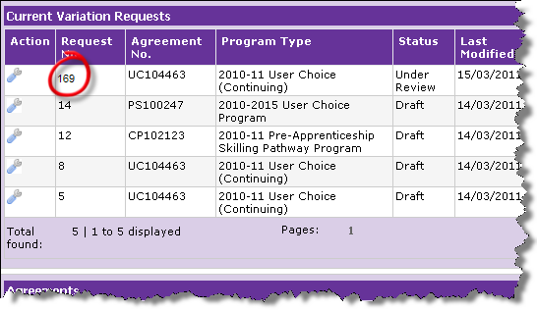

Step |  | Action
2. | In the column named “Action”, point your mouse over the “spanner” image. Click “open” to view details of the specific AVR.  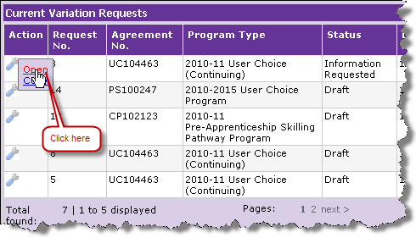
3. | Ensure the AVR is the intended AVR for withdrawal by verifying the Request Number and corresponding details. The Variation Request Details page is displayed. Click on the Notes and Attachments tab.  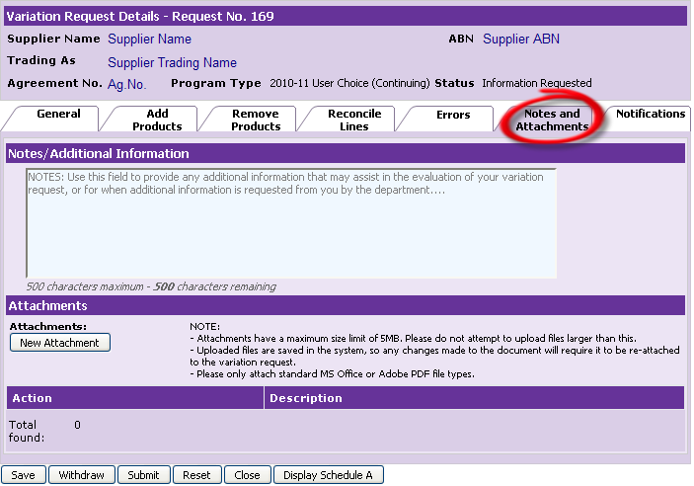

Step |  | Action
4. | Click on “New Attachment” to add supporting document(s) to your AVR.  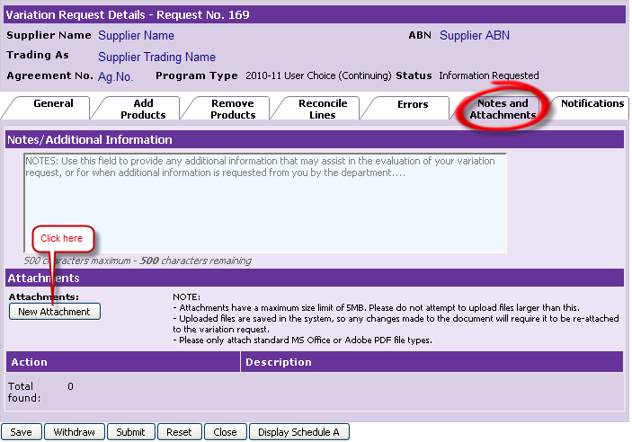
5. | A “New attachment” pop-up window is displayed. Click on Browse to locate your document and you must provide a short description relevant to the document.  Note: The mandatory description field must have an appropriate short description to accurately describe the content of the document you intend to attach.  Click Attach to add the document to the AVR.  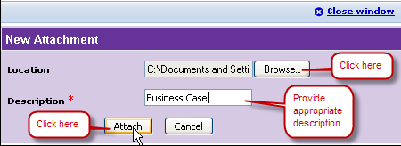

Step |  | Action
6. | The Variation Request Details page is displayed. You have successfully attached a supporting document to your AVR. You can continue to add more attachments if required by choosing “New Attachment”. Note under the attachment section, the description that you entered in the previous step.  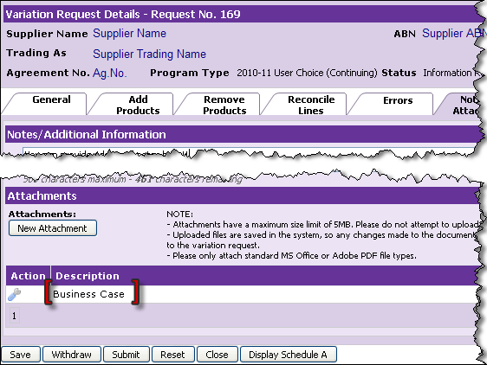
7. | Click “Submit” to validate the attachment.  Note if you get an error on submitting the AVR click Helpdesk to learn more about the error.  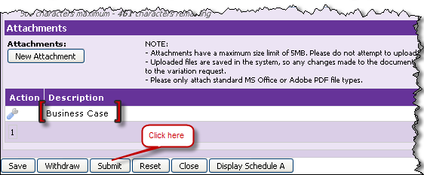

Step |  | Action
8. | The Review and Confirm Variation Request Details page is displayed. You can see your attachment/s and the description under the “Attachments” section. Click “Confirm” to send the attachment to the Department.  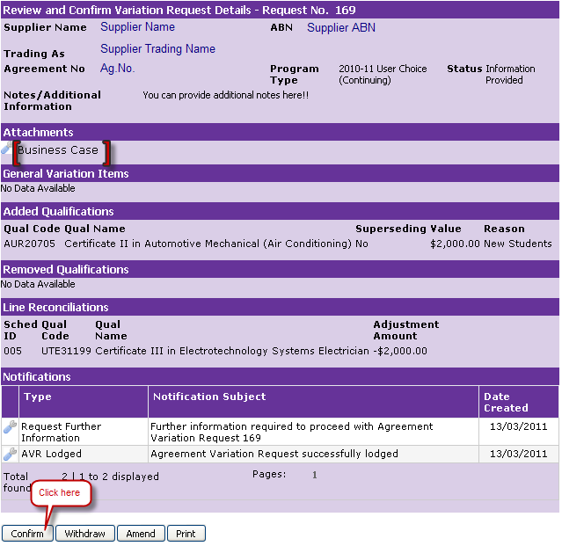
9. | You have now successfully sent your supporting document to the Department.  Note the “Confirm” and “Amend” buttons are missing.  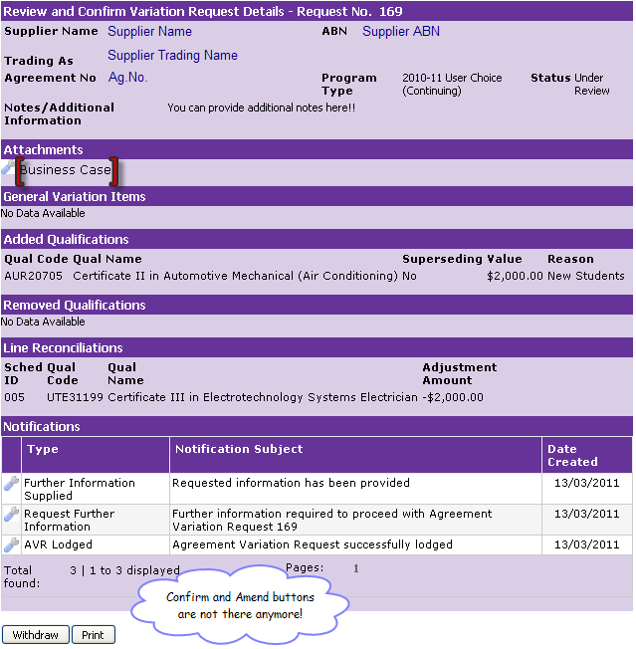

How do I delete an attachment?
You can add and delete attachments when the AVR is in Draft or Information Requested status. All the AVRs from which you can delete the attachment will appear on the main Variations Online page under the Current Variation Request section.
Follow the instructions below to learn how to delete an attachment that was previously added to your AVR:

Step | Action
1. | Identify the AVR that contains the attachment you wish to delete. You can identify the AVR by its unique Request Number.  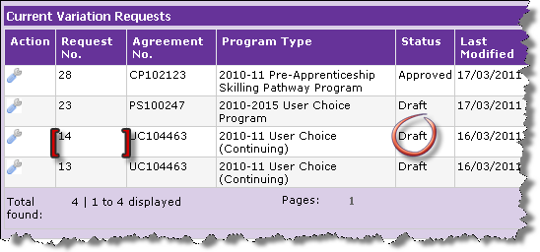
2. | In the column named “Action”, point your mouse over the “spanner” image. Click “Open” to view the AVR.  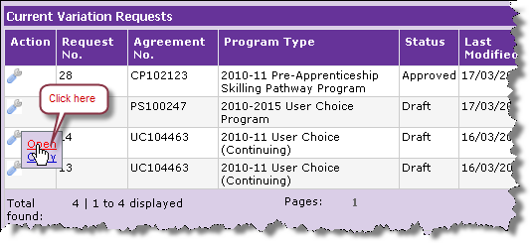

Step |  | Action
3. | Variation Request Details page is displayed. Click on “Notes and Attachments” tab to view your attachment(s).  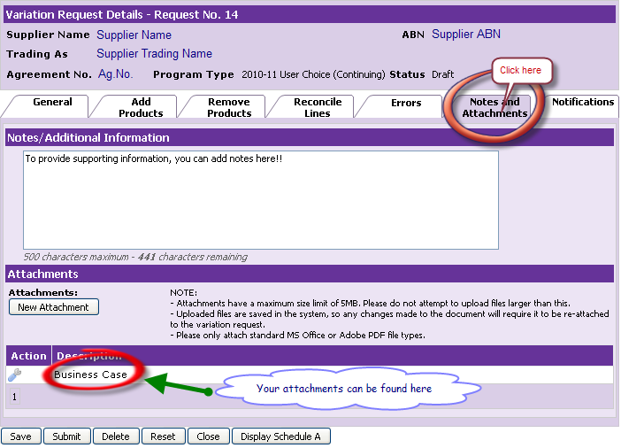
4. | Under the “Attachments” section, in the column named “Action”, point your mouse over the “spanner” image. Click “Delete” to delete your attachment.  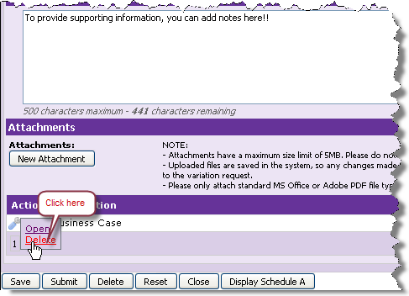

Step |  | Action
5. | Your attachment has now been deleted.  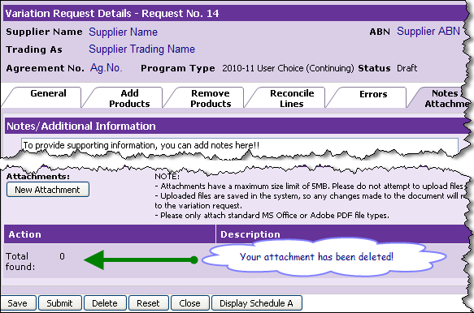

How can I delete my Agreement Variation Request?
You can delete your AVR anytime before you have sent the AVR to the department. The AVR is sent to the Department as soon as you click “Confirm” on the “Review and Confirm Variation Request Details” page. That means you can delete your AVR only when the status of the AVR is “Draft” or “Awaiting Confirmation”.
Follow the instructions provided below to learn how to delete an attachment before it is sent to the Department.

Step | Action
1. | On the main Variations OnLine page, under Current Variation Requests section, identify the AVR you wish to delete by its unique Request Number, corresponding Agreement Number and Program Type. If you are unable to identify the Draft AVR, please refer to “cannot find my Draft AVR” section.  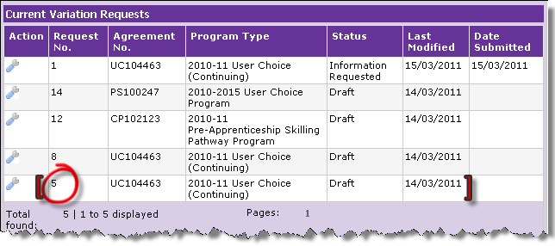

Step |  | Action
2. | In the column named “Action”, point your mouse over the “spanner” image. Click “open” to view details of the AVR you wish to delete.  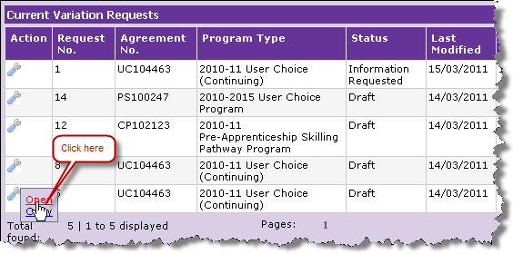
3. | Note the Request Number on the Variation Request Details page.  Ensure the Agreement is the intended Agreement for which the AVR is to be deleted. You can verify the correct Agreement by the Agreement Number and Program Type in the Variation Request Details page.  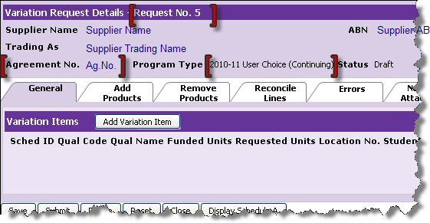

Step |  | Action
4. | To delete the AVR click “Delete”.  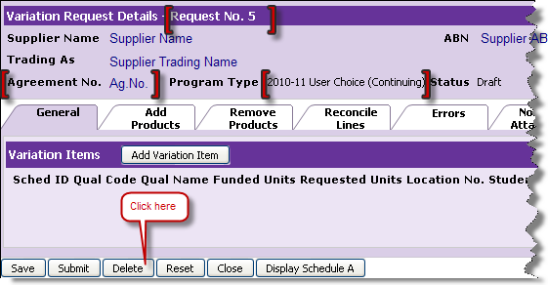
5. | Click Ok to delete the AVR.  Note: If you click OK, the AVR will be permanently deleted.  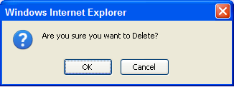
6. | You have successfully deleted your AVR.  Note your AVR does not appear on the Current Variation Requests list any more.  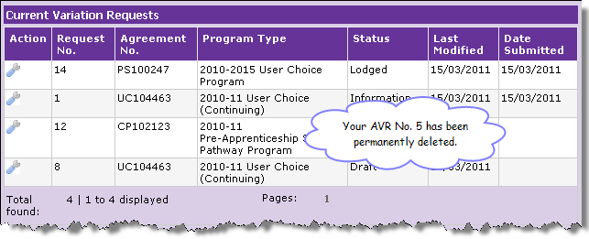

How can I view the Schedule A for an Agreement?
The Department encourages you to keep a copy of your Schedule A as well as the Payment Claims Summary of your Agreement accessible when you are creating the Agreement Variation Request for the Agreement.
Note: Reference to Schedule A also includes Delivery Schedule.
Follow the instructions provided below to learn how to view the Schedule A for the Agreement for which you wish to create an AVR.

Step | Action
1. | Identify the corresponding Agreement of the AVR you wish to view the Schedule A. You can identify the Agreement by the Agreement Number.  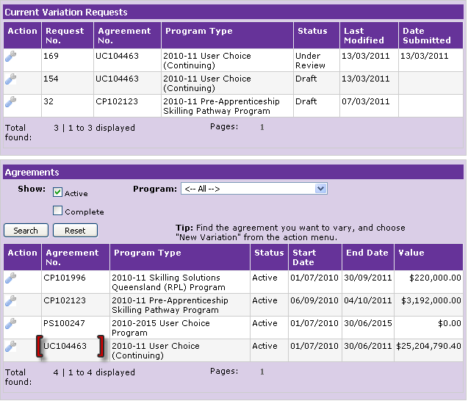

Step | Action
2. | In the column named “Action”, point your mouse over the “spanner” image. Click “Schedule A” to view Schedule A for the agreement.  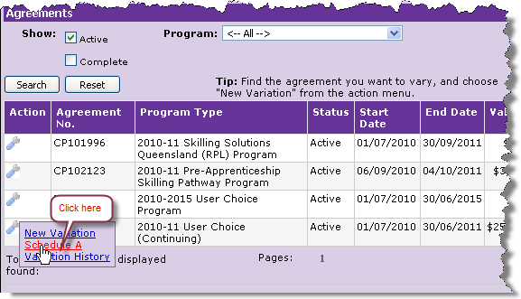
3. | Open file pop-up is displayed. Click Ok to open and view the Schedule A for your Agreement.  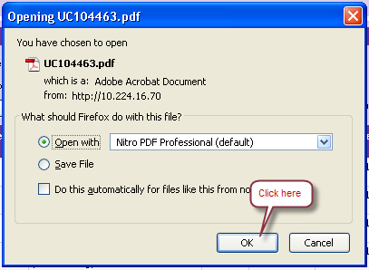

Step | Action
4. | You can ALSO view the Schedule A for your Agreement by clicking on the Schedule A button that appears on the Variation Request Details page.  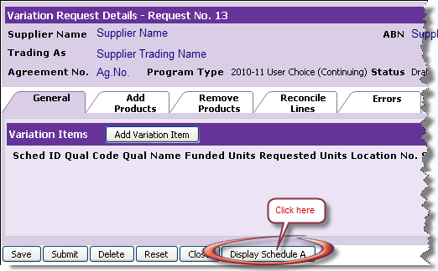

Which variation elements can be included in an Agreement Variation Request?
Each Agreement Variation Request can contain multiple variation elements. A variation element is an individual piece of information or item contained on an agreement which can be varied. For example, variation elements include the number of hours on a training schedule line, or the request to add a qualification to an agreement. The set of variation elements that is available in the system is dependent on the program type that the agreement falls under.
Only those elements or items that are able to be varied for the program type will be available in the system. The variation elements available for each program are detailed below.
User Choice Program
- Increase individual schedule line values.
- Add Qualifications
- Remove Qualifications
- Reconcile contract amounts (performed in conjunction with Add/Remove products).
Strategic Initiatives – elements listed will vary depending on each initiative type:
- Adjust Schedule line value allocation – Request movement of funds between schedule lines.
- Delivery Location – Request a change of location for a schedule line.
- Delivery Period – Request an adjustment to the end date of a schedule line.
- Delivery Quantities – Request a change to the number of hours, or number of participants for a schedule line.
- Payment Rate – Request a change to the cost per hour, or cost per participant for a schedule line.
- Add Qualifications
- Add Superseding Qualifications
- Add Competencies
- Add Superseding Competencies
- Remove Qualification
- Remove Competency
Pre-qualified Supplier
- Add Qualifications.
- Remove Qualifications
- Change whether individual qualifications are published on QTIS or not.
NOTE: Individual agreement types within a program often have unique characteristics, and are constructed differently. While the above listings are a good guide to what items may be varied on an agreement, there may slight differences for individual agreement types within a program.

How can I add notes to my AVR
Adding notes to your AVR explains to the Department the reasons why a variation is being requested and assists the Department in considering your variation request. Additionally, you can also attach supporting documents to your AVR through the attachments facility.
Follow the instructions provided below to learn how to add notes to your Draft AVR.
Step | Action
1. | On the main Variations Online page, under Current Variation Requests section, identify the AVR you wish to add notes to by its unique Request Number, corresponding Agreement Number and Program Type. If you are unable to identify the Draft AVR, please refer to “cannot find my Draft AVR” section.  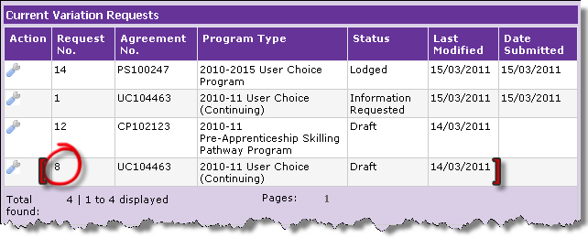

Step | Action
2. | In the column named “Action”, point your mouse over the “spanner” image. Click “open” to view details of the AVR you wish to add notes to.  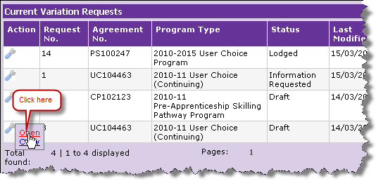
3. | Note the Request Number on the Variation Request Details page.  Ensure the Agreement is the intended Agreement and the AVR is the intended AVR for which you wish to add notes to. You can verify the correct Agreement by the Agreement Number and Program Type in the Variation Request Details page.  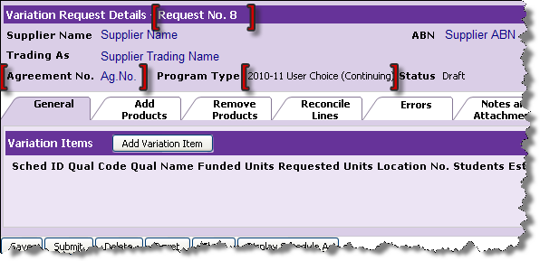

Step | Action
4. | To enter notes click on “Notes and Attachments” tab.  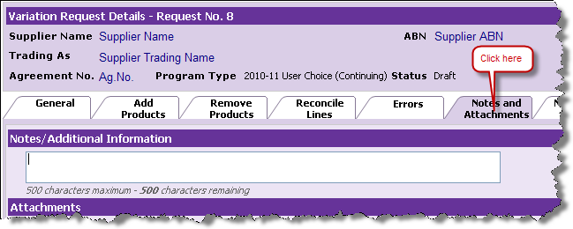
5. | Add your supporting information in the notes/additional information area and click “Submit” to validate the notes.  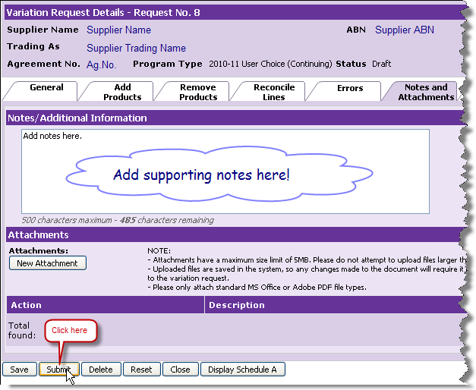

Step | Action
6. | Check your notes to ensure that the contents reflect your intention and are relevant to the AVR.  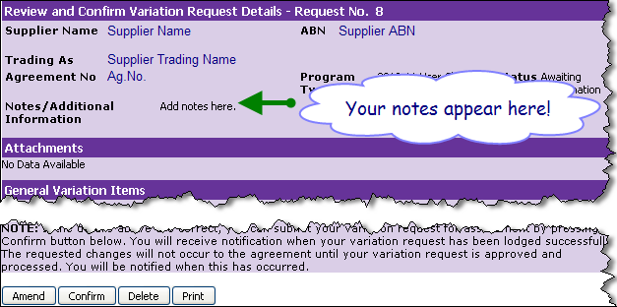
7. | Click “Confirm” to send your supporting notes to the Department.  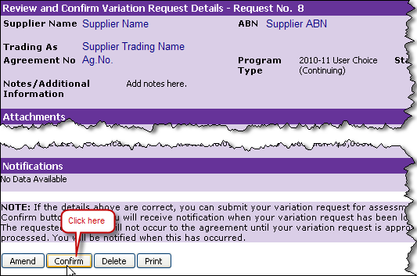

Step | Action
8. | You have successfully submitted your supporting notes to the department.  Note the Confirm and Amend buttons are now missing.  