Information sharing and services coordination for children charged with offences - consent form (easy English)
Legislation: Youth Justice Act 1992 Part 9, Div 2A
Young person details
 | Name
 | Date of birth (day/month/year)
 | Gender |  | Male
 |  |  | Female
 |  |  | Other
 | Home address
 | Phone number
 | Cultural heritage
Parent or guardian details
 | Parent or guardian name (include child safety officer)
 | Home address
 | Phone number

Who has information about me?
 | Queensland Police Service |  | Department of Communities, Housing and Digital Economy
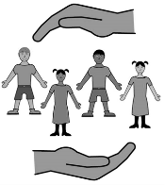 | Department of Children, Youth Justice and Multicultural Affairs |  | Department of Seniors, Disability Services and Aboriginal and Torres Strait Islander Partnerships
 | Department of Education |  | Department of Health
 | Queensland Corrective Services |  | Service provider:

What information is it?
 | who I am
 | my family
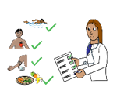 | my health
 | my school
 | my culture
 | my Youth Justice
 | my offences or court
 | other (what is it?):

Who am I giving information to?
 | Queensland Police Service |  | Department of Communities, Housing and Digital Economy
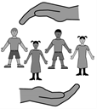 | Department of Children, Youth Justice and Multicultural Affairs |  | Department of Seniors, Disability Services and Aboriginal and Torres Strait Islander Partnerships
 | Department of Education |  | Department of Health
 | Queensland Corrective Services |  | Service provider:

Why?
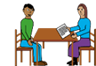 | to be part of making plans to help you
 | to help a court understand what you need
 | to offer services, programs or support for you
 | to find out your needs
 | to send you to the right services for help
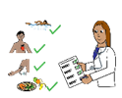 | to look at your health or disability needs

I know this information will only be given to the people/places I named in this form.
I know this information will only be given to other people/places if the law says it must.

Young person __________________________________________________________________________

Signature _________________________________ Date _____________________

Witness _______________________________________________________________________________

Signature _________________________________ Date _____________________

Privacy notice
These are the services:
 | - Queensland Police Service |  | - Department of Communities, Housing and Digital Economy
 | - Department of Children, Youth Justice and Multicultural Affairs |  | - Department of Seniors, Disability Services and Aboriginal and Torres Strait Islander Partnerships
 | - Department of Education |  | - Department of Health
 | - Queensland Corrective Services |  | - Service provider:

These services will use this information to:

 | - find out what you need
 | - help you get support
 | - collect and share information with other services (if ticked above).
 | You are allowed to know what information is being shared about you.
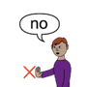 | Your information may be shared even if you do not agree.
 | Your personal information will be managed in line with the Information Privacy Act 2009.

