Supplier User Manual
Variations Online (VOL)

Contents
Creating Agreement Variation Request 2
Who can create an Agreement Variation Request? 2
Why am I unable to create an Agreement Variation Request? 2
How do I find an Agreement? 2
How do I create an Agreement Variation Request? 4
How can I check if an Agreement Variation Request has been created? 7

Creating Agreement Variation Request

Who can create an Agreement Variation Request?
Any actively registered POL user in your organisation can create an AVR for an active Agreement.

Why am I unable to create an Agreement Variation Request?
To successfully create an AVR, there must be an active Agreement. You will not be able to create an AVR against an agreement that is not active, or create an AVR for Agreements that will expire within 30 days. To find out more read: Search Active Agreements to find all the Active Agreements that your organisation has with the Department. You can restrict the search to a particular Program via the drop-down if required.

How do I find an Agreement?
The Agreement section will reflect the most up-to-date information about the Agreements displayed. By default, when you log in, the Agreements section will automatically populate with the Agreements that have been made available to you for lodgement of AVRs via POL.
You can search for a specific Agreement and limit the search by Program Type. You can also filter the results by the Agreements that are Active or Completed. Note: an AVR can only be created against the Agreements that are active.
Follow the instructions provided below to search for your Agreement.

Step | Action
1. | Under the Agreements section, you can find all the Agreements.  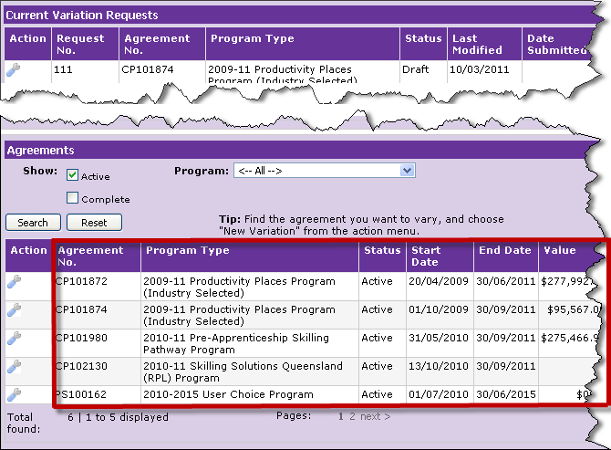
2. | You can filter the Agreement list by selecting the relevant Program Type from the drop down menu.  You can further filter the Agreement list by checking the Show Active button.  If you want to refresh the Agreement list, you can do so by simply clicking the search button.  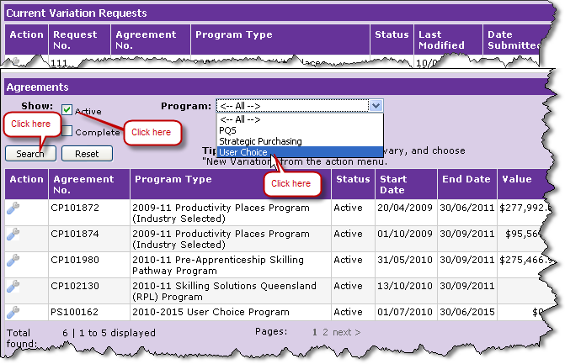

How do I create an Agreement Variation Request?
Follow the instructions provided below to create an AVR.

Step | Action
1. | Identify the Agreement for which the AVR is to be created. You can identify the Agreement by the Agreement Number.  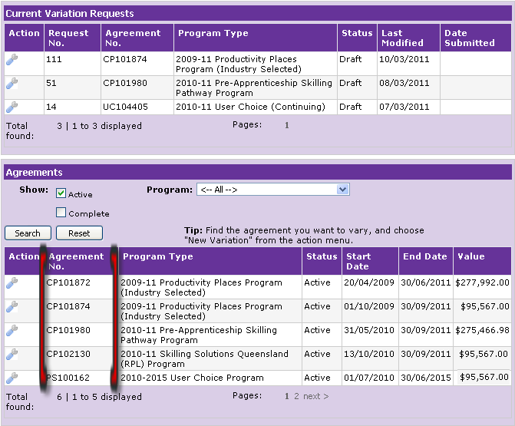

Step | Action
2. | In the column named “Action”, point your mouse over the “spanner” image and click on New Variation.  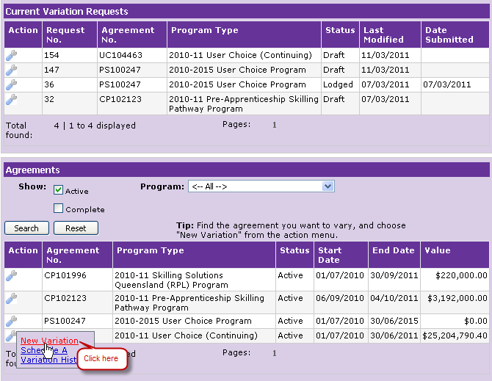
3. | If you already have a draft AVR against a specific Agreement, you will be prompted to use the draft AVR.  If you click “No”, you will be returned to the previous page. In this case, follow the instructions for “How do I resume a Draft (partially completed) AVR?”  If you click “Yes”¸ you will be taken to the Variation Request Details page. A new AVR will be created with status as Draft and a unique number will be allocated to the AVR.  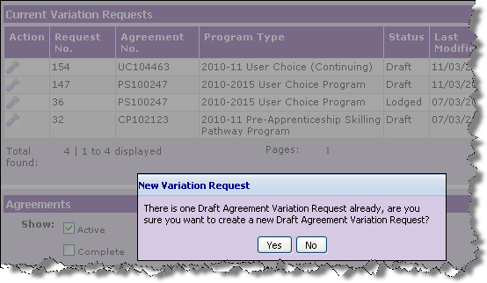

Step | Action
4. | The Variation Request Details page is displayed.  Note the Request Number on the Variation Request Details page.  Ensure the Agreement is the intended Agreement for which the AVR is to be created. You can verify the correct Agreement by the Agreement Number and Program Type in the Variation Request Details header.  Enter the information for your variation request. Refer to Add Variation Elements to learn more about adding information to your AVR. If you are unable to complete the AVR in one session or simply wish to save what you have done, click the “Save” button, and go to the next step. If you are satisfied that all information has been added correctly and wish to complete the AVR creation process, refer to “How do I submit my AVR”.  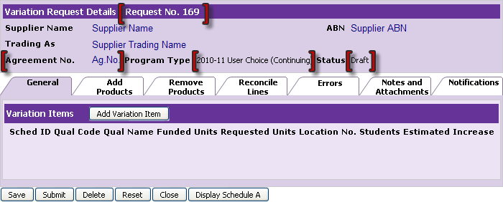
5. | The Current Variation Requests page will display the new AVR with the unique identifier under Request Number, status in Draft and the date last modified.  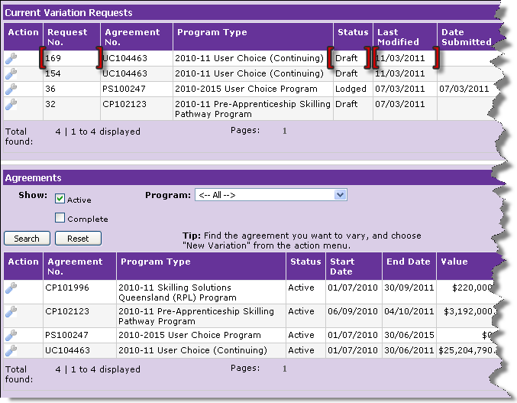

How can I check if an Agreement Variation Request has been created?
As soon as the process of creating an AVR is initiated, the status is always Draft. The Draft AVR must be submitted for validation and it is only after successful validation that the AVR can be lodged.
When a Draft AVR has been created the following occurs:
- the Draft AVR is allocated a unique number
- the Draft AVR appears under the Current Variation Requests section
- the date Last Modified is shown.

