**Final report - Evaluation of intensive case management**

Intensive case management

5 May 2023

* **Nous Group** acknowledges Aboriginal and Torres Strait Islander peoples as the First Australians and the Traditional Custodians of country throughout Australia. We pay our respect to Elders past, present, and emerging, who maintain their culture, country and spiritual connection to the land, sea, and community.

This artwork was developed by Marcus Lee Design to reflect Nous Group’s Reconciliation Action Plan and our aspirations for respectful and productive engagement with Aboriginal and Torres Strait Islander peoples and communities.  
  
*Disclaimer:*

*Nous Group (****Nous****) has prepared this report for the benefit of Department of Children, Youth Justice, and Multicultural Affairs (the* ***Department****).*

*The report should not be used or relied upon for any purpose other than as an expression of the conclusions and recommendations of Nous to the Client as to the matters within the scope of the report. Nous and its officers and employees expressly disclaim any liability to any person other than the Client who relies or purports to rely on the report for any other purpose.*

*Nous has prepared the report with care and diligence. The conclusions and recommendations given by Nous in the report are given in good faith and in the reasonable belief that they are correct and not misleading. The report has been prepared by Nous based on information provided by the Client and by other persons. Nous has relied on that information and has not independently verified or audited that information.*

© Nous Group

Contents

1 Executive Summary 1

1.1 Key findings 4

1.2 Summary recommendations for future improvement 6

2 Background and program summary 10

2.1 The ICM Program evolved from Caboolture as a model for reducing reoffending among high-risk young people 10

2.2 The ICM program is a combination of practice approaches designed to reduce youth recidivism among high-risk young people 10

2.3 The ICM Program is made up of key features, including the practice model within 13

2.4 The ICM Program now operates in multiple Youth Justice Service Centres across Queensland 15

2.5 The 2017 SPEP Evaluation of ICM identified several strengths and opportunities for program improvement 15

3 Evaluation scope and objectives 17

3.1 The evaluation assesses the program across key categories of enquiry for the period 2018-2022 17

3.2 The evaluation aims to provide clarity on the role of ICM in Youth Justice through better understanding the program’s success 17

3.3 The evaluation has analysed the program using a rigorous mixed-methods approach 17

3.4 There were some key limitations that should be understood when interpreting the analysis 18

4 Effectiveness 19

4.1 The expected outcomes of the ICM Program are multi-faceted 19

4.2 Program reach 21

4.3 Reductions in youth offending 21

4.4 System Gains 29

4.5 Family functioning 30

4.6 Early intervention with siblings 32

4.7 YLS/CMI ratings offer a lag indicator into the changing risk and protective factors of ICM young people 34

4.8 Costs and benefits 37

5 Appropriateness 42

5.1 Program objectives and purpose 42

5.2 Program strategy 43

5.3 The ICM Program 48

5.4 Reporting and monitoring 54

5.5 Governance 55

6 Implementation 57

6.1 Program purpose 57

6.2 Program strategy 57

6.3 ICM Program fidelity is largely maintained across sites, with some gradations in overall maturity 58

6.4 Reporting and monitoring 71

6.5 Governance 71

6.6 Success factors and barriers for implementation 72

Appendix A Methodology 76

A.1 Technical Appendix ICM Program statistical modelling 76

A.2 Qualitative Appendix 79

# Executive Summary

The Intensive Case Management (ICM) Program[1] forms an important part of the ‘reduce re-offending’ pillar of the Queensland Youth Justice Strategy, which aims to keep communities safe. It has been purposefully designed as a targeted intervention to address the multiple factors that impact on chronic juvenile offending, including problematic substance use. It also aims to enhance family and kinship connections and promote engagement in educational and training initiatives.

The ICM Program began as a pilot in Caboolture in 2013-14 as a novel staffing and practice model for reducing reoffending among high-risk young people. The initial iteration of the program drew on the principles of Multisystemic Therapy (MST) and Collaborative Family Work (CFW) to guide the practice model and approach. It also included detailed offence profiling to better understand patterns in offending behaviour and causal links. The program evolved in 2017 with the addition of the Good Lives Model (GLM), which coincided with the rollout of ICM to additional Service Centres. The program evolved again in 2020 with the incorporation of the Strengthening Families Protective Factors (SFPF) framework.

The theory of change for the model is that young people with higher levels of offending require intensive, family-led, and therapeutic approaches to help change patterns of behaviour. ICM was designed to target high-risk young people aged 10-17 years with a high intensity of cognitive behavioural therapies, youth support and family work sessions. Support is also provided to parents and siblings to address familial risk factors.

The objective of this evaluation was to provide clarity on the role of ICM in Youth Justice through better understanding the Program’s success at seven Service Centres: Caboolture, Redcliffe, Brisbane North, Logan, Gold Coast, Cairns and Rockhampton. The scope of enquiry was guided by four broad domains: effectiveness, appropriateness, implementation, and future improvements. Findings from the lines of enquiry would assess program effectiveness, build an evidence base, support program improvements, inform future investment decisions and demonstrate value for money.

**The ICM Program is an evidence-based program that reaches high-risk young people and families**

The Intensive Case Management (ICM) Program was introduced to strengthen capacity for evidence-based practices for youth experiencing higher rates of offending. The ICM Program was devised specifically for Queensland Youth Justice (Youth Justice) by drawing on internationally proven practices.

A literature review undertaken for the evaluation found the practice elements incorporated into the ICM Program are evidence-based for producing lasting impacts on reduced reoffending. There is also an opportunity to build the evidence-base further through understanding the impact of these approaches for young people that identify as First Nations or Culturally and Linguistically Diverse (CALD), are in the out of home care system, and have spent periods of time in detention.

ICM is an evolving program designed for small caseloads to offer intensive support to young people and their families who elect to participate. The average reach of the target cohort – high (6+) Serious Repeat Offender Index (SROI)[2] and moderate to very high overall Youth Level Service/Case Management Index (YLS/CMI) ratings – over the life of the program was approximately 17%.[3] Therefore, there is opportunity for the ICM Program to continue servicing these clients into the future.

The ICM Program intends to reach young people that score high, or are at risk of scoring high, (5-6+) on the SROI, and who have a high to very high YLS/CMI rating, varying degrees of family functioning, and government system interactions. During the period 2018-2022, the program has reached 134 distinct young people, and engaged directly with 456 family members (including direct early intervention with siblings) across seven Service Centre locations (within the scope of this evaluation).

Figure 1 summarises the key program delivery and outcomes statistics from the evaluation.

Figure 1 | Profile of the ICM Program



## Key findings

**The ICM Program is an appropriate model to be used in Youth Justice Service Centres, as it offers an effective case management approach for high-risk young people and families**

Youth Justice works with many chronic youth offenders and the ICM Program is the appropriate response for this cohort. The evaluation heard resoundingly from practitioners that the ICM Program is an opportunity to work in a better way – with families involved and the capacity to deliver high intensity therapeutic interventions and wraparound support – which is more likely to reduce recidivism in high-risk offenders. The program is evidence-based and designed with good practice features that have been proven to be effective in other youth offending reduction programs.

Young people and families who experienced the program highly valued the collaborative and culturally appropriate way of working. Practitioners regarded the program model and practices as highly relevant to their broader work and valued it as a source of practice development and training, but they were concerned that their elevated skillsets and complexity of work were not reflected in their remuneration.

The current reporting and monitoring processes appropriately capture the core delivery activities of the program. However, the current processes fail to systematically capture the full range of benefits realised by clients. Instances of poor adherence to established processes jeopardise the quality of data available for monitoring and evaluation purposes. A decentralised model of governance appears to be efficient for the geographically dispersed Service Centres but remains reliant on the single Program Manager/Developer for practice leadership.

**The ICM Program is more effective than alternative Youth Justice approaches in reducing offending among the more serious offending cohort**

The evaluation found ICM Program produces positive outcomes for families with complex needs which can have a profound impact on young people, their siblings and families. This includes reductions in reoffending frequency and seriousness. Approximately 30% of the ICM participants (38 of the 134) did not reoffend (as of 31 July 2022). When compared to the matched cohort that received other Youth Justice supports, the ICM Program cohort saw a greater reduction in reoffending frequency and seriousness. ICM Program young people saw a ~50% greater reduction in offending seriousness than matched young people receiving other Youth Justice supports.

The offending analysis indicates that reductions in reoffending behaviour are sustained over long periods of time.

**The ICM program model was regarded as being culturally appropriate, particularly for First Nations families**

The outcomes, in terms of offending reductions and family functioning, are seen with First Nations young people and families in ICM. The analysis, both quantitative and qualitative, indicates that the program worked for First Nations families as well as it did for non-First Nations families. There is support, including from practitioners and families that identify from various cultural backgrounds, to increase the involvement of cultural practitioners and cultural elements in the delivery of the program.

**Qualitative evidence suggests the ICM Program was effective in achieving outcomes at the family and systems level**

The interviews with staff, young people, and families revealed the ICM Program achieves outcomes for improving family functioning and achieving gains within government systems. ICM was found to show improvements among the highest risk young people in important protective factors (family circumstances, education and employment).

The evaluation also observed that early intervention with siblings was taking place, and anecdotal evidence suggested that the gains made were positive, largely in the form of pro-social and family functioning behaviours. However, the offending outcomes for this were unable to be observed due to confidentiality of siblings.

**The reductions in reoffending from the ICM Program yield strong, positive economic benefits for the criminal justice system and broader society**

There were 90 ICM Program clients that started and completed their ICM Program between FY19 and FY22. The approximate cost of the ICM Program over this period across the seven Service Centres was $7.4m. The largest economic benefit of reduced reoffending frequency and severity outcomes was to the criminal justice system, which ranged from $8.1m to $15.7m (benefit:cost ratio of 1.1 to 2.1). The economic benefit increases to $9.8m to $19.1m when considering the wider societal benefits of reduced reoffending including benefits to victims from reduced injury and property damage, (benefit:cost ratio of 1.3 to 2.6).

The cost and benefits analyses were not exhaustive of all costs and benefits realised by the ICM Program. Costs that could not be quantified included Service Centre overheads used but not funded through ICM, the costs borne by external service providers in supporting the delivery of the ICM Program, and the ‘replacement costs’ incurred by society for other publicly funded services taken up by clients that would otherwise not have been accessed during periods of detention. Benefits of ICM that could not be quantified included early intervention with siblings, improved family functioning and system gains.

**ICM was well-implemented and understood across sites, which led to a high level of model fidelity**

The purpose of the ICM Program was well understood and agreed across sites, but the way in which it was implemented varied due to location-based nuances in how the program was funded and the degree to which it relied on existing staff resources for delivery. For example, funding did not always include the core positions required to deliver the model or the discretionary spend for child-related costs. Additionally, locations that had high proportions of First Nations clients relied heavily on the support of cultural positions to lead engagements.

Overall, there was a high level of model fidelity, with few cases of failure to undertake the required training, referral assessment, intervention planning, intervention dosage, caseload, or program duration. This fidelity to the model is likely to have contributed to the positive outcomes of the program.

Feedback from ICM Program teams revealed several success factors as well as some barriers to implementation. The success factors occurred both at the program level and at the individual practitioner level. Program level success factors included a whole-of-office support to enact the resource intensive model and an active community of practice as a means of peer support and practice uplift. Successful practitioners needed to be able to build trust and positive relationships with young people and families; be able to draw on office supports as required; be suitably skilled and experienced with complex cases and family work; consistent in their delivery offering a continuity of service; and confident in their practice. The biggest barrier to implementation (experienced at Cairns and Gold Coast) was vacancy in the ICM Program Case Manager position due to turnover and periods of funding cessation. The challenge of high staff turnover was exacerbated in regional areas where recruiting suitably skilled practitioners proved difficult.

## Summary recommendations for future improvement

These recommendations aim to enhance a program that has been successful overall. The recommendations for improvement of the ICM Program are grouped by various categories, as seen below. The recommendations are referenced throughout the report where they are relevant to findings.

### Program investment and reach

Maximise the use of the ICM Program for youth and families with high SROI rating (including First Nations families). This recognises that the program is offering Youth Justice an appropriate and effective practice framework for high SROI young people.

|  |
| --- |
| Recommendation 1: Invest to expand the reach and capacity of the ICM Program into additional Youth Justice Service Centres to work with a greater number of youths assessed as high-risk (and high SROI)  ICM is regarded as an appropriate approach for Youth Justice to address higher-risk youth and families. The ICM program should be implemented at Service Centres that have enough young people with a 6+ SROI. The program is proven to work well for this important cohort.  Further expansion will support further roll out of ICM through another five (or more) additional locations across Queensland. This will require funding for dedicated ICM roles. Youth Justice should consider which sites are ‘ready’ to resource the required roles within Service Centres for meeting case management loads. |

|  |
| --- |
| Recommendation 2: Ensure ICM is appropriately funded to ensure teams have and retain the capacity to deliver the model (including therapeutic elements) with fidelity and intensity.  Youth Justice should implement dedicated ICM roles in Service Centres to protect the fidelity of the model.  Generally, an ideal ICM team structure looks like 1 Team Leader per 4-5 staff with Case Managers, Youth Workers and Youth Family Community Resource Officer (YFCRO) in a 1:1:1 ratio.  Funding and position types should be somewhat tailored to the Service Centre. The ideal team structure may be achieved through a combination of funded positions and existing site resources, but this can jeopardise model fidelity and team continuity.  The Youth Worker and YFCRO positions should be remunerated appropriately for their increased level of practice capability and cultural understanding. |

|  |
| --- |
| Recommendation 3: Invest in greater program management capacity to support the growth and practice dimensions of the model  Youth Justice could consider splitting the Program Manager role into two. The second Program Manager role should be an identified role, to provide greater cultural oversight to ICM. Alternatively, local and identified Practice Leaders at each of the Service Centres may provide the practice and cultural support.  Ultimately, greater investment in program management and leadership is needed to:   * Uphold model fidelity * Increase capacity to effectively implement the program * Promote greater cultural practice support for sites * Uplift capability of staff through more regular training opportunities   The evaluation endorses support through additional role(s) that complement the Program Manager. |

### Program design

Preserve the program intent and strengthen it into the future.

|  |
| --- |
| Recommendation 4: The ICM Program design and objectives should be retained  The evaluation has found the ICM Program to be effective in achieving outcomes for high risk and high SROI young people. The model is highly appropriate and effective – the interventions are evidence-based and should be maintained. The focus on selecting higher risk youth and voluntary participation should remain as eligibility criteria.  The program should continue to monitor and promote best practices internally to maximise the therapeutic emphasis of ICM. |

|  |
| --- |
| Recommendation 5: Consider how to engage young people within a timeframe that preserves the model while considering cost.  This would:   * Help to ensure that upfront investment in each young person at the start of onboarding process is efficient to mitigate the costs of the program, while continuing to, * Preserve the voluntary nature of the program (which is recognised as important).   Clients should be actively and intensively engaged in the combination of practices including therapeutic sessions within this timeframe to ensure program resources are effectively deployed and evidence-based approaches are applied according to guidance.  A reasonable timeframe for young person’s engagement would be approximately 3 months, though this should be considered by the Program Manager(s). |

|  |
| --- |
| Recommendation 6: Review program service delivery and intensity to confirm the program is supporting female young offenders in ways that are consistent with evidence.  The evaluation has found the ICM program is more effective at reducing the overall risk ratings of male youth offenders than female youth offenders. There may be further program development for a more gender responsive delivery model. |

|  |
| --- |
| Recommendation 7: Clarify the model as it relates to young people facing periods of detention during the program,  Further program development is required to ensure the approach is appropriately adapted to support youth in detention. This should explore how transitions in and out of detention can be supported, how case planning and goal selection can be adapted, and how staff can be coordinated.  In particular, the approach to ceasing support of the young person and their families during long-term detention remands needs to be clarified. |

### Program enablers

Deliver both the practice and program elements in an enhanced way.

|  |
| --- |
| Recommendation 8: Provide more regular training opportunities to staff through a combination of resources.  The model relies on intensive training. This should continue going forward. Additional resources toward Program Manager roles should create space for more regular training and supervision.  The program should also create opportunities for experienced Team Leaders and Case Managers to deliver training programs. |

|  |
| --- |
| Recommendation 9: Develop an outcomes framework that establishes ways of systematically understanding family and system gains.  The evaluation endorses the Outcomes Framework that the Department is currently developing. It should build into this a way for the ICM Program to track family and system outcomes that goes beyond a case study approach.  Outcomes tracking should be conducted no more frequently than at monthly intervals to mitigate the administrative burden on Case Managers and Youth Workers. |

|  |
| --- |
| Recommendation 10: Consider the ongoing role and format of the Community of Practice.  If Youth Justice chooses to expand the program, it will need to consider how the function of the Community of Practice (CoP) changes.  Youth Justice should consider if there should be regional CoP’s (e.g., North, South, and Central) or if a larger Community of Practice is used to spotlight innovative approaches across Queensland.  The evaluation endorses the CoP as a mechanism for sharing outcomes and insights on the program. |

### Cultural oversight

Enhance the cultural competency of ICM.

|  |
| --- |
| Recommendation 11: Pair an investment in identified positions with additional cultural training.  Identified positions at each site should create capacity for Indigenous Support Services Officers (ISSO) and YFCROs to deliver more cultural competency training. The second identified Program Manager role should provide leadership for implementing more cultural competency training for ICM.  Youth Justice should consider how cultural training could enhance the program. Some areas to consider include:   * How to use practice tools such as the ‘Tree of Life’ in ICM * Working with First Nations families * Trauma-informed/aware and healing-informed, and * Location-based cultural competency. |

|  |
| --- |
| Recommendation 12: Proactively include the Youth Justice Cultural Unit in cultural oversight of the program.  Youth Justice should include its Cultural Unit in decision making about recruitment of identified roles and cultural competency training.  This group can be a valuable resource for the program to continue working effectively with First Nations families. |

# Background and program summary

## The ICM Program evolved from Caboolture as a model for reducing reoffending among high-risk young people

The ICM Program began as a pilot in Caboolture in 2013-14. The program is made up of a combination of practice models and approaches but began from a combination of the principles of Multisystemic therapy (MST) and Collaborative Family Work (CFW). The program also incorporated detailed offence profiling to help fully understand patterns of behaviour and causal links.

ICM evolved in 2017 when the Good Lives Model (GLM) was incorporated into the model. This coincided with broader roll out of the program beyond Caboolture[4]. In 2019, the program was rolled out further to six additional locations. Then in 2020, the Strengthening Families Protective Factors (SFPF) Framework was introduced to the practice model. At different points of the program’s evolution, certain ICM locations adopted additional practice elements. The most notable example of this, was when Cairns introduced its ‘Tree of Life’ concept to the program as a more culturally responsive practice resource for adapting the Collaborative Family Work model when working with First Nations families.

The current ICM Program Manager/Developer is responsible for creating the ICM Program, particularly in terms of its practice elements. This is indicative of the ‘decentralised’ approach that is characteristic of the program to-date.

While the model evolved on-the-ground, the ICM Program forms an important part of the Youth Justice Strategy that aims to keep communities safe. It has been purposefully designed as a targeted intervention to address the multiple factors that impact on chronic juvenile offending. The program’s primary objective is reducing offending behaviour and improving young people’s and families strengths and capabilities for pro-social functioning.[5]

## The ICM program is a combination of practice approaches designed to reduce youth recidivism among high-risk young people

The theory of change for the model is that young people with higher levels of offending require intensive, family-led, and therapeutic approaches to help change patterns of behaviour.

The ICM Program was designed to target high-risk young people aged 10-17 years with a high intensity of cognitive behavioural therapies, youth support and family work sessions. Support is provided to the family, including targeted support to siblings. The evidence indicates that working with families can assist in reducing the social factors that contribute to reoffending for young people and the risk of offending for their siblings. The key elements of the ICM Program are used with the aim of addressing the factors that contribute to high levels of offending and anti-social behaviour, which is intended to reduce recidivism.

The model is summarised in Figure 2 below.

Figure 2 | ICM Program in practice[6]



### The program was designed to provide intensive and integrated support, both for the young person and the family

The ICM Program is a framework that supports collaborative practice, integrated and intensive case management with both young people and their families, carers, and/or kinship members.

ICM Program Case Managers act as part of a ‘Hub’ for service coordination and are themselves supported by the broader Youth Justice Offices. Case Managers are trained on a specific practice framework and its underpinning theories.

### The ICM Program is an adaptation of multiple practice approaches

The ICM Program is a strength based, action orientated, outcome focused, and relationship centred model. These features of the model are inspired by an adaptation of multiple practice approaches:

* Multisystemic Therapy (MST) – An intensive family and community-based program that combines aspects of cognitive, behavioural, and family therapy.
* Good Lives Model (GLM) – A strengths-based rehabilitation theory with the aim to have clients live a ‘good’ and meaningful life. It is premised on human action or behaviour being driven by attempts to achieve primary life goods across eleven key life domains.
* Collaborative Family Work (CFW) – A problem-solving intervention for families. It prioritises what the young person and family want to work on first in line with life goods and capacity building to develop strategies to address behaviours of concern and improve family functioning and care giver practices.
* Strengthening Families Protective Factors (SFPF) Framework – A framework that supports families to build key protective factors to support children to thrive and mitigate risk.
* The Hub concept of case management – A collaborative approach to case management in both the planning and delivery of interventions. It fosters positive support networks (protective factors) and disrupts the cycle of helplessness.

As seen in Figure 2 above, the four approaches manifest in a base set of activities that are delivered by the ICM Program Case Manager in collaboration with other Youth Justice support and external agencies, as required. These include:

* Detailed assessment and profiling – are tied to systems analysis of current social systems and external services through the lens of the Strengthening Factors Protectives Factors framework; criminogenic analysis through the lens of the Good Lives Model, which views offending behaviours as fulfilling needs that would otherwise be fulfilled by pro-social behaviours if one was to live a meaningful (or “good”) life.
* Youth Work Support – delivered by the overall Hub and therapeutic alliance of which a core component is delivering education/training/employment opportunities or specific court requirements such as community service or other programmatic engagement.
* Family Sessions – are based on Collaborative Family Work (RIDGES model) and the Strengthening Families Protective Factors Framework, which seek to identify issues the family would like to see change, build capacity to develop strategies that address behaviours of concern, and improve family functioning and care-giver practices.
* Offence-focussed sessions – based on motivational interviewing and other cognitive behavioural techniques to address the offence cognitions, with an emphasis on skill building.

### The model is underpinned by an understanding of the young person’s risk-level

The ‘risk, needs and responsivity’ (RNR) principles and Youth Level of Service/Case Management Inventory (YLS/CMI) underpin the delivery of all programs and activities at Youth Justice, including for ICM. The eligibility and suitability of ICM young people and their families, as well as the intervention planning, is also informed by offence profiling, the Good Lives Model matrix, and systems analysis.

The RNR principles are extensively used across youth justice systems both in Australia and internationally. These three principles, otherwise known together as the RNR principles, are relevant across the spectrum of youth justice programs from those that target early intervention through to those that target young people entrenched in the youth justice system:

* The Risk Principle, which states that the intensity and duration of services should increase as risk level increases.
* The Needs Principle, which aims to assess the young person’s needs and target them in treatment or through specific services and supports.
* The Responsivity Principle, which considers individual characteristics such as personality, culture and educational levels and delivers services in a way that accounts for these.

According to RNR, case management is generally more successful when the level of contact and engagement intensifies in line with the young person’s risk level. Namely, that:

* Low-risk young people should receive low-intensity options – such as early diversion from charging, remand and formal court processing, low intensity and shorter duration supports, and services that are primarily aimed at low-risk young people to avoid mingling with higher risk young people.
* Medium to high-risk young people should receive higher intensity options – such as a focus on more intensive services, more frequent contact with the young person, for a longer period, and a greater number of concurrent supports.

The RNR principles enable practitioners to identify and focus on the attributes of the clients most suited to certain types of programs while providing more direct therapeutic supports.[7]

The Youth Level of Service/Case Management Inventory (YLS/CMI) is a tool designed to provide a preliminary estimate of the level of risk for antisocial behaviours as well as an indication of areas for intervention in young offenders.[8] The YLS/CMI reports on eight key areas (history of conduct disorder; current school or employment problems; some criminal friends; alcohol/drug problems; leisure/recreation; personality/behaviour; family circumstances/parenting; and attitude/orientation) as well as an aggregation of these areas into an indication of overall assessed risk. Studies have shown YLS/CMI is a suitable predictor of re-offending.[9],[10] However, there is a lack of research on the utility of the tool with young First Nations offenders, which is of importance given 65% of the ICM Program cohort identify as First Nations.

## The ICM Program is made up of key features, including the practice model

The ICM Program can be broadly summarised into five key features. These are highlighted in Figure 3 and include:

* Program purpose: The program purpose or intent refers to the ‘why’. It represents highest-level intent of the program, in the context of youth justice in Queensland. The ICM Program’s purpose is to be an opportunity for Youth Justice to provide intensive support to high-risk youth with the aim of reducing reoffending. It also has the secondary purpose of intervening early with young people through work with siblings of the client.
* Program strategy: The program strategy refers to the ‘how’ (i.e., how is the purpose achieved). The ICM Program strategy is to target opt-in supports at both the young person and the family through giving Case Managers more time to work with each young person.
* The ICM Model: The ICM Program refers to the ‘what’ (i.e., what is done to achieve the purpose and strategy). The ICM model refers broadly to multiple elements, including:
  + Practice model – the evidence-based principles and theories that underpin the practitioner’s approach
  + Staffing model/ Workforce – who is tasked with delivering the model
  + Delivery – how the model is delivered and the engagement with that delivery (includes frequency of contact, client engagement, time on program, and coordination of external supports)
  + Supports – such as training, supervision, and a community of practice.
* Reporting and monitoring: The reporting that is in place to understand if the ‘why’, ‘how’, and ‘what’ is being achieved.
* Program governance: The oversight that is in place to ensure that the ‘why’, ‘how’, and ‘what’ is being achieved.

These elements of the program will be used to structure the findings for both the ‘Appropriateness’ and ‘Implementation’ sections of the report.

Figure 3 | The key elements of the ICM Program

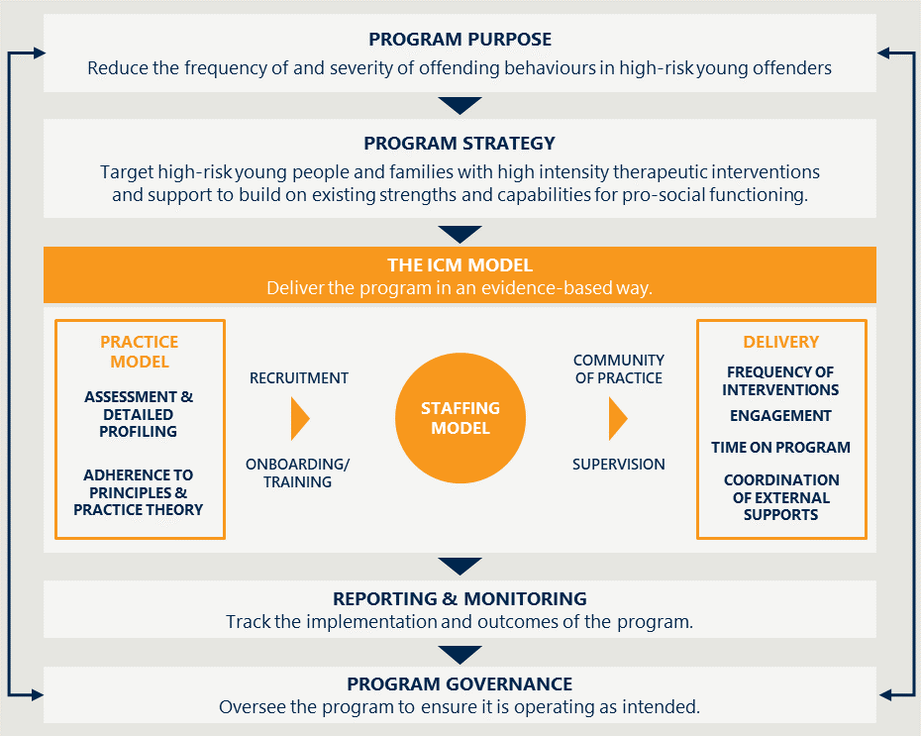

## The ICM Program now operates in multiple Youth Justice Service Centres across Queensland

As described in Section 2.1, the program commenced at various times in the various locations. The program includes the locations listed below (which includes the dates they commenced as ICM Program sites):

* Caboolture (2014)
* Townsville (2017) – *Note: Townsville is funded separately to the other sites and is out-of-scope for this evaluation.*
* Cairns (2019)
* Rockhampton (2019)
* Redcliffe (2019)
* Brisbane North (2019)
* Logan (2019)
* Gold Coast (2020)

The ICM Program Manager currently oversees the program across all listed sites. The Program Manager is responsible for implementing the program at all sites, upholding model fidelity and practice consistency (through training, supervision etc.), and ensuring that program staff complete reporting and monitoring activities in a consistent way.

## The 2017 Evaluation of ICM identified several strengths and opportunities for program improvement

The Standardised Program Evaluation Protocol (SPEP) evaluation of the ICM program occurred in 2017. The identified strengths of the ICM Program in 2017 continue to be the strengths of the program in 2022. The SPEP evaluation scored ICM strongly on its design as a therapeutic intervention for its inclusion of three therapeutically rated practices: cognitive behavioural therapy, mentoring and family counselling. The design is aligned with research on effective practices to reduce recidivism, which include collaborative case planning and continuous service delivery aspects. All clients had some intervention related to education/vocation, which was noted to further increase effectiveness. Case Managers were highly trained and had access to ongoing mentoring and support.

Opportunities for program improvement were several, some of which have since been addressed. However, the SPEP Evaluation made some summary recommendations which continue to be relevant today. It recommended:

* Better articulation of the intended purpose of Youth Worker support and providing specific accreditation pathways for youth work staff involved in the delivery of ICM. These align with Nous’ view that the Youth Worker position is core to ICM delivery but is yet to be dedicated to ICM and the elevated practice is not yet recognised through higher remuneration. See Recommendation 1 of this report.
* Further development of processes to accurately capture and monitor data in relation to the number of different services delivered. A key question for Nous’ evaluation was around model fidelity, which included analysis of the number and duration of interventions delivered to clients. However, there continue to be limitations around the accuracy and completeness of intervention data.
* Comprehensive evaluation framework to include outcome measurement and the evidenced use of client feedback. Nous’ experience of ICM revealed that the outcomes of ICM are multi-layered and as such require a comprehensive outcomes framework to capture the full benefit of the program, which is critical to justifying the investment. Nous has endorsed the new outcomes framework, see Recommendation 9 of this report.

# Evaluation scope and objectives

## The evaluation assesses the program across key categories of enquiry for the period 2018-2022

This evaluation assesses the ICM Program across multiple areas, which are outlined in this report. These include the following domains and high level questions that have guided our inquiry:

* Appropriateness – To what extent is the program appropriate for the target cohorts? To what extent is it appropriate for the program to be delivered by Youth Justice?
* Implementation – To what extent has the program been implemented as intended to operate effectively across sites?
* Effectiveness/ Outcomes – Has the program achieved its intended outcomes in a cost-effective way?
* Future improvements – How can the program be improved going forward?

The Service Centres within the scope of the evaluation are Caboolture, Logan, Redcliffe, Brisbane North, Gold Coast, Cairns, and Rockhampton. A key decision that the project team made was to exclude the Townsville site from the evaluation (because it is funded and implemented differently than other sites). The period of 2018-2022 is the focus of the evaluation – building on the work of the previous evaluation in 2017 and assessing the sites that received ICM during this period.

## The evaluation aims to provide clarity on the role of ICM in Youth Justice through better understanding the program’s success

The primary objectives of the evaluation are:

* Determine if the ICM Program is appropriate as a practice framework for Youth Justice
* Assess the program implementation to understand what factors are required to offer ICM successfully
* Help the Department understand the extent to which the ICM Program has been an effective intervention in achieving its aims (reducing and preventing future adolescent offending)
* Understand and communicate the value of the ICM Program to inform future funding priorities, expansion of the program and new program design
* Gather information that can help demonstrate the likely economic impacts and cost efficiency of the program.

Youth Justice intends that the findings from the evaluation will be used to assess program effectiveness, build an evidence base, support program improvements, inform future investment decisions and demonstrate value for money.

## The evaluation has analysed the program using a rigorous mixed-methods approach

The evaluation draws on quantitative and qualitative analysis to create robust findings and recommendations for the ICM Program.

* Advanced statistical modelling: The evaluation used advanced quantitative analysis of ICM performance using datasets held by the Department. A range of outcomes were analysed for ICM clients and compared to a matched cohort of young people participating in ‘general casework’. A full technical appendix detailing the methodology is provided in Appendix A.
* Stakeholder consultation: The evaluation collected evidence from various stakeholders, including Youth Justice and ICM staff, community organisations, government agencies (system stakeholders), ICM young people and ICM families. A detailed list of stakeholders is in Appendix A.
* Case studies: The evaluation accessed case studies that were collected by the Department. The evaluation also drew upon interviews with young people and families to create some case studies.

## There were some key limitations that should be understood when interpreting the analysis

There are several methodological considerations to be aware of when interpreting the findings of this evaluation:

* Completeness and accuracy of quantitative data. Some of the data provided, particularly the spreadsheet for recording interventions maintained by practitioners, is incomplete and inaccurate due to varied adherence to recording processes and data loss.
* Case study outcomes are not necessarily current. Some of the case studies used were several years old. The outcomes described, particularly around reoffending rates post program completion, may no longer be up to date.

# Effectiveness

This section explores the extent to which ICM has achieved its core objectives in reducing reoffending and assisting families to address underlying factors that contribute to offending behaviour. In addition, the ICM Program seeks to contribute to wider system improvements by coordinating access to other supports and to improve family functioning and wellbeing.

## The expected outcomes of the ICM Program are multi-faceted

The ICM Program logic is focused on the ultimate primary outcome of reducing reoffending of the young person, both in terms of frequency and severity of reoffence. The program theory of change assumes that gains in family functioning and system integration, combined with young-person-focused interventions, will contribute to improved offending outcomes.

Interventions with the siblings also take place through the ICM Program. Working with the siblings is a second-order aim of the program that allows ICM to operate in the early intervention space while also improving family functioning for the young person of interest.

The outcome areas for the program serve as the high-level structure for this section of the report.

The ICM high level program logic is shown in Figure 4.

Figure 4 | The high-level logic of the ICM Program

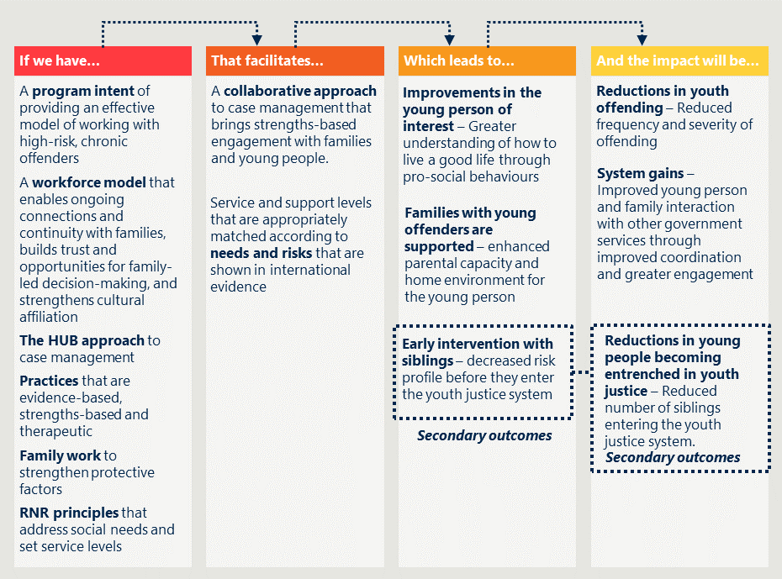

### The program logic informs how outcome areas shape the findings

The outcome areas of interest to the evaluation are summarised in Figure 5 below.

Figure 5 | Summary of ICM outcomes

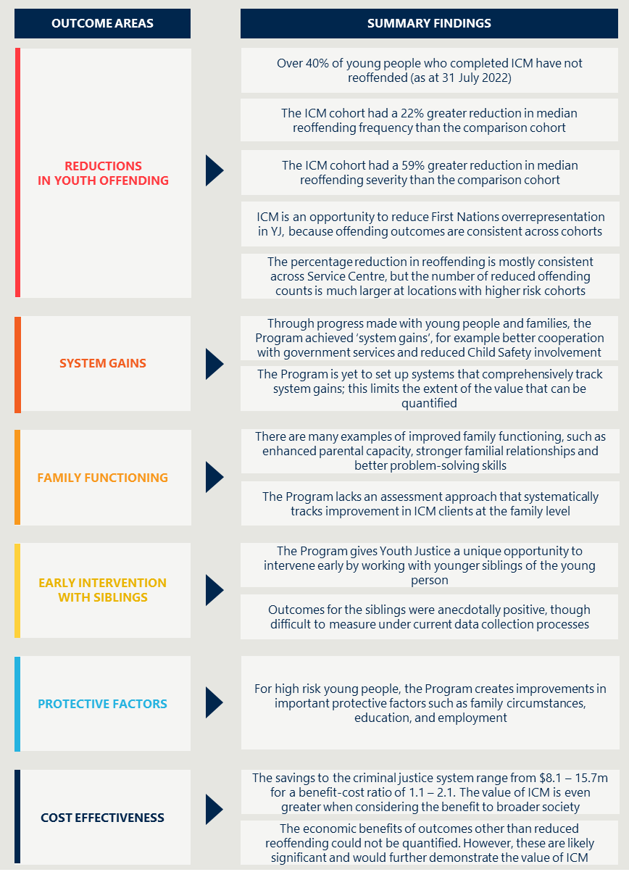

## Program reach

Between 2018 and 2022, ICM provided intensive support to 134 distinct young people and 456 family members including siblings. The program targets youth offenders with high and very high YLS/CMI ratings and often high SROI ratings. In practice, a proportion of ICM clients only had moderate overall risk ratings (see Figure 26) but may have been high in particular domains of focus for ICM such as ‘family circumstances’ or ‘education and employment’.

When calculating the program’s reach of eligible candidates, the group of all young people in QLD considered were those with moderate to very high YLS/CMI risk ratings and high (6+) SROI. The program’s average reach of this specific group from the evaluated locations over the life of the program is 16.8%. Since the program has been largely running at capacity (i.e., caseload of 5 per case manager), a low reach suggests there is an opportunity to expand ICM at the evaluated locations.

## Reductions in youth offending

The outcomes regarding offending behaviours shown in this section of the report can be viewed in terms of both absolute and relative changes in offending frequency and severity, as compared to cohorts of young people that are interacting with other youth justice supports.

The evaluation has analysed the offending of 134 participants in ICM against a matched cohort made up of the same number of comparable young people. The comparison group represents young people over the same passage of time, matched on age, sex, Indigenous status, location, and family characteristics to create a proportionally matched group to the ICM cohort. This gives us an understanding of the likely pathway a young person would have faced if they did not access ICM. From this analysis we can draw conclusions about the likely impacts, how they might vary according to location, and whether the benefits are faced by different groups.

A full technical methodology is provided in Appendix A.

### A significant number of young people on the ICM have not reoffended after completing the program

Offending data supplied by Youth Justice for the purposes of this evaluation indicated that a high proportion of ICM clients have ceased offending altogether. Of the young people who have completed the program (90), 43% (38) have not reoffended as of 31 July 2022. The time since program completion with no further instances of offending (charges) as of 31 July 2022 ranged from 11 days to over 3 years. This is a significant finding, particularly when considering the high-risk nature of the cohort.

Figure 6 | Reported status of ICM participation including cessation of reoffending

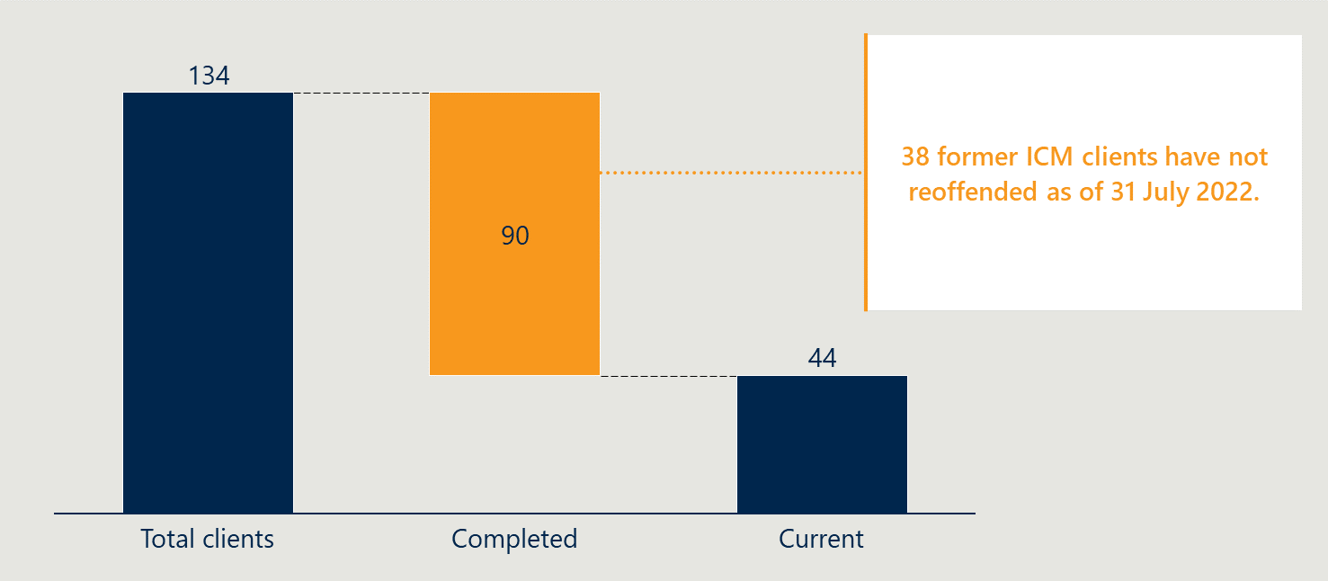

### ICM is more likely to contribute to a reduction in reoffending frequency than other Youth Justice supports

ICM is more effective at reducing reoffending than other alternative Youth Justice support options. This highlights the strength of ICM compared to alternative Youth Justice interventions.

The analysis shown in Figure 7 shows a comparative reduction in reoffending frequency for ICM young people, compared to the comparison group. There is a 22% greater reduction in median frequency of offending in ICM (51%) when compared to Other Youth Justice Supports (29%). The cessation of offending amongst a large proportion of the ICM cohort likely contributes to this difference.

Figure 7 | Reduction in frequency of reoffending in ICM and comparison cohorts

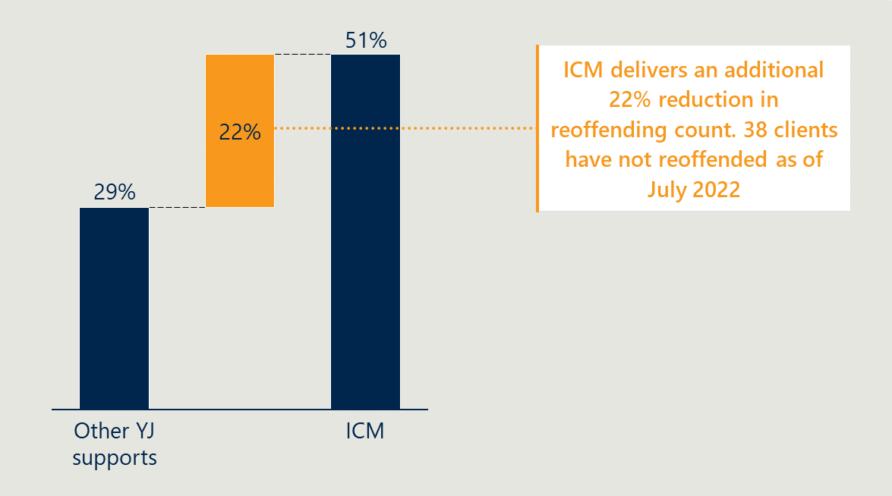

Figure 8 shows the range in offending counts (90% confidence interval – uncertainty stemming from the statistical approach used to isolate the marginal effects of ICM) about the median for 3 different time points – 6 months pre-program, during program, and 6 months post program – for both the ICM cohort and the comparison cohort. Both cohorts see a similar trend of strong reduction in offending frequency from pre to during, followed by a smaller increase post program. However, the median reduction from pre to post amongst the ICM cohort (51%) is much stronger than in the comparison cohort (29%). This, along with the understanding that over 40% of former clients that completed ICM did not reoffend (some for over 3 years), indicates that ICM creates a lasting impact on reduced offending.

The emphasis of the ICM is either more effective in addressing underlying causes of offending and/or more effective in changing attitudes or patterns of behaviour in youth than other Youth Justice supports.

Figure 8 | Effects of program participation on reoffending frequency

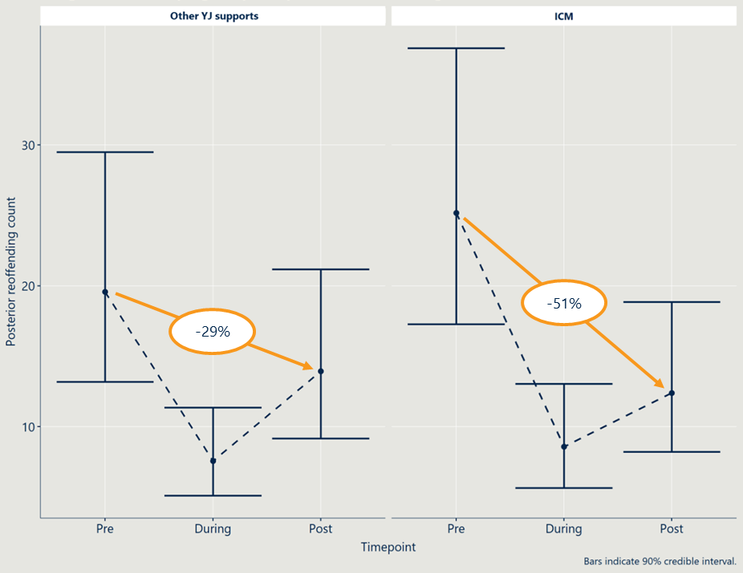

The ICM cohort has a higher 6-month pre-intervention reoffending count compared with the cohort from other Youth Justice supports. This reflects that the ICM program targets the higher-risk young people in the youth justice system. The fact that the program produces better offending outcomes than general casework with ‘more difficult’ young people is a promising indication of the efficacy of the model.

Consultations with staff, young people, and families of ICM participants supports the hypothesis that the ICM Program has a lasting impact on offending outcomes. Many ICM Case Managers and Youth Workers identified multiple examples of the young person offending less frequently during the program, which is unsurprising, but the marginal effects analysis shows that outcomes are also seen six months post-intervention.

Figure 9 | Case study – Reduction in frequency of offending[11]

|  |
| --- |
| Highly recidivist, serious violent offender stops offending |
| Background  A history with Child Safety and high risk-factors from intergenerational criminality.  A young person that commenced offending at age 13 had escalated to several serious violent offences including 1 x Act intended to maim/disfigure/disable, 6 x armed robbery with violence, and multiple other offences of violence, knife, and property offences. By the time she joined ICM as a 17-year-old, she had a history of 3 x detention orders, 2 x conditional release orders, 2 x probation orders (3 years and 2 years) and 4 unsupervised orders.  This young person also had a history with Child Safety across multiple states since birth and was subject to a Long-Term Guardianship order in Qld. Child Safety records reflected themes of physical, sexual, psychological harm, parental substance misuse, abandonment, and nutritional and medical neglect. She had developmental trauma, repeated attachment disruptions and significant psychosocial stress, which contributed to a formal diagnosis of ‘other reactions to severe stress disorder’. Entrenched in anti-social and pro-criminal peer networks, the young person suffered maladaptive coping strategies, including chronic poly-substance misuse and multiple periods of hospitalisation and/or detention due to harm to self and others.  Interventions  The young person actively engaged in offence-focused interventions, therapeutic psychological counselling, education and vocational courses, pro-social goal setting and recreational activities.  Outcomes  The young person has not offended in the 12-months post completing the ICM Program and is now assessed as a low-risk of reoffending requiring minimal supervision.  She returned to school full-time and enrolled in TAFE with the goal of becoming a Youth Worker in the future. She actively engages a psychologist and community support network, which has motivated her in pro-social goals attainment and maintaining an offence-free lifestyle.  The young person completed all their Youth Justice orders in September 2021 and maintains abstinence from illicit substances. |

### ICM is more effective at reducing the severity of reoffending than other Youth Justice supports

The severity of reoffending analysis highlights two important findings:

1. Offence seriousness patterns change under the ICM Program with a reduction in higher offence seriousness.
2. The outcomes achieved by the ICM Program are better than those observed with a matched sample from other Youth Justice supports.

Table 1 shows how the relative proportions of offence severity categories shifted 6 months pre to 6 months post intervention. The clear trend across both the ICM cohort and the comparison cohort is a shift in offending severity from high to low. However, this trend was stronger in the ICM cohort which saw a greater percentage reduction in high severity offending categories 2-5 than the comparison cohort. Furthermore, the largest individual category change for ICM was in category 8 (the least severe category), and for the comparison cohort was in category 7 (the second least severe category). This means the least severe offences in the ICM cohort increased as a proportion of all offences – it was not a ‘real increase’ in this offending type. In other words, when ICM young people do reoffend, the offence-type is more likely to be less severe. This further demonstrates that ICM is comparatively more effective in reducing the severity of reoffending than alternative YJ supports.

As reported in the reoffending frequency analysis, the frequency of offending is down, meaning these proportions post-program encompasses a lower number of offences being committed overall for the ICM Program cohort.

Table 1 | Median percent change in offending category proportions (pre to post), by cohort

|  |  |  |  |  |  |  |  |
| --- | --- | --- | --- | --- | --- | --- | --- |
| Severity category | 2 | 3 | 4 | 5 | 6 | 7 | 8 |
| ICM (%) | -89.6 | -89.5 | -76.4 | -26.0 | 23.3 | 103.1 | 579.2 |
| Other YJ Supports (%) | -56.6 | -54.9 | -12.2 | 27.1 | 69.9 | 152.0 | 120.8 |

Figure 10 provides a more detailed view of the reoffending seriousness outcomes. It shows the results of Table 1 with the median represented by dots. Table 1 shows 90% confidence intervals – uncertainty stemming from the statistical approach used to isolate the marginal effects of ICM. While the median results provide a valuable indication of the ‘middle’, it is important to recognise there is a large degree of uncertainty with these results.

Figure 10 | Effects of program participation on reoffending seriousness[12]

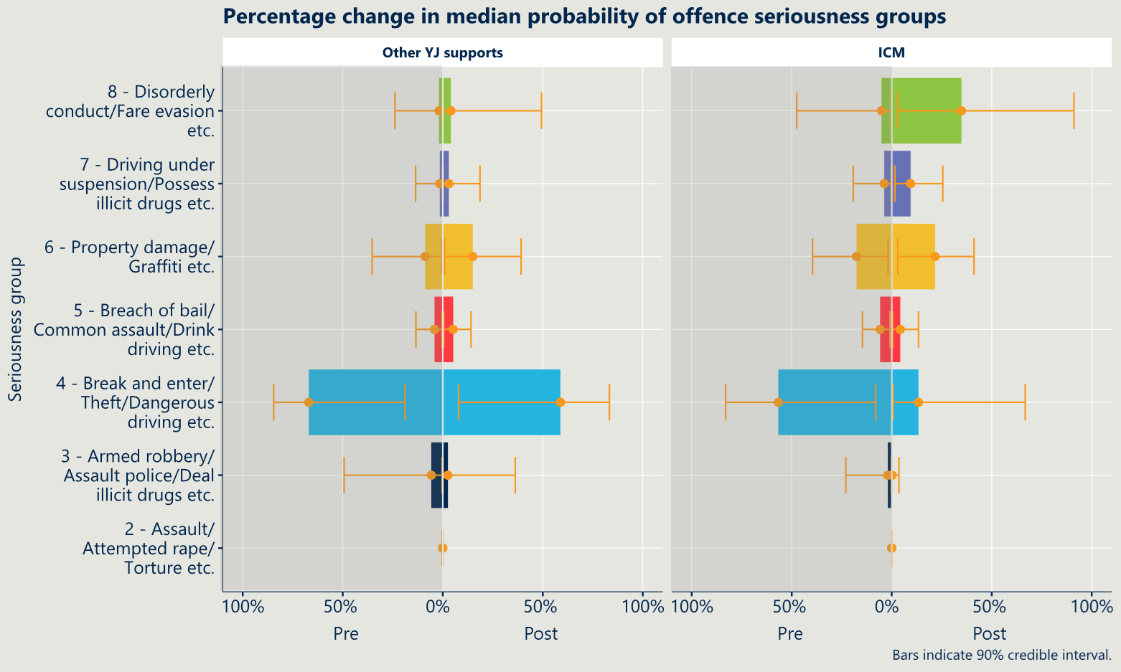

Figure 11 | Case study – Reduced severity of re-offending14

|  |
| --- |
| 16-year-old reduces their risk factors and severity of offending |
| Background  Rapidly escalating severity of offending fueled by high-risk factors  A young person first commenced offending at age 14 with motor vehicle and stealing offences. Within one month, this escalated to include arson after burning a house with damages estimated to be approximately $300,000. They continued to light more unauthorised fires and was placed on the ICM Program due to his significant escalation in offending severity.  The young person’s risk factors included significant family transience, homeless and intergenerational criminality, disengagement from school, exposure to extreme family violence, substance misuse and neglect of basic needs. Child Safety records indicated significant signs of post-traumatic stress disorder as a result childhood exposures to violence.  Interventions  The young person entered the ICM Program in September 2015 and remained on the program for 9 months. During this time, he joined the Duke of Edinburgh program, commenced in the Youth Justice Education and Training Program (Youth Justice ET), completed the Aggression Replacement Training Program, engaged fortnightly with a psychologist, and willingly participated in family work sessions with his mother and siblings. The young person also engaged in vocational courses, employment skills, cultural awareness, healthy relationships, personal development, football, consequential thinking, pro-social goal setting and independent/healthy living skills.  Outcomes  Seriousness of offending and risk factors were much lower post-ICM completion  During the ICM Program, the young person did not reoffend. However, since returning to general case management they were charged with 1 x trespass offence for which he received a reprimand. The young person displayed a significant reduction in severity and frequency of offending. |

#### The ICM Program reduces the proportion of ‘crimes against the person’, like breaking and entering and theft



The analysis shown in Figure 10 (previous page) indicates a reduction in the severity of offending, particularly for what can be termed as ‘crimes against the person’, like breaking and entering and theft. This is shown in the above call out box (72% reduction in ICM compared to 13% for ‘other YJ supports’).

This builds on the academic literature, which suggests there is evidence that Multisystemic Therapy (MST) can have an impact on certain behaviours more than others.[13] Specifically, research to date has found a relationship between the use of MST and a decrease in externalising behaviour and property offences. However, the marginal effects analysis also showed no change in Category 6 of offending behaviour – property damage, graffiti etc. which would fall under externalising behaviour.

It is important to note that the ICM Program draws upon principles and elements of MST, but it does not implement it in its exact form. Most notably, the regular use of MST clinicians (post-graduate trained) and clinical psychologists that are available 24/7 is not a feature of the ICM Program. This is likely to explain why the ICM Program outcomes are not directly reflective of MST outcomes seen in the literature.

#### The ICM Program produces strong post-intervention outcomes for severity of reoffending, which indicates that reform for the young person is sustainable

While the analysis showed offending frequency was lowest during the program intervention (which is to be expected), it shows that severe offending in the form of break and enter, theft etc. continued to decrease six months post program. The inverse is true of the least severe offence category (8 – disorderly conduct, fare evasion etc.), as this continued to increase as a proportion of total offences post-intervention. It is important to note that less severe offending where re-offending occurs is a positive, and difficult to achieve outcome, for the high-risk young people in this program.

Combined with the reduction in offending frequency seen Pre to Post indicates that the program is having a sustained positive impact on young person’s frequency and severity of offending by shifting their offending profile to less frequent, less serious offences. These trends with a decrease in Pre to Post offending frequency and severity also continued 12-months post for ICM Program clients with at least 12 months of post program data.

### The ICM Program is an opportunity to reduce First Nations overrepresentation in Youth Justice, because offending outcomes are consistent across cohorts

The ICM Program is equally effective for all subgroups analysed.

The analysis looked at reoffending counts, reoffending seriousness and YLS/CMI risk rating for the ICM cohort broken down by :

* First Nations status
* Age
* Sex

The analysis showed minimal variation in outcomes by subgroup status, with all subgroups following a similar trend to the overall analysis in each outcome area.

Of the 38 young people that did not reoffend, 20 identified as First Nations. This means that the ICM Program works for First Nations young people. As a program, it offers Youth Justice an opportunity to reduce the overrepresentation of First Nations young people in youth justice.

In the whole ICM cohort, slight variations in outcomes were seen when comparing males and females. Figure 12 shows that males in the ICM Program are more likely to be rated at a lower risk than Females, at all timepoints (before, during and after program engagement); and they have a slightly greater reduction in risk post-program engagement.

Figure 12 | YLS/CMI risk rating of ICM participants, male and female comparison



### Offending outcomes are similar across regions, noting differences in magnitude of impact

#### Frequency of reoffending

The overall trend in reduction of frequency of reoffending from pre to post is larger in the ICM Program cohort than the comparison cohort (as described in section 4.3.2). This result is consistent across the Service Centres. Among the ICM Program cohort the greatest reduction in reoffending frequency was 50-51% across all Service Centres. Among the comparison cohort, the reduction in reoffending requency was around 28-29% at all Service Centres.

While these figures appear to show the ICM Program is equally effective across all Service Centres, it is worth noting that the risk profile and offending profile of the participants differ across locations. The actual magnitude of offending counts reduced was significantly larger in locations with riskier cohorts such as Brisbane North. This observation aligns with the views from stakeholders at those sites – that the ICM Program is most valuable to Service Centres with higher proportions of high-risk young people.

#### Severity of reoffending

Category 3 and 4 offences – the two most serious category of offences (noting that category 2 offences were not committed by either cohort) – reduced significantly among ICM Program participants at Brisbane North, Caboolture, Cairns, Gold Coast and Rockhampton. These sites were able to significantly reduce the severity of reoffending.

Logan and Redcliffe were also able to reduce the severity of offending, but the reduction was smaller at these locations. Severity shifted from category 3 to 4 and less so to the low-severity crimes (categories 6-8).

## System Gains

A second-order outcome of the ICM Program is to help the family and young person make progress through government systems and services. That could be both in the form of:

* Linking the young person and/or family with appropriate systems or services.
* Helping the young person and/or family to make progress to the point of no longer requiring certain system or service interactions.

The evidence available to the evaluation on this outcome is limited. The evaluation primarily draws upon interviews with stakeholders and case studies to make an assessment of system gains.

### Through the ‘Hub’ approach and building of trust, the ICM Program has successfully achieved system gains for young people

Consultations with young people, families, and staff revealed that the ICM Program is an effective mechanism for achieving system gains.

The evaluation heard two key reasons why the ICM Program is an effective mechanism for achieving system gains:

1. The ICM Program builds trusted relationships with families, which enables the case manager to strategically re-introduce other service relationships to families where trust was previously broken.
2. The intensive and integrated support model of the ICM Program enables the Case Worker to strategically coordinate services to interact with families when appropriate.

System gains can produce important cost savings for the Queensland Government.

Figure 13 | Case study – Curbing intergenerational criminality and Child Safety involvement14

|  |
| --- |
| Dual client with Child Safety stopped offending and retained custody of her second child |
| Background  A history with Child Safety and high risk-factors from intergenerational criminality  A young person commenced offending at age 13, with a rapid escalation in severity and frequency of offending. By age 14, they had committed serious robbery with violence offences, property and motor vehicle offences. The young person’s mother and stepfather were incarcerated for severe violent offences including attempted murder. Their birthfather and older siblings also have criminal histories. The young person was subject to a Short-Term Custody Order with Child Safety and placed in multiple different residential facilities between the ages of 12-16.  Other risk factors included significant poly substance misuse, regular absconding from residential facilities, pro-criminal and older peer network, early sexualised behaviours, and disengagement from school in primary years. The young person had an extensive trauma history, spent extended periods of time remanded in custody and had a fatalistic attitude towards criminality and incarceration.  Prior to the ICM Program, the young person gave birth to their first child, who was removed from her care by Child Safety at birth . Following this she continued with her anti-social and offending behaviours with an escalation of substance misuse.  Interventions  During the ICM Program the young person’s interventions included: healthy relationships, personal development, Changing Habits, and Reaching Targets Program (CHART), consequential thinking, pro-social goal setting and attainment, motivational interviewing, independent living skills and parenting skills/positive attachment.  Outcomes  Pro-social and protective parenting without Child Safety involvement  Apart from one occasion of reoffending during the program, which was of much less serious nature and resulted in a community service order, she has not committed any further offences and has completed all her Youth Justice orders.  In 2016, the young person gave birth to her second child and Child Safety assessed her as protective and not requiring intervention. There have been no child safety notifications of concern made in relation to her and her parenting capacity since the birth of her second child. She is motivated to maintain a pro-social lifestyle and pro-active, protective parenting for her children. She has maintained full-time care of her child with her partner who together have a stable relationship and independent living |

### The ICM Program is yet to set up systems that comprehensively track system gains; this limits the extent of the value that can be seen

ICM teams often perceive the achievement of broader system gains, particularly with clients who are also involved with Child Safety; for example, fewer Child Safety assessments and out-of-home placements. However, it was noted by ICM staff that these outcomes are not systematically captured in current data collection and reporting processes. Therefore, evaluations of the ICM program cannot currently quantify the system gains (e.g., leaving relationships with domestic violence) made by clients and families and their economic impact.

*See Recommendation 9: Develop an outcomes framework that establishes ways of systematically understanding family and system gains.*

## Family functioning

A key part of the logic that underpins the ICM Program is that a young person has a better chance of not reoffending or reducing their reoffending if they can draw on support from a functional family environment. The ICM Program is underpinned by two theories that inform how it works with families of young people: Collaborative Family Work and Strengthening Family Protective Factors framework.

The idea of ‘family functioning’ is broad and covers areas such as parental capacity, familial relationships, and problem-solving skills. The evaluation primarily drew upon interviews with stakeholders and case studies in forming a view on the family functioning outcomes achieved.

### There are many examples of improved family functioning under the ICM Program

The evaluation heard many qualitative examples of improved family functioning. The strengths-based and family-led approaches were empowering for families and brought them closer together. Staff felt they were able to challenge families on their perspectives and actions without them disengaging because of the strong relationships they developed. Anecdotes included examples of:

“Upskilling the family creates around the clock intervention.”

- ISSO

-

* Upskilling families to lead problem solving activities through the Collaborative Family Work framework
* Collaborating with Southern Outlook adventure-based learning to build familial relationships, trust, confidence, and leadership

“Families are often so disconnected. We provide opportunities for an activity to occur, then make it part of their everyday lifestyle.”

- ICM case manager

-

* Reconnecting separated parents or parents that left the picture to support the young person during the ICM Program
* Building parental capacity and awareness of their role in supporting the young person
* Building an understanding of available services
* Developing trust in government and willingness to cooperate.

Figure 14 | Case study – Improved family functioning[14]

|  |
| --- |
| Collaborative family work restores a mother-son relationship and curbs offending behaviour |
| Background  A young person was placed on the ICM Program due to serious offending and extreme familial risk factors  A young person started offending at age 14 and by age 15 his criminal history included sexualised offences, property offences and threatening violence offences. His father and older brother were wanted by the Police for alleged child sex offences and violent offences, respectively. Both men moved frequently, including interstate, to avoid police capture.  He joined the ICM Program in July 2016. At the time he lived with his mother, two sisters, and girlfriend – who was victim to his offending (stalking and threatening). There was a notable Child Safety history including transience, domestic violence, placement in domestic violence refuges, neglect, and excessive exposure to sexual material. After a couple of months in the program, his mother and sisters relocated to live with the mother’s new partner. At the time she was unconcerned for the young person’s welfare, directly informing him she did not care if he did not relocate with the family. The young person chose not to relocate with his family and was left without financial support or accommodation. His relationship with his mother was characterised by hurt, anger and rejection.  Outcomes  Despite the family conflict, rejection and dysfunction, his relationship with his mother improved and he has demonstrated resilience in pro-social goal attainment  Family intervention and the use of mediation-style case work with the young person and his mother resulted in their relationship improving, and she resumed parental support in the form of financial assistance. Further, his mother attended his Year 10 graduation, purchased a graduation outfit for him and took him to dinner. The young person relocated to live with his mother and siblings, which was facilitated by a comprehensive case transfer process. |

### The program lacks an assessment approach that systematically tracks improvement in ICM Program clients at the family level

During family work sessions, ICM staff may ask families to self-score family functioning on a scale from 0 to 5, where 0 means poor and 5 means good. This score is captured in spreadsheet along with the intervention and case notes from each session. While a single number is a useful ‘pulse-check’ on how the family felt on a particular day, it provides no context on why they felt this way or what may have been achieved unless it is accompanied by additional case notes. Furthermore, a single number may not reflect individual relationships or feelings towards family life. Therefore, a more holistic family functioning assessment pre and post the ICM Program would provide a more robust view of improved family functioning achieved through the ICM Program.

“Beyond the ‘good news stories’, we don’t really capture these potential long-term wins.”

- Team Leader

*See Recommendation 9: Develop an outcomes framework that establishes ways of systematically understanding family and system gains.*

## Early intervention with siblings

Siblings of the primary young person involved in the ICM Program can also benefit from the program. As a result of being exposed to similar risk factors, siblings are often also involved with the court system, Youth Justice or at risk of pursuing a similar offending trajectory. The benefits of positive outcomes for the young and improved family functioning flow through to the siblings in the course of early intervention.

“I want to see a way to better track family improvement. It currently feels less proactive and more reactive to whatever crisis is happening that week.”

- Team Leader

-

Note that the evaluation is unable to assess outcomes for the siblings in terms of offending or Youth Justice involvement due to privacy constraints.

### The ICM Program gives Youth Justice a unique opportunity to intervene early by working with younger siblings of the young person

The collaborative family approach to the ICM Program gives Case Managers, Youth Workers and cultural supports the opportunity to work with siblings of the main client. Younger siblings are often exposed to similar risk factors (e.g., anti-social peers, intergenerational criminality, domestic and family violence, etc.) but are yet to commence problematic behaviours and serious offending. ICM staff noted that the opportunity to intervene early with the younger siblings is highly valuable as they can foresee the offending trajectory in the status quo situation.

“I helped the mother enrol her daughter in school. This is time I could have spent with the young person, but I potentially stopped another child entering the Youth Justice system.”

- Former ICM case manager

-

### Outcomes for the siblings were anecdotally positive, though difficult to measure under current data collection processes

Current data collection processes allow ICM Program staff to capture the key client for each intervention. This includes the option to select ‘sibling’, which enables the records of interventions delivered solely to siblings to be segmented. In combination with other recorded fields such as date, duration of intervention, primary need addressed and attendance, practitioners can monitor what has been delivered to siblings. While these fields are informative and could help practitioners identify gaps in service delivery to date, they do not provide a view of the outcomes achieved with siblings. Outside of the case notes and good news stories there is no systematic process for capturing sibling outcomes.

*See Recommendation 9: Develop an outcomes framework that establishes ways of systematically understanding family and system gains.*

Figure 15 | Case study – Early intervention with siblings[15]

|  |
| --- |
| Two siblings of an ICM Program client have their offending trajectories interrupted by early intervention |
| Background  Two siblings with criminal histories on pathways to more serious offending  A young person identifying as Pasifika commenced offending at age 14. His offending profile consisted of property, motor vehicle and assault-related offending. He had a total of 43 offences and multiple periods on remand by the time he commenced the program a year later at age 15.  He had two siblings, both had contact with court system, and one was also subject to Youth Justice supervision for robbery, unlawful use of motor vehicle, and entering dwellings.  Interventions  The young person engaged in offence focussed interventions (including chart) and returned to schooling and engaged in other voluntary programs pursuing his interests in music and sport. The sibling on Youth Justice supervision participated in the Transition to Success program then began a paid traineeship.  Outcomes  The young person and siblings ceased offending and developed pro-social peer networks  The young person and his siblings all gained employment and ceased offending. The young person’s connection with family strengthened and could positively negotiate conflicts with his parents when they arose, which encouraged him to spend time at home. Both siblings noted improved family functioning and have all shifted peer relationships with reduced influence from antisocial peers. |

## YLS/CMI ratings offer a lag indicator into the changing risk and protective factors of ICM young people

The marginal effects analysis for the YLS/CMI assessment areas demonstrates the overall changes in the ICM Program and other Youth Justice support cohorts by each risk level.

The quantitative analysis for YLS/CMI assessed changes in risk by analysing eight YLS/CMI risk factor domains deemed most relevant to the ICM Program for both the ICM cohort and the matched cohort receiving other Youth Justice support. These areas are:

* Overall risk rating
* Education and employment
* Family circumstances
* Attitudes and orientations
* Personality and behaviour
* Substance abuse
* Peer relations
* Leisure and recreation

For the overall risk rating as shown in Figure 16 below, both cohorts, but particularly the ICM Program cohort, sees a reduction in the probability of being rated very high between pre and post engagement. However, there is also an increase in the probability of being rated high and moderate. There is slightly more change to be seen for the ICM Program cohort, indicating that the ICM Program has a larger positive effect on young people in the program by reducing their overall risk rating, moving from very high to lower risk ratings.

The evaluation recognises that risk ratings may not show or detect dynamic changes because they are conducted at specific intervals which do not coincide with post program completion timeframes.

Note for Figures 16, 17 and 18 below, the ‘Posterior Probability’ indicates the probability that the cohort (Other YJ Supports or ICM) sees a change in each of the ratings (low, moderate, high or very high) at different points of time (pre-, during- or post-intervention). For simplicity, increases in low or moderate (dotted lines slopping up) is good and decreases in high or very high is good.

Figure 16 | Overall risk rating



### For high-risk young people, the ICM Program creates improvements in important protective factors such as family circumstances, education and employment

Family circumstances, education and employment are the two YLS/CMI areas which see a greater improvement for the ICM Program cohort compared with other Youth Justice supports. This is shown in Figure 17 and Figure 18.

The family circumstances analysis shows a positive trend for both cohorts, but with a sharper improvement for the ICM Program, which is maintained post-program engagement.

The changes seen in these areas indicate that the ICM Program has a positive impact on family functioning, education, and employment for these young people. It also reveals that the improved reoffending outcomes achieved for ICM Program young people may be primarily achieved through more ‘primary’ YLS/CMI areas like family, education, and employment.

Figure 17 | Family circumstances YLS/CMI ratings, ICM cohort comparison[16]



Figure 18 | Education and Employment YLS/CMI ratings, ICM cohort comparison



Ratings in the other YLS/CMI areas stay largely the same in across both cohorts indicating that the ICM Program has had minimal impact in these areas.

The full technical methodology and analysis for all YLS/CMI risk factor domains is shown in Appendix A.

Overall, the strength of the outcomes within the ICM Program have necessitated the following recommendations for a greater investment in the program, seen in *Recommendations 1-3*. It also justifies *Recommendation 4: The ICM Program design and objectives should be retained.*

## Costs and benefits

Chronic offending is costly for the criminal justice system and broader society. Although chronic offenders are a small proportion of the total offending population, they account for a large proportion of the total cost. On average, each chronic offender costs between $186,366 and $262,799 (in 2014 dollars) to society by the time they turn 26 years old.[17] Therefore, interventions that reduce chronic offending can yield large economic and social benefits for the criminal justice system and broader society.

Nous has assessed some of the costs and benefits of the reduced reoffending outcomes presented in sections 4.3.2 and 4.3.3. The timeframe considered in the analysis is the four years inclusive of FY18-19 to FY21-22, during which 90 ICM Program clients completed the program. Therefore, clients that were active at end of FY21-22 or had commenced the program after FY21-22 were excluded from the cost and benefit analysis.

### Costs

The costs of running the ICM Program are two-fold:

* Employee expenses including remuneration, training, and travel; and
* Supplies and services including service procurement.

Funding for the ICM Program between FY18-19 through to FY21-22 across all locations was approximately $4.80m.[18] However, this understates the true cost of running the ICM Program. Feedback from staff across all Service Centres revealed other site resources were drawn on by the ICM Program but not funded through the Program. The primary cost not captured is the time spent by staff directly delivering the ICM Program or supervising/mentoring those that directly deliver the program. This includes the Program Manager, Site Managers, Team Leaders, Indigenous Support Services Officers (ISSO), Youth Family Community Resource Officer (YFCROs) and some Youth Workers. The cost of these employees across all locations was approximately $2.61m. Together with the actual funded amount, the approximate cost of the ICM Program was $7.42m[19]

The costs of delivering the ICM Program go beyond that incurred by Youth Justice. External stakeholders are key to delivering the required frequency of interventions and providing wrap around support. Approximately 30% of interventions (see Figure 22) are delivered by external stakeholders and this cost has not been accounted for.

The benefits of the ICM Program (discussed in 4.8.2) are somewhat offset by ‘replacement costs’. As young people reduce their reoffending, they often accept other government or publicly funded services. Examples include specialist education pathways, alcohol and drug services and mental health services. These services play an important role in supporting the transition out of the criminal justice system. However, the evaluation has no confidence in the magnitude of these costs and therefore they have not been considered in the costs analysis – equally the additional benefits from participation in other interventions is also excluded.

### Benefits

The outcomes achieved by young people and their families through the ICM Program include reduced offending, improved family functioning, system gains and the benefit of early intervention for siblings (refer to Figure 5). Reduced offending is the main aim of the program and could be quantified through the available data. However, the evaluation was not able to quantify the economic value of improved family functioning, system gains (e.g., reduced Child Safety involvement) and early intervention with siblings. Therefore, only the economic benefits of reduced offending could be calculated.

The economic benefits of reduced offending are:

* Savings from reduced burden on the criminal justice system (i.e., courts and police) and days in custody
* Savings outside of the criminal justice system from costs borne by victims and wider society (e.g., property damage or loss, injury to other persons etc.).

The monetary costs of offending have been used to calculate the benefits of reduced reoffending. Table 2 presents the costs of the various offences and the corresponding QASOC codes of severity.[20] Note that these costs are presented in their FY 2021-22 adjusted values using the Consumer Price Index from the Australian Bureau of Statistics. Police costs and court costs were adjusted from their 2016-17 values[21] and wider costs from 2011-12 values[22]. A fixed value of $2000 (adjusted to FY 2021-22 value from its original FY 2020-21 value) as the cost of custody per person per day was also used.[23]

Table 2 | Costs per offence type indexed to Financial Year 2021-22 values

|  |  |  |  |  |
| --- | --- | --- | --- | --- |
| QASOC code | Offence type | Police cost | Court cost | Wider social cost |
| 1 | Homicide and related offences | $141,901 | $20,188 | $2,361,120 |
| 2 | Acts intended to cause injury | $5,911 | $1,195 | $2,090 |
| 3 | Sexual assault and related offences | $20,689 | $6,714 | $9,245 |
| 4 | Dangerous or negligent acts | $4,596 | $521 | $253 |
| 5 | Abduction, harassment and other | $9,741 | $2,130 | $1,013 |
| 6 | Robbery, extortion and related | $13,635 | $3,100 | $2,835 |
| 7 | Unlawful entry with intent/burglary, break and enter | $4,411 | $1,108 | $3,537 |
| 8 | Theft and related offences | $2,637 | $842 | $1,530 |
| 9 | Fraud, deception and related | $3,085 | $1,189 | $524 |
| 10 | Illicit drug offences | $3,980 | $796 | $507 |
| 11 | Prohibited and regulated weapons and explosives offences | $4,593 | $781 | $507 |
| 12 | Property damage and environmental pollution | $2,951 | $1,007 | $4,139 |
| 13 | Public order offences | $2,463 | $571 | $253 |
| 14 | Traffic and vehicle regulatory offences | $1,676 | $722 | $253 |
| 15 | Offences against justice procedures | $3,388 | $619 | $253 |
| 16 | Miscellaneous offences | $1,676 | $722 | $253 |

### Results

The economic benefit of the ICM Program was modelled for three cases of potential benefit – lower, median, and upper savings levels.[24] For each case, savings to the criminal justice system and broader society were calculated. The results are presented in Table 3 and Table 4. (See Appendix A.1.3 for details on how each metric was calculated).

The main economic benefit of reduced offending is the avoided cost to the criminal justice system. Savings are achieved through fewer interactions with court and police and fewer days in custody. Table 3 presents the savings to the criminal justice system on gross, net and per young person basis.

The potential savings vary widely, but in all cases the result is positive for the ICM Program. The likely gross savings range from $8.1m to $15.7m for a total cost of $7.42m. This leads to a benefit-to-cost ratio of between 1.1 and 2.1. Ratios in this range suggest the ICM program is cost-effective.

Table 3 | Savings to the criminal justice system

|  |  |  |  |
| --- | --- | --- | --- |
| Metric | Lower value | Median value | Upper value |
| Gross savings ($) | 8,069,109 | 11,738,280 | 15,717,625 |
| Program cost[25] ($) | 7,417,334 | 7,417,334 | 7,417,334 |
| Net savings ($) | 651,775 | 4,320,945 | 8,300,291 |
| Net savings per young person ($) | 7,242 | 48,011 | 92,225 |
| Benefit-cost ratio | 1.1 | 1.6 | 2.1 |

Reduced offending also leads to savings outside the criminal justice system. Individuals and society subject to crime experience a loss of living standards through personal injury or property damage. The monetary value of these broader societal impacts are substantial quantities that are important to consider. Adding the savings from the justice system to wider social savings yields the total savings presented in Table 4, which range from $9.76m to $19.1m, with a benefit-cost ratio of 1.3-2.6. These savings are considerably higher than if wider social savings are not considered, and further demonstrate the cost-effectiveness of the ICM Program.

Table 4 | Total savings to the criminal justice system and broader society

|  |  |  |  |  |
| --- | --- | --- | --- | --- |
| Metric | Lower value | Median value | Upper value | |
| Total savings ($) | | 9,762,373 | 14,132,155 | 19,100,282 |
| Total benefit-cost ratio | | 1.32 | 1.91 | 2.58 |

# Appropriateness

As previously mentioned, the appropriateness of the ICM Program design will be assessed against the key features of the model, as shown in Figure 3. At a high-level, these features include:

* Program purpose
* Program strategy
* The model (including the practice model, staffing, and delivery)
* Reporting and monitoring
* Governance.

This section of the report is largely informed by stakeholder consultations and desktop research.

## Program objectives and purpose

### The ICM Program aligns with the Youth Justice strategy to reduce reoffending and intervene early with families

The key framework that guides the Department’s work is the *Working Together Changing the Story: Youth Justice Strategy 2019-2023*. The strategy outlines how the Queensland Government will strengthen the prevention, early intervention, and rehabilitation responses to youth crime in Queensland.

The Strategy outlines a commitment to build on work to date by doing more of what works to reduce young people offending and re-offending and keep communities safe. It also commits to addressing the causes and consequences of youth offending by working together with children and young people, families, and communities. The four pillars of the Strategy are shown in Table 5.

Table 5 | Four pillars of the Youth Justice Strategy[26]

|  |  |  |
| --- | --- | --- |
|  | PILLAR 1 - Intervene early | Children and young people in families at risk have their health, wellbeing, safety, and education needs met. |
|  | PILLAR 2 - Keep children out of court | Children and young people with early or low-level offending have positive family and community influences, are engaged in education, training, and alternative activities, and get support to address their behaviours. |
| Jail with solid fill | PILLAR 3 - Keep children out of custody | Children and young people who have offended have a safe place to live and are supervised and supported to repair harms, address behaviours, and reconnect with families and communities as an alternative to incarceration. |
|  | PILLAR 4 – Reduce reoffending | Children and young people who are repeat offenders get responses, punishments and support that work to stop re-offending and enable successful reintegration with their families, culture, and communities. |

The ICM Program supports the Youth Justice Strategy in its overall aims to keep Queenslanders safe in their homes and communities. It also supports the Youth Justice Strategy pillars of early intervention, and reduction of re-offending, by responding to the complex, multi-faceted profile of young people in a tailored and intensive manner. The program seeks to identify young people most at risk of reoffending, assess their circumstances, tailor service responses to address the multiple causes of adolescent offending, and coordinate uptake of these services.

### The ICM Program offers Youth Justice a way to work with high-risk young offenders in Queensland

The ICM Program has been purposefully designed as a targeted intervention to address the multiple factors that impact on chronic juvenile offending. The program’s primary objective is reducing offending behaviour and improving young people and family strengths and capabilities for pro-social functioning.[27]

Most offending is attributed to a small group of highly recidivist individuals, often tracked through the Serious Repeat Offender Index (SROI). In Queensland, chronic youth offenders make up only 11% of the all youth offenders but are responsible for 33% of all crime committed.[28] The ICM Program targets this group of young people with a level of support significantly greater than what can be offered through what is often called ‘general casework’ or is otherwise available through Youth Justice Service Centres in Queensland.

The ICM Program targets high-risk young people aged 10-17 years with a high intensity of cognitive behavioural therapies, youth support, and family work sessions. The family support, which includes support for siblings of the young person, is core to the logic of the program and is part of what makes it a novel approach to working with young people in the youth justice context.

## Program strategy

### The design of the ICM Program is consistent with proven good practice features for effective youth offending reduction programs

Nous completed a literature review that identified four key success factors across programs comparable to the ICM Program from various Australian and international jurisdictions.[29] Programs were most effective when there were:

“I established a relationship with someone from each local support service. They would help me identify what supports would work for individual cases.”

- Former ICM case manager

“Elders have no idea what we are doing but ask for ICM because they have seen what it can achieve for families.”

- ISSO

* Positive relationships
* A strengths-based approach, and
* Service-need fit.

*Positive relationships: Collaboration between case workers, the community, and police helps to create effective case management and increase program reach and appropriateness of referrals.[30]*

The Hub principle is a multi-agency approach with case managers acting as the central point of contact for the young person. The establishment of therapeutic alliances to provide wraparound support has meant that the ICM Program teams can develop collaborative relationships with community, family, government and non-government providers, and therapeutic services. Collaboration with external agencies was enhanced where they were co-located, e.g., Brisbane North Youth Justice Service Centre co-located with Youth and Family Support Service, who also work intensively with families. Brisbane North also partnered with Kurbingui for drug and alcohol related interventions and would also help plan case management.

Through the support of cultural positions such as ISSOs and YFCROs, ICM Program teams can establish trust and rapport with clients and communities and operate in a culturally responsive manner. Feedback from staff was that First Nations elders have positive perceptions of the program, which has led them ask for the ICM Program for their communities, promoting greater program reach.

*Strengths-based approach: Case management is a common element of youth justice responses. The research reports that a strengths-based approach is effective for case management conducted outside the formal justice system. These approaches assist to address educational, employment, vocational, accommodation, health, social and family support outcomes.*

The practices used in the ICM Program are supported by evidence. The evidence for MST, GLM and Collaborative Family Work is established over a long timeframe and applied to the youth justice context. Strengthening Families Protective Factors framework is a more recent addition with an emerging base of evidence to support its applicability to a youth justice context. Each involve a wider appreciation of the context for offending and seek to draw on or build strengths for the young person, including connections with family. Furthermore, their use together under one model of practice was unique to the ICM Program. However, all four of the underpinning theories are strengths-based. ICM Program teams use strengths of the young person, family, and community to leverage positive change. The overarching goal – to reduce frequency and severity of offending behaviours – is achieved through the objectives of enhanced family functioning, pro-social community engagement, enhanced engagement with educational/vocational training, reduction in substance misuse, and reduced out of home placements. Therefore, the ICM Program has been designed according to the best practice approaches.

*Service-need fit: Research has shown that an accurate assessment, sound case plan and appropriate intervention are important to reduced youth recidivism.[31],[32] This requires being able to tailor programs to the criminogenic needs of each specific young person.[33]*

All successful referrals to the ICM Program undergo a comprehensive 2–3-week assessment at the commencement of the program. A criminogenic analysis is completed which consists of offence profiling and the Good Lives Needs Matrix. The criminogenic needs identified and YLS/CMI ratings inform the case plan. This ensures the right therapeutic alliances and level of service is delivered to reduce reoffending.

### Youth Justice is the most appropriate stakeholder to lead the ICM Program

The ICM Program is a logical fit to be delivered by Youth Justice for multiple reasons. Internal and external stakeholders (such as community organisations) overwhelmingly supported this view and helped to identify some key reasons why Youth Justice is the stakeholder to deliver the ICM Program:

* The Department is appropriately skilled and possesses the risk tolerance to work with the target cohort
* Many in the Service Centres have the experience and desire to work with families with complex needs, while for many external providers, ICM Program clients and families are often deemed ‘too complex’
* The Department is well-connected with external stakeholders across Queensland and other jurisdictions, which enables them to effectively foster the right therapeutic alliances for each client
* The highly recidivist cohort is known and connected to Youth Justice through general casework. Practitioners often already have some awareness of the young people referred to the ICM Program. The transition from general casework to the ICM Program and the rapport building process with a new case manager is more efficient and effective because it is delivered through Youth Justice.

Figure 19 summarises how the ICM Program integrates into a broader Youth Justice Service Centre, including resource flows between general casework and the ICM Program, as well as auxiliary supports.

Figure 19 | ICM Program fits within Youth Justice Service Centres



### The ICM Program gives Youth Justice case workers the capacity to respond to the high level of client complexity and risk

The ICM Program was designed to effectively target chronic youth offenders. These clients and their families are complex, often with histories of intergenerational criminality, trauma, substance abuse, Child Protection involvement, antisocial attitudes and behaviours. A high proportion of ICM Program families are First Nations or Culturally and Linguistically Diverse (CALD). These families can also be large, particularly in locations like Cairns and Redcliffe where the average is five other family members per young person. With size comes complexity, and the young people and their families have a wide array of needs, which are shown in Table 6. Working with a family unit of this size with many needs is time-intensive, which makes a reduced caseload of five unique families (compared to the average general caseload of 15-20 young people) an appropriate design feature. Despite the reduced caseload, when considering the total number of people an ICM Program Case Manager interfaces with per week, they can match or even exceed the general caseload in some locations.

|  |
| --- |
| **The ICM Program gives practitioners the space and confidence to run significant family restorative justice sessions**  “We held a big family lunch in the local park with 13 people including representatives from Child Safety to understand who the matriarch of the family was and would act as the primary caregiver for the young person. The case worker and the ISSO led the family through a yarning map. Through this it was decided by the family that the grandmother would be the primary caregiver which resolved tensions and uncertainties. Child Safety closed the case, and the young person would be staying with his grandmother and going to school.  We could do this because of the ICM Program. We had time, capacity, and confidence to do it. Admittedly, getting everyone together could have gone very bad, but I would not have got in trouble because the ICM Program affords us this flexibility.”   * ISSO |

Table 6 | Characteristics of high complexity clients addressed through the ICM Program[34]

|  |  |
| --- | --- |
| Disengagement from education, training, or employment  Pro-criminal / antisocial attitudes  Family functioning/dynamics  Mental health  Legal  Substance abuse  Cultural  Medical  Homelessness  Emotional regulation  Identity and sense of belonging | Peer relationships  Limited social skills  Needs associated with disability  Aggressive or violent behaviour  Domestic/family violence (experiencing or perpetrating)  Limited empathy  Suicide risk / self-harm  Grief and loss  Trauma  Neglect |

The model may not be as needed in locations with smaller general caseloads of which a lower proportion are high risk. Staff at the Gold Coast Service Centre noted that general caseloads are only about 10-15, of which, about half are high or very high risk. Also, the approach to general casework at Gold Coast was already risk-based rather than order-based. Together, the reduced caseload and risk-based approach meant general case workers at Gold Coast were operating with general case load model that was closer to the ICM Program in intensity than other Service Centres. The workforce consistency challenges on the Gold Coast made it difficult for the evaluation to assess if this difference in local context had an impact on program outcomes.

### The program is designed to wrap support around the family

The ICM Program works more intensively with families than is otherwise possible through general casework. The more recent addition of the Strengthening Families Protective Factors framework to the ICM model served to deepen clinician practice to empower families more greatly. Feedback from the Program Manager revealed that broadly Youth Justice operates on a family-informed or family engaged basis due to higher caseload numbers, where as the ICM Program supports family-led practice. . The stages of evolution of family practice in case management are shown in Figure 20.

Figure 20 | Evolution of family practice through Youth Justice case management

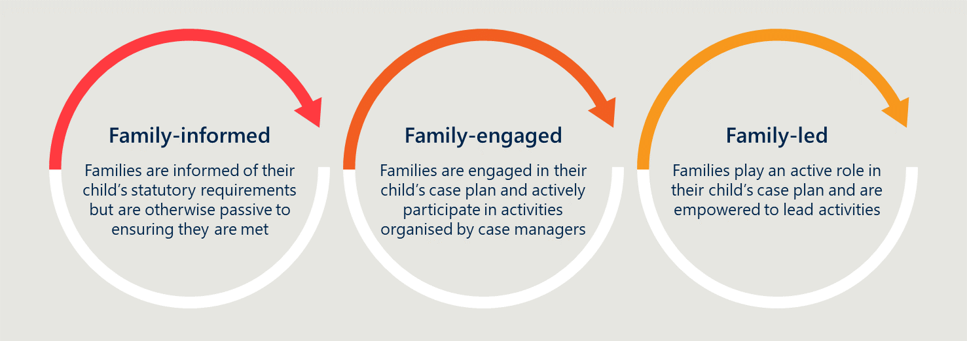

The program supports young people (program purpose) in part through supporting their family. The ICM Program is designed with key features in mind that allow for the family to be fully supported. These features include:

* Scope for Service Centres to allocate discretionary spend toward ICM Program families: The program allows Service Centres with the ICM Program to allocate funds toward supporting ICM Program families. This also reflects other principles of the model, including GLM. *This is explored further under ‘Governance’ 5.5.*
* The voluntary nature of program involvement: Despite ICM Program families and young people being classified as high-risk, the program is designed to be voluntary. This helps ICM Program Case Workers to build a sense of buy-in with the families, which is important for its success.

### The voluntary nature of the ICM Program helps to build trust with families, particularly for those that identify as First Nations

The voluntary nature of the ICM Program in an otherwise compulsory statutory environment was praised by staff and families. Staff noted that it showed respect to the families, as it sought to do something ‘with’ rather than ‘to’ them by having a ‘yarn’, which aided the development of trust and buy-in from the outset. Families noted the processes of seeking their consent was empowering, as they felt part of the process – something they did not typically experience in the context of youth justice and work with other government agencies.

“The voluntary nature helps to build a connection that is not forced. It gives us some ownership over the process.”

- ICM parent

One tension created by the voluntary nature is a degree of needing to ‘sell’ the program and setting clear expectations around the duration of support. There is a risk that overpromising can lead to dependency and mitigating this requires setting clear expectations from the outset.

## The ICM Model

### The practice frameworks and principles ensure client needs are met, while satisfying statutory obligations

ICM Program staff developed an elevated practice through the underpinning principles and frameworks. Practitioners gain the information about their clients they need through skills such as offence profiling (to make connections between life events and offending behaviour) and tools like the adapted Good Lives Model Needs Matrix (to identify ‘primary goods’ that are lacking and action plans to address deficits). Together these ensure the case planning is informed and robust.

In the Hub approach to case management, the ICM Program Case Manager is responsible for all statutory requirements of client orders. They further coordinate stakeholder engagement and foster the right therapeutic alliance with external services who share the case plan and intervention goals. Together, they aim to deliver at least 2 offence-focused sessions, 1-2 family sessions and 1-2 youth support sessions each week. This often amounts to daily engagement for clients which is appropriate given the level of need.

“A lot of parents are fatigued, and the Hub principle allows us to take on their burden. We do all the groundwork, and they only receive 1 phone call.”

- ISSO

The specified caseload of five unique families per case manager is appropriate for the ICM Program. Case managers noted that even one additional client hampers their ability to adequately service existing clients. The evaluation views the designed caseload of approximately five unique families is the appropriate caseload. This should be safeguarded in the future rollout of the ICM Program.

### The ICM Program aligns with best practices but the evidence for some of the underpinning theories is still emerging for youth offending reduction contexts

As discussed in Section 2.2.2, the ICM model is an adaptation of several underpinning theories and principles which together have shaped the practice frameworks and activities delivered. Holistically, the ICM Program and approach aligned with best practices identified through literature, as discussed in Section 5.2.1. The literature review completed by Nous found MST and GLM were well-evidenced in their effectiveness in contributing to youth justice outcomes. Collaborative Family Work was developed by Chris Trotter over 20 years. The Strengthening Families Protective Factors Framework has a strong evidence-base in Child Protection and an emerging evidence base in Youth Justice. Current research primarily focused on each of the primary models or framework, with a gap in research that shows how these programs can work together under one model of practice. Therefore, the ICM Program is unique way of bringing together multiple models of practice.

### Internal ICM Program training receives strong uptake, and is often used to upskill staff that are not directly involved in the ICM Program

The ICM Program serves as a mechanism for capability uplift and professional fulfillment for staff in Service Centres to work with families with complex needs. ICM Program training is delivered to ICM Program staff as a matter of priority, and then rolled out to other Case Workers and Youth Workers when training opportunities are available. This is an effective approach because the training serves as an opportunity to enhance the entirety of Youth Justice’s practice. As staff cycle through the ICM Program and return to general case work, the benefits of new practice frameworks, enhanced case planning skills and a more mature family practice flow through to the whole office.

“Having done the training, I know if I ever went back to general casework that I’d be a better caseworker for it.”

- Former ICM Case Manger

The ICM Program also serves as a novel career pathway for those in Youth Justice that are seeking the opportunity to work more with families. Youth Justice staff noted this as one of the reasons internal ICM Program training receives strong uptake. The Program’s approach to training as both a way to ensure the model is delivered correctly and to uplift Youth Justice Service Centre capability is logical and sound.

### The core practice frameworks and principles are not culturally specific, but the broad approach is culturally appropriate

The evaluation overwhelmingly heard that the ICM Program is culturally appropriate in design. However, the Youth Justice Cultural Unit was not consulted about ICM Program at the early design phase. This is because the Cultural Unit was not established in 2013/2014 when the ICM program was developed. The program was later reviewed by the Cultural Unit after it was developed to confirm its cultural appropriateness. At the time of program development, extensive consultation occurred with a First Nations colleague with many years of experience working with families in both youth and adult criminal justice settings throughout Qld, NSW and NT. First Nations staff from across regions have also contributed to the program development throughout its continued expansion.

The ICM Program Developer/Manager also chose to incorporate Collaborative Family Work into the ICM Program, in part, because it was evidence-based for First Nations families.

The ICM Program is designed in a way that allows staff the opportunity to work in a more culturally appropriate way than they typically would otherwise. We heard through consultations with First Nations Youth Justice staff and families that this is primarily because of three program design factors:

* The ICM Program is family-led: The model calls for ICM Program staff to view young people in the context of their family and the community around them. The ICM Program works with families to help solve the challenges that they identify, rather telling them what to do. Viewing support through the lens of family generally aligns with the cultural values for First Nations, Pasifika, and Māori peoples.
* ICM Program case workers are given time to build trust: Through a smaller case load than ‘General Casework’, the ICM Program allows Case Managers time to work with families more intensely and over a sustained period (6-12 month). Conceptions of time in non-Western culture favour a less linear and rushed view of time – taking the time to build relationships is important.
* The ICM practice model is strengths-based: Many families from diverse cultural backgrounds, particularly First Nations peoples, have experienced a long history of been viewed through a deficit lens. They are told they have gaps to be closed and problems to be fixed. The ICM Program helps to increase the supports around families to be strong. The voluntary nature of the program also provides families and the young people with a sense of ownership.

### ICM Program is delivered through a combination of funded positions, local staff arrangements and external agencies

The ICM Program is resourced through a combination of funded positions together with additional resources based on Service Centre resource allocations. Youth Justice invested in ICM Program funded positions which included 11 PO3 Case Managers across participating Service Centres. These Case Managers were supported by existing Youth Workers, cultural supports and Team Leaders.

All sites had 1-2 ICM Program Case Managers, but feedback from stakeholders interviewed across the Service Centres revealed that the degree of support staff available to the Case Managers varied across sites. Regional variations in the staffing model were related to the:

* Dedicated vs undedicated nature of Team Leaders and Youth Workers to the ICM Program
* Availability of cultural support through ISSO and YFCRO positions

The staffing model at each Service Centre is described in Table 7.

Table 7 | ICM team resourcing, by location

|  |  |  |  |  |
| --- | --- | --- | --- | --- |
| Location | Number of case managers | Dedicated ICM Team Leader | Dedicated ICM Youth Worker | Dedicated cultural positions |
| Caboolture | 2 | 2 (not dedicated) | 1 (self-funded from site resources, plus draw on others as required) | 1 x ISSO (not dedicated) |
| Redcliffe | 1 | 1 (not dedicated) | 1 (self-funded from site resources) | 1 x ISSO (not dedicated) |
| Brisbane North | 1 | 1 (not dedicated) | 1 (not dedicated) | 1 x ISSO (not dedicated) |
| Logan | 2 | 1 (not dedicated) | 1 (not dedicated, plus draw on others as required) | 1 x ISSO (not dedicated) |
| Gold Coast | 1 | 2 (not dedicated) | 1 (not dedicated, self-funded from site resources) | 1x ISSO (not dedicated) |
| Cairns | 2 | 1 | Nil (draw on support as required). | 2 x YFCRO (self-funded from site resources).  1 x ISSO (not dedicated). |
| Rockhampton | 2 | 1 (not dedicated) | Nil (draw on support as required). | 1 x ISSO (not dedicated) |

The levels of staff support available to ICM Program Case Managers is summarised in Figure 21. While no Service Centre possessed the maximal scenario, the levels of staff support are illustrative of the various resourcing models detailed in Table 7.

Figure 21 | Levels of staff support available to ICM Program Case Managers

Feedback from ICM Program teams and the cultural unit revealed the success factors and considerations for an effective staffing model. The success factors are:

* Stability in key roles, especially the Case Manager, to effectively implement the model
* Local leadership support and oversight for coaching and mentoring opportunities
* Skill and capability including training and professional support
* Cultural knowledge and community connections to effectively engage client and develop the right network of support

The concerns and considerations are:

* Adequate recognition of skills and capability of Case Managers and cultural knowledge of Case Managers, Team Leaders, and Youth Workers
* Criticality of staff retention in delivering an appropriate service level to clients
* Gender balanced teams to prevent communication barriers and be more culturally responsive
* Increasing the number of identified positions given the importance of cultural support to engagement with a primarily First Nations cohort

#### Staff noted significant challenges associated with compensation, particularly for those bringing additional value through cultural lived experience

Youth Justice stakeholders reported concerns regarding the recognition and remuneration of ICM Program roles. ICM Program workers are regarded as working with more complex matters which requires a high level of skills and experience. Stakeholders reported these skills exceeded the PO3 and AO3 categorisations for Case Managers and Youth Workers, respectively. The ability to attract and retain suitably qualified staff is regarded as a key success factor for ICM Program. Stakeholders identified the current remuneration as being inadequate to the roles and a factor that could threaten ICM Program performance over time.

Stakeholders also highlighted the importance of cultural knowledge and connection to the ICM Program. Concerns were raised that these skills and experience were not being fairly acknowledged through remuneration and supports. Concerns were held regarding the extent of commitment being provided by First Nations workers, who would often be required to provide supports beyond working hours and without remuneration.

First Nations staff interviewed expressed their support of the ICM Program and indicated that they received support from various sources including other First Nations staff, local managers, and teams. However, they described the requirements of their roles as going beyond the job and extending into community connections and extended working expectations arising from families and their communities.

The evaluation deems the design decision to build in location-dependent flexibility to the workforce model as appropriate. The program relies heavily on each site being able to draw upon different types of support to deliver targeted family supports. For example, Cairns ICM Program families all identify as First Nations. It makes sense that as a site, Cairns draws more heavily on ISSOs and YFCROs to support the Program delivery. However, as the Program continues to evolve it should seek to build a more consistent workforce model.

See *Recommendations 1, 10, and 12.*

### ICM Program workers receive professional development and practice supports

The Program framework requires all ICM Program staff to undergo ICM Program-specific training prior to commencing on the Program. For Case Mangers this is a 4-day intensive training package and for Youth Workers it is a modified version of this run over 2 days. Qualitative feedback from staff is that this training is of high quality. However, several staff noted opportunities for refresher training are infrequent.

ICM Program staff receive an appropriate amount of ongoing mentoring and support. Case Managers receive fortnightly formal supervision with their Team Leader, weekly informal coaching from the Team Leader, and have access to the Program Developer for mentoring as required. Opportunities for new Case Managers to shadow their predecessor or receive support (e.g., complex case discussions, offence profiling, and practice resources) from the Program Developer were noted as particularly valuable to developing confidence. Youth Workers receive supervision from their Program Coordinator and informal supervision from the ICM Program Case Manager. They also have access to the Team Leader and Program Developer as required.

The Program Developer also facilitates a monthly community of practice for all ICM Program Case Managers and Youth Workers. This serves as a valuable opportunity for knowledge sharing between the Service Centres. Examples of effective practices or tools are often shared, which benefits all Youth Justice. The community of practice also serves to develop a sense of community between an otherwise small ICM Program team that share similar challenges and wins in their day-to-day work.

### Families and ICM Program staff often advocated for continued support for young people during periods of detention

ICM Program clients are chronic offenders, and many continue to offend during the Program – often at a reduced frequency and/or severity. Nonetheless, this offending often results in clients needing to undertake periods of detention during the Program. These interrupt the delivery of the Program.

Several parents who experienced this firsthand with their young person felt it was inappropriate that the Program stopped during a time when support was needed the most. Multiple ICM Program Case Managers and Team Leaders mentioned this as a limitation of the Program. While this as a limitation is acknowledged, it is logistically challenging for this program to be delivered in detention. It is particularly challenging in locations like Cairns where young people are in detention in Brisbane or Townsville.

See *Recommendation 7: Clarify the model as it relates to young people facing periods of detention during the program.*

## Reporting and monitoring

### The ICM Program collects data in line with broader Youth Justice requirements and additional data to uphold model fidelity

In line with the statutory case management framework, clients engaged in the ICM Program are subject to regular reviews of YLS/CMI Risk/Needs Assessment, which remain current throughout the Program period. Case noting occurs for every client, family, and Hub contact. Further to this, stakeholder meeting minutes are recorded. Through these processes and corresponding documentation, the following is monitored:

* Attendance/ engagement with Youth Justice
* Specific content of individualised offence focussed interventions
* Progress toward individualised goals
* Client, family, and stakeholder feedback in relation to program
* Changes made to intervention plans (in response to feedback)
* Risk level (and protective factors) across domains
* Client strengths

Throughout the program period the following information is further collected by the ICM Program Case Manager and recorded in an excel spreadsheet:

|  |  |
| --- | --- |
| * Client identifier * Date program commenced * Custody prior to program start * Remand periods pre, during and post program * Number of supervised and non-supervised orders prior to program * Outstanding court (alleged offences) at time of program start * Most serious offences prior to program * Offences during program period * Commission of alleged offences (Y/N) during program period | * Number of proven offences during the program period * Court outcome * Outstanding court matters for offences during the program period * Assessment of reduction in nature of offending * Current program status * Removal from program * Completion of program * Date program finished and duration of time on program |

The Department also collects offending data on all Youth Justice clients. This data informs the offence profiling used in the assessment and intervention planning phases of ICM Program.

A central Performance and Reporting team collates all reoffending data to track reductions in the frequency and severity of reoffending. For ICM Program clients, this includes offences up to 6 months following program completion. This data is used in internal and external evaluations of program performance.

### The current reporting and monitoring approach emphasises an adherence to model fidelity but could be more systematic in capturing the full range of program outcomes

Reporting by practitioners focused on what had been delivered. For example, the number of interventions, the type of interventions, who delivered the intervention, who the intervention was for, what need was addressed through the intervention, client attendance, and duration of intervention. These metrics are useful in monitoring what has been delivered and understanding if there are any gaps or unaddressed needs that should form part of the future case plan. Since the bulk of the reporting effort goes toward monitoring an adherence to program fidelity, practitioners noted that current reporting processes failed to systematically capture the outcomes of the program and other system gains achieved with families. Case notes and case studies (‘good news stories’) are the only avenues for capturing system gains, family functioning improvements or early intervention with siblings. Therefore, current reporting processes do not fully capture the value of the ICM Program. However, the evaluation acknowledges the challenges associated with balancing staff administration activities and capturing the full value of the program.

“The bloody spreadsheet is a nightmare. There is so much qualitative change that is tricky to capture.”

- Team Leader

See *Recommendation 9: Develop an outcomes framework that establishes ways of systematically understanding family and system gains.*

## Governance

### The ICM Program uses a decentralised model of governance but remains reliant on the Program Manager as a central point of oversight

After the initial pilot phase of ICM at Caboolture, ICM’s rollout across Queensland meant that program governance was delegated to the sites. Team Leaders and Site Managers were ultimately responsible for the day-to-day operation, except Cairns which had a unique ICM Team Leader position. However, it was common for the Program Manager to be involved in local recruitment decisions, training, mentoring, and monitoring. Therefore, there remains a degree of centralised governance in the program, which is appropriate as far as it is practical.

The key challenge is maintaining capacity for the Program Manager to be involved in various local management decisions while providing senior practitioner advice across sites. As ICM continues to expand to more Service Centres it will become increasingly difficult for the single Program Manager to serve as a central point of oversight.

See *Recommendation 3: Invest in program oversite at the Program Manager level.*

### Guidelines for spending on child-related costs are more flexible under ICM than general case work, which allows practitioners to be more strategic and effective

Site leadership teams are responsible for approval of discretionary spending on child-related costs. In the past this would have been constrained to costs related to court, work, education, and travel. However, site leadership teams noted that ICM Program allows for greater flexibility in spending, which supports ICM Program teams in achieving their goals with young people. Examples included personal bedding and furniture for a young person to encourage them to stay home, and painting equipment to create a fun and engaging family work session.

The flexible spending guidelines are appropriate as they align with the theoretical basis of GLM which is that there are multiple domains to a ‘good life’, including leisure and play. Site Management and Case Managers spoke highly of the flexible funding as valuable for Case Managers to work effectively with families.

|  |
| --- |
| “We bought a bed and bedside tables for a girl who is now living with her dad for the first time in a while. Hopefully, she stays now, when before she was sleeping on the couch.”  - Site Manager |

# Implementation

This section of the report covers the implementation of the ICM Program and model across the seven Youth Justice Service Centres in scope for the evaluation.

It is important for the evaluation to assess the implementation of the ICM Program for two key reasons:

* Future planning: The lessons learnt from implementation across sites will be important to future planning and funding decisions for the Department
* Impact on outcomes: The outcomes achieved at each site are directly influenced by how well the program was implemented at each site. Furthermore, this is identified in the academic literature as being a key success factor to establish an effective youth offending reduction program.[35]

The ICM Program and model implementation is assessed across the key elements of the program. ‘Model fidelity’ is assessed across multiple domains within the model itself. These elements include:

* Program purpose
* Program strategy
* The ICM model (note: this is where ‘model fidelity’ is assessed)
* Reporting and monitoring
* Governance

See Figure 3 for an outline of the key program elements.

This section also summarises the implementation ‘success factors’ and ‘barriers’.

## Program purpose

### The purpose of the program is well-understood and agreed across sites

Feedback from all sites revealed that staff largely understood the ICM Program’s foremost purpose was to reduce the frequency and severity of offending in chronic youth offenders. This understanding was held while cognisant that delivery extends to the family more broadly.

Interviews with Case Managers, Youth Workers, Team Leaders, and Site Management revealed consistent understanding across roles. Practitioners commented that the Program Manager/Developer had been valuable in consistently clarifying the purpose of the Program.

Broadly, stakeholder consultation indicates that the program purpose has been well-communicated across the board.

## Program strategy

### The importance of working with the family is understood and implemented across almost all sites

While young people were broadly viewed as the key clients of ICM Program (see Figure 22), practitioners also understood the importance of working with families. Family-level risk factors have the potential of becoming protective factors given the right intervention and support. For example, low income, poor parenting, and substance abuse can all be addressed to create a more supportive, secure, and stable family environment.

“From ICM I have seen an ability to work intensively with family. It would be great if this was the standard model in Youth Justice.”

- Team Leader

“Upskilling the family creates around the clock intervention.”

- ISSO

The evaluation heard some, very limited, instances of Youth Justice staff at the ‘upper management’ level questioning the role of Youth Justice in supporting the family. One site had received some internal pushback, though they preferred to keep the details of this anonymous. While this was viewed as a frustration, it was not a barrier to implementing the Program at that site.

Figure 22 | Number of interventions by key client, 2020-2022

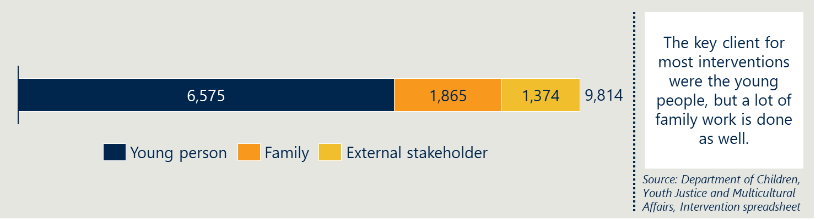

## ICM Program fidelity is largely maintained across sites, with some gradations in overall maturity

The ICM Program logic model outlines the inputs, activities and outputs required to achieve the intended engagement and outcomes for ICM Program clients and their families. The core elements outlined in the model are:

* Training
* Referral
* Intervention planning
* Delivery
* Engagement
* Staffing and recruitment.[36]

These elements have been used as the basis to assess and compare locations on model fidelity and maturity of implementation. Our understanding of ‘the model’ as it was intended is informed by the program framework and the expectations of the Program Developer as they have evolved. The baseline for each of the five elements is outlined below in Figure 23.

Figure 23 | The six elements of program fidelity

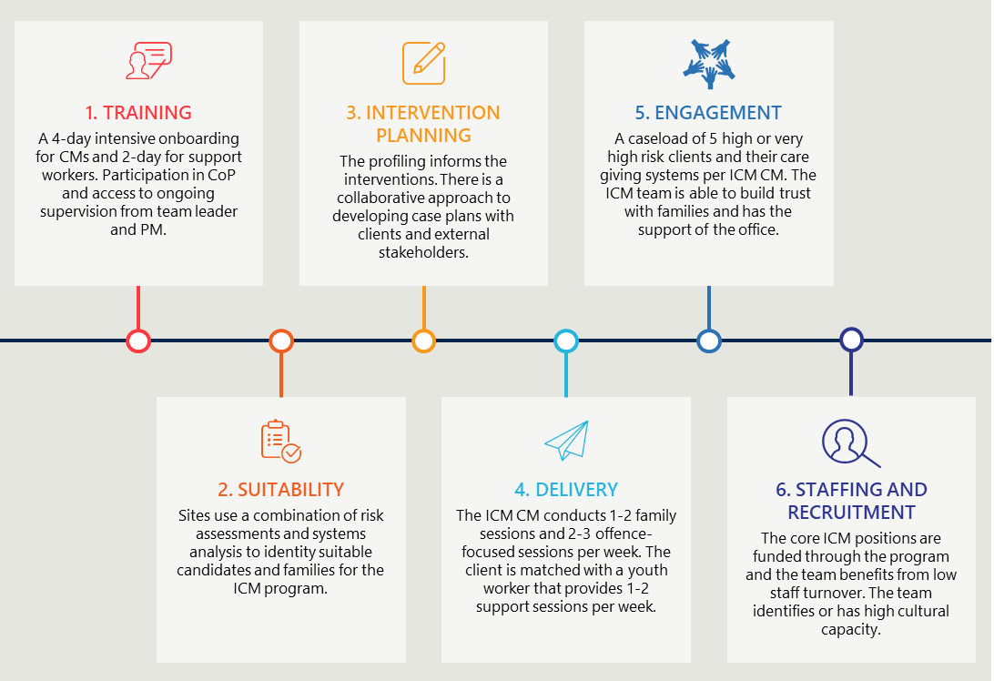

### Training

Part of what makes the ICM Program different to general casework is the practice frameworks and theoretical underpinnings used by staff. All staff undergo training before joining the ICM Program team. For Case Managers this is a 4-day training package while support workers complete a modified version of this run over 2 days. Periodically, further upskilling is available to ICM Program team members through the Community of Practice, through coaching, mentoring, and shadowing experiences with Team Leaders, as well as externally delivered training sessions.

#### Most ICM Program staff have a good understanding and appreciation for the Program, but practical understanding relies on the ‘Program Developer/ Manager’

Feedback from Youth Justice staff indicated that there has been strong uptake of ICM Program training when it is offered. Across all Service Centres, ICM Program Case Managers were able to demonstrate a good understanding of the underpinning theories and how they apply to their everyday practice. The support staff were also aware of the theories but, to a lesser extent, reflective of the shorter onboarding training they undergo and the nature of their work being more oriented around youth support rather than delivering cognitive behavioural therapy.

While all practitioners noted the internally delivered training had been of high-quality, some felt opportunities for refresher training were infrequent due to heavy dependency on the Program Developer to deliver training across all Service Centres. There has already been one example of an ICM Program Case Manager not completing the 5-day onboarding training after being in the role for approximately 6 months. This may become a more common issue if ICM Program continues to rollout across Queensland and the Program Developer is stretched across more sites.

See *Recommendation 8: Provide more regular training opportunities through a combination of resources.*

### Suitability

Existing Youth Justice clients that are referred to the ICM Program must be deemed eligible and suitable before transitioning to the program. Eligible clients must be aged 10-17 years and assessed as high or very high risk across multiple domains. They may also be subject to child safety intervention. Certain exclusions include severe psychiatric illness, detention orders longer than the length of the program and subject to adult imprisonment orders.5

#### All sites used YLS/CMI ratings and systems analysis to assess suitability for the ICM Program, with largely consistent levels of success

There was strong feedback from all stakeholders that the wraparound support offered through the ICM Program would benefit most Youth Justice clients. However, the requirement for low caseloads of five in ICM Programs to facilitate intense delivery meant that assessment was an important step in selecting the most suitable clients.

Some sites had difficulty choosing ICM Program clients from a large pool of already high-risk young people. For example, most Brisbane North’s clients were high risk, which made narrowing down potential candidates for the ICM Program challenging. One way in which this was helped was through systems analysis. Suitable candidates needed to have at least one willing parent or guardian and not too many other programmatic interventions that would result in over-intervening.

Overall, 87% of referrals to the ICM Program were successful. This suggests that there was a good understanding of eligibility and suitability assessment criteria across the Service Centres. As seen in Figure 24, locations had high successful referral rates except for Gold Coast. This is likely due to the high turnover in the ICM Program Case Managers experienced by the Gold Coast Service Centre.

Figure 24 | Successful referral rates by location, 2020-2022

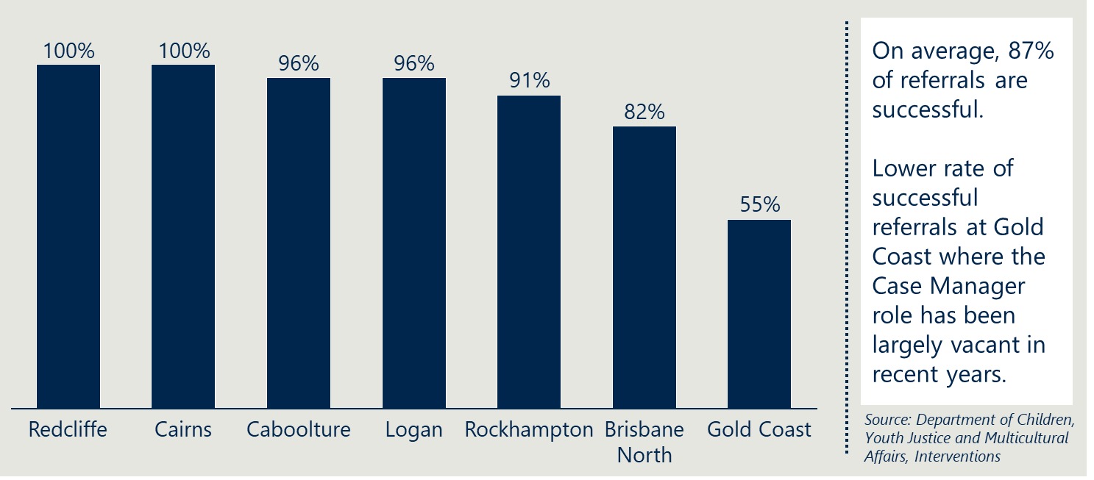

#### The median SROI rating of ICM clients was 5.8, which means most entered the ICM Program at an inflexion point in their offending trajectory

Although SROI does not form the eligibility or suitability criteria for the ICM Program, it is a valuable measure that indicates the likely future offending. Feedback from the Department was that a SROI rating of 6 is the point at which the severity and frequency of offending increases sharply. The median SROI rating across all locations (when applied retrospectively to former clients) was 5.8. As seen in Figure 25, the median SROI ratings at Logan, Brisbane North, Redcliffe, and Caboolture were all above 6. Therefore, these sites were likely dealing with young people who were more progressed in their offending trajectories than Rockhampton and Gold Coast, which had lower average SROI of between 3 and 4.5. There has likely been an element of early intervention with the young people from these Service Centres whose offending behaviour would have likely worsened substantially without intervention.

Figure 25 | Median SROI rating of ICM clients, by location

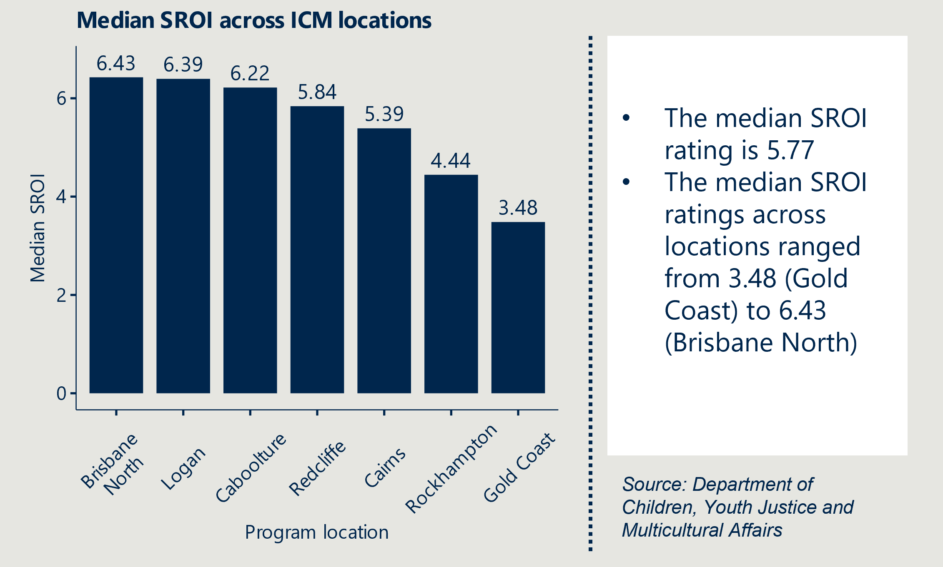

#### Most ICM clients have a high or very high overall risk ratings, which suggests most have been suitable for the program

The YLS/CMI overall risk rating for the ICM Program cohort ranges from medium to very high. As seen in Figure 26, most client across all locations had high or very high-risk ratings. This is one of the key eligibility criteria of ICM, which means the ICM Program is being delivered to a suitably high-risk cohort who stand to gain the most from the program.

Figure 26 | Level of ICM Program client risk across locations



Where there are higher proportions of moderate risk clients (i.e., Cairns and Rockhampton), there is an indication of lower model fidelity, but there may have been alternative reasons for assessing these referrals as suitable (e.g., high SROI).

#### Sites differed in perspectives on whether the client’s initial willingness to participate made a material impact on their suitability for the program

Obtaining the consent of young people and families is a requirement of voluntary participation in the ICM Program. However, many staff noted some clients were initially sceptical and unwilling to participate. At some sites, this unwillingness meant clients were not suitable. On the other hand, sites like Redcliffe convinced young people to participate that were hesitant if it were believed they would benefit greatly from the program. Between 2020 and 2022, at least nine clients did not receive the right service level due to non-compliance or an unwillingness to participate, as shown in Table 8**Error! Reference source not found.**. Therefore, it is important that the assessment phase is selective as an unwillingness, if unchanged, can hamper program completion.

Table 8 | Client inappropriate service level, all locations (2020-2022)[37]

|  |  |
| --- | --- |
| Reasons for inappropriate service level | Count |
| ICM Program Case Manager position vacancy – due to periods of leave, turnover in the role, program funding cessation | 11 |
| Client was unwilling to participate – due to low compliance or transience outside the local region | 9 |
| Client was unable to participate – due to periods of remand, bail revoke, or relocation to a region without ICM Program. | 8 |
| Undisclosed | 3 |

### Intervention planning

Intervention planning is process of planning the sessions to be delivered in line with statutory order requirements and the client’s identified needs that ultimately will reduce reoffending. This process occurs both at the commencement of the program following the rigorous assessment phase, but also throughout the program as circumstances change and feedback is received. The plan should also strengthen individual and social protective factors by facilitating attachments to education and by encouraging positive peer group associations.

#### Practitioners found offence profiling to be highly valuable in informing the intervention plan

Offence profiling for ICM is thorough. It identifies trends in the frequency and severity of offending, family history of offending, triggers, motivators/criminogenic needs, protective factors/strengths, what works well and does not work well with the young person. Part of the profiling is the Good Lives Model Needs Matrix, which defines the ’11 primary goods’ and prompts action plans to address each. Together with the profiling, case managers are well-informed to create effective and targeted plans that address the underlying needs and minimise the risks of reoffending.

Overwhelmingly, the evaluation heard from ICM Case Managers that the detailed profiling was highly valuable. They noted that it was helpful to gain a full picture of the young person to date, which informed their thinking on offending behaviours, and government system engagement.

#### Most locations demonstrated a collaborative approach to developing case plans with feedback from clients and external stakeholders informing future interventions

ICM Case Managers at the centre of the Hub model work with families and other external supporting agencies. Case Managers noted the importance of a collaborative approach to informing a holistic intervention plan that works best for the client and family and builds on the work completed by previous case workers or external stakeholders. ICM clients and families are often large and highly complex, which requires a team-based approach. The transition periods from general casework to ICM and vice versa were noted as important period for effective handovers as they provide valuable background into what works and does not work with each client.

### Delivery

ICM is a high-intensity support model that needs to deliver a particular frequency and number of interventions to be effective. The model specifies:

1. 2-3x offence-focused sessions per week
2. 1-2x Family work sessions per week
3. 1-2x Youth support sessions per week

The program also coordinates external supports to deliver interventions that support the ICM Program.

#### Sites that used culturally specific frameworks help to create cultural safety for First Nations, Māori, and Pasifika families

“We did a First Nations painting which helped us to set our goals as a family. I liked it, we need to get back into it soon.”

- ICM Family (Cairns – identifies as First Nations)

The program draws upon multiple supports to uphold cultural safety of the model. One such support is the use of culturally specific frameworks, taken both from internal and external sources. The most notable examples of cultural frameworks used within the program are the Tree of Life and Tautua. These are described further below.

* Tree of Life – This is a concept that arose internally from the Cairns Youth Justice Service Centre and was rolled out to all other Service Centres as an optional tool for delivery. The Tree of Life is an exercise and a framework that is culturally specific to First Nations families. It is a way for Case Managers and Youth Workers to ground the mapping of values, goals, identity, hopes, dreams, barriers, and actions. These are grounded in the storytelling and visualisation of the ‘Tree of Life’. See Figure 27 for how the concepts connect under the visual concept of the Tree of Life.
* Tautua – This is a cultural program that was developed at Logan Youth Justice Service Centre prior to ICM. The program is guided by Trauma-informed practice. It is targeted at young people who identify as Pacific Islander. Tautua emphasises an educational framework within a culturally responsive learning space built around core Pacific values. It focusses on repairing familial relationships, increasing cultural understanding, and understanding family systems through the lens of community and spirituality. The evaluation only observed the use of this cultural program in Logan, which aligns with the demography of that site.

Evidence from stakeholder consultations suggests that culturally specific programs and tools enhanced the cultural safety of young people and families. Families and young people from Cairns and Logan commented on these cultural programs and characterised them as engaging and fulfilling as part of the program. ICM Case Workers, ISSOs, and Youth Workers re-iterated the value of these programs as important compliments to the core ICM practices.

Outside of Cairns and Logan, cultural safety was largely enhanced through workforce and the general cultural accessibility of the ICM model. While the Tree of Life framework was shared through the Community of Practice, it was not described as critical to complimenting the program at any other sites. The evaluation anticipates that these frameworks will be used more readily if sites can establish identified positions and other cultural supports.

See *Recommendations 1, 3, 11, and 12.*

Figure 27 | Tree of Life – a strengths-based framework

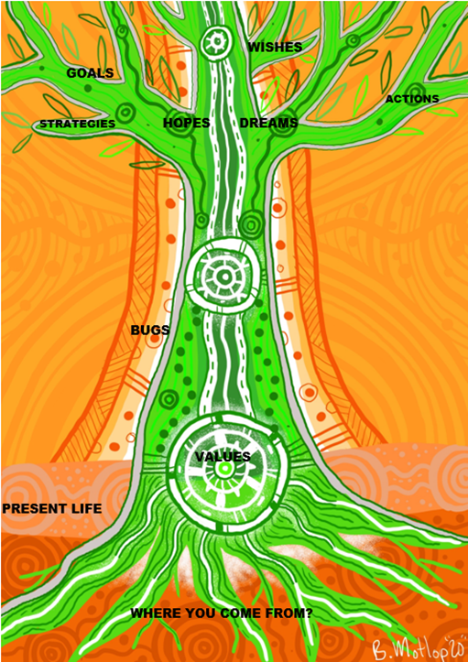

#### Interventions and engagements are flexible to the needs of the young person and their family

Feedback from ICM teams has strongly suggested that a high degree of flexibility is required. Clients are often operating from a state of survival and significant distrust in ‘the system’. One impact of this is extenuated transition periods onto and out of the program. A need for flexibility also manifests in the day-to-day as the ‘how’, ‘who’, ‘when’ and ‘where’ of intervention delivery can be subject to change in response to client transience, non-attendance, individual or family crises, or parental work commitments. The flexibility of the ICM Program is further described in Figure 28.

Figure 28 | Flexible delivery of ICM Program

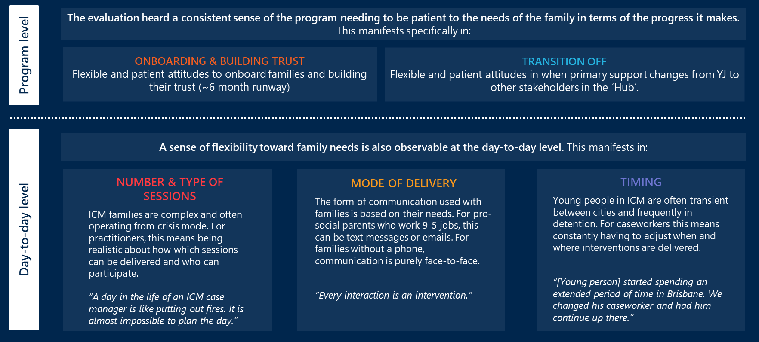

#### Most interventions delivered focused on the young person, which aligns with the model’s intent

According to the model, about 60-80% of interventions should be focused on the young person, either through offence-focused or youth support sessions, with the balance being family work sessions.5 As seen in Figure 22, of the interventions delivered across all sites between 2020 and 2022, 67% were focused on the young person as the key client, 19% were focused on family members, and 14% were with external stakeholders (ultimately for the benefit of the young person and/or family) which related to community, culture, mental health, education and alcohol and other drugs. This division of effort between primary and secondary clients aligned with the model’s intended design. A similar trend is seen in a at a regional level. Therefore, there is high model fidelity in the type of interventions being delivered across all sites.

#### The intended number and frequency of interventions is delivered across most sites, from what can be observed in the data

One of the key questions of model fidelity is whether there has been adherence to the specified number and frequency of interventions per client per week.

Figure 29 shows the average number and duration of interventions received by ICM clients across each of the sites between 2020 and 2022. It shows that on average only Redcliffe, Caboolture and Logan delivered the specified number of interventions to clients each week. However, there is an inverse relationship between the number and duration of interventions, which is the sites that delivered fewer interventions (Brisbane North, Gold Coast and Rockhampton) also delivered longer interventions. Therefore, it appears that some sites choose to do fewer but longer interventions, which reflects that the program is upholding model fidelity while being flexible to locational approaches.

Figure 29 | Average number and duration of interventions delivered per client per week, by location (2020-2022)

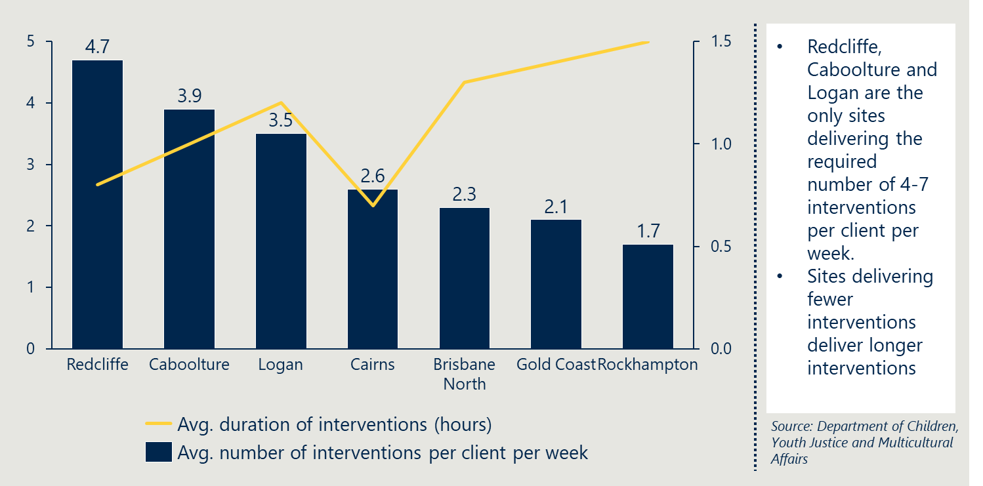

It should be noted that the data used in Figure 29 is taken from the intervention spreadsheet, which is known to be limited in that it does not record all interventions delivered by ISSOs and YFCROs. The impact of this is the average number of interventions per client per week would be understated. This is particularly the case for Cairns, which had the fewest records due to lost data and was known to be more reliant on ISSOs and YFCROs to deliver interventions.

#### More than one in five clients received an inappropriate level of service

Of the 134 clients that have completed the ICM Program, 31 did not receive an appropriate level of service for reasons summarised in Table 8, meaning that the level of service was less than the model dictates as appropriate. The most common reason for receiving an inappropriate level of service was a vacancy in the ICM Program Case Manager position due to periods of leave, turnover in the role and disruption caused by periods of funding cessation. This presents an opportunity for the operation of the ICM Program to improve service level through greater staff retention and succession planning to cover vacancies that occur through periods of leave, internal staff promotions and staff turnover.

Transience and an unwillingness to participate was the second biggest reason for an inappropriate service level. Rates of client absenteeism from intervention sessions (see Figure 30), highlights absenteeism was low in Logan (5%) but much higher elsewhere with the greatest rate of absenteeism recorded in Cairns (25%). Some absenteeism is to be expected within the program due to the high-risk nature of the ICM Program participants.

Figure 30 | Client intervention attendance rates, by location

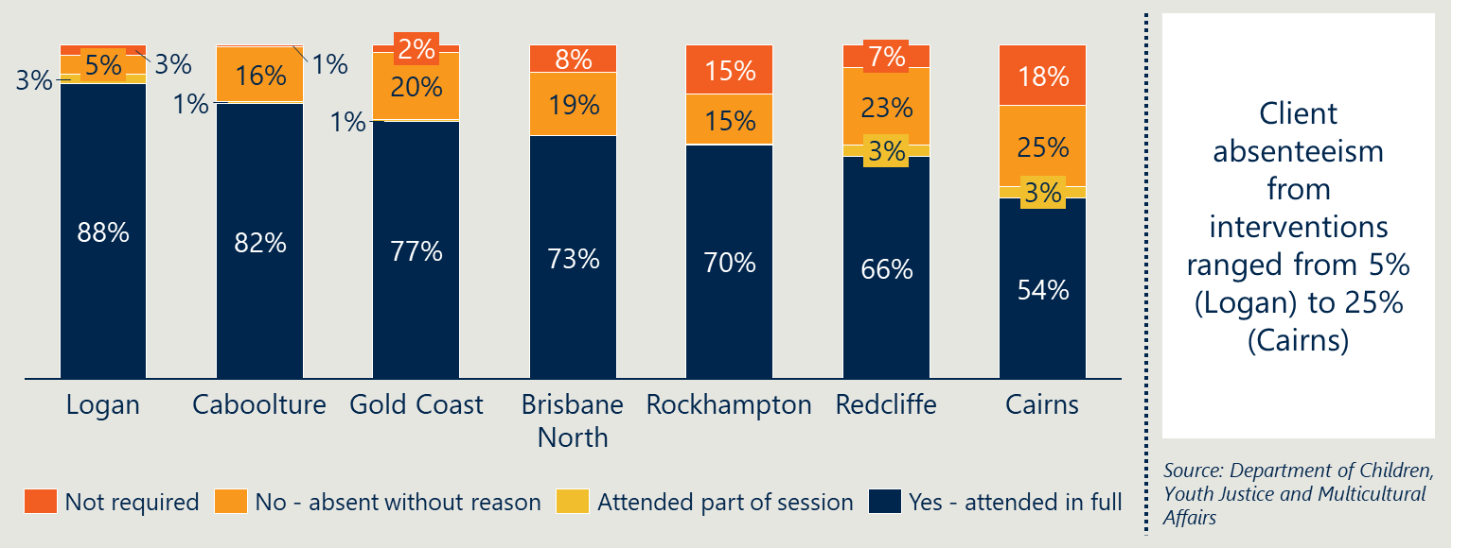

See *Recommendations 1, 5, and 7.*

### Engagement

Achieving the right number and frequency of interventions for clients is facilitated by two important constraints:

* Caseload – ICM Program Case Managers should have a caseload of approximately 5 young people and families. This ensures they have the capacity to deliver a high intensity of interventions to each client; and
* Timeframe – ICM Program Case Managers should transition clients off the program within 12 months. The amount of contact should decrease over time as young people and families achieved greater independence from Youth Justice.

#### The average caseload per ICM Program Case Manager is 5-6, but can stretch to 7 for a variety of reasons

Feedback from ICM Program Case Managers has been that the required caseload of 5 has largely been adhered to. However, it was also noted by most case managers that they can often stretch to 6 or 7 for a variety of reasons, including:

* Overlapping periods of transition between clients – Transitioning clients onto and off the ICM Program can be challenging, and often there will be periods where new cases and old cases overlap
* Pressure to take on more cases during periods of busyness – Some ICM Program Case Managers noted that there has been pressure at times to take more clients when the rest of the office was busy. Youth Justice centres must ensure statutory obligations are being met and without safeguarding the ICM Program Case Managers caseload has led to periods where they take on general case work.
* Family composition – Some families had more than one young person as registered ICM Program clients. An ICM Program Case Manager in Rockhampton had 7 young people, but 4 were from the same family, which created efficiencies in delivery.
* Transfer between locations – Several clients relocated part way through their program. Those that moved to another region with the ICM Program were transferred which would have suddenly increased the caseload for the new location.

Safeguarding the ICM Program Case Managers’ low caseload requires a whole-of-office support of the ICM Program, as well as the necessary resourcing for Service Centres to ensure general casework is adequately staffed such that ICM Program teams are not drawn away from the program.

Note that the data collected for average caseload per Case Manager does not reflect what the evaluation consistently heard. This is likely due to missing data and incomplete record keeping of who is practically still on the ICM Program Case Manager’s caseload.

See *Recommendations 1 and 3.*

#### The average period of engagement on the ICM Program is 36 weeks and on average all sites delivered the program within the required 12-month timeframe

The original design of the ICM Program specified a program duration of 6 months, but this was later extended to 12 months in recognition of the significant upfront time investment required to develop client trust, consent, and willingness to participate. On average across all sites, clients spent 36 weeks on the program, which is lower than the maximum timeframe.

As seen in Figure 31, the average across sites ranged from a low of 26 weeks at Redcliffe to a high of 42 weeks in Rockhampton and Logan. In total, there have been 13 cases (or approximately 10% of the ICM cohort) where the time on program extended beyond the 12-month maximum timeframe. Themes from consultations indicated that lengthy program timeframes are often due to difficulty transitioning clients off the program. This can be because:

* The young person and/or family continues to depend on the support; and/or
* The case manager wants to see through a particular outcome.

While there have been cases that extended beyond 12-months, it is worth noting that this is still much shorter than the maximum 2-year timeframe offered in the comparable ThroughCare program run by Aboriginal and Torres Strait Islander Legal Service (ATSILS).

Figure 31 | Average number of weeks clients spent on the ICM Program, by location (2018-2022)

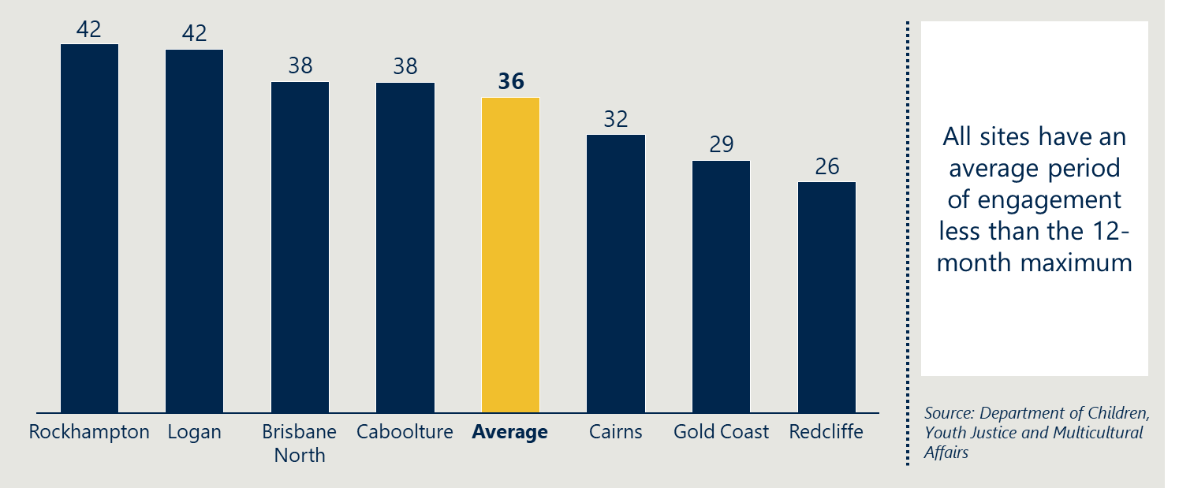

### Staffing and Recruitment

#### Identified cultural and community positions within Youth Justice, although not funded under the ICM Program, played a large role in supporting the cultural safety of the model

The evaluation found that across many of the ICM Program sites, staff from cultural backgrounds (including First Nations staff) were relied upon to build trust with families. This is because families from a cultural background naturally felt more culturally safe with staff who are from the same or similar cultural background.

Staff who identified from backgrounds most relevant to the ICM Program cohort (First Nations, Māori, or Pasifika) were seen across many different roles. There were broadly two scenarios observed depending on the staff from cultural backgrounds at each site:

* Where there was a Case Manager or Youth Worker from a relevant cultural background, they were relied upon to create cultural safety for families.
* Where there was **not** a Case Manager or Youth Worker from a relevant cultural background (or insufficient capacity), the local office ISSO or YFCRO was relied upon to create cultural safety for families.[38]

In the second scenario, during our consultations, identified staff were noticeably tasked with a high workload to meet the needs of cultural safety across the whole office. This was both directly said by identified staff, and clear to see based on the amount of work they described in their day-to-day.

“I would never lead a family session without [YFCRO]. It wouldn’t be culturally appropriate”

- ICM Case Manager (Cairns)

The clearest example of an identified staff member being asked to go above and beyond their role was in Cairns. ICM Program Case Managers noted that they leaned on the Cairns YFCRO to deliver cultural activities in family sessions.

Cairns is unsurprisingly the starkest example of identified staff being asked to work more with families, as the ICM Program participants in Cairns are 100% First Nations.

Identified staff and members of the Youth Justice Cultural Unit noted that placing this additional burden on YFCROs, ISSOs, and Youth Workers who identify from a cultural background is unsustainable and does not fairly remunerate them for the cultural competency they bring to the program.

See *Recommendation 1.*

#### Staff turnover in the ICM Program Case Worker role disrupted the implementation of ICM Programs at certain locations

In the original design of the ICM Program, it was intended that the Case Manager would rotate every twelve months to prevent burnout. This was later increased to every 2 years, given six months was not enough time on the program for most clients. Feedback from staff at each of the site visits revealed that the degree of turnover in the role (summarised in Table 9) was especially high at Gold Coast and Cairns, for various reasons such as maternity leave, internal promotion, and resignation. As the program has developed over the years with more practice resources, training and support, staff in some locations are remaining in the Case Manager role for longer periods of time (e.g., Caboolture and Logan).

The ICM Program Case Manager position is core to the program, without which the program cannot operate. It was noted by current staff at these sites that the high turnover significantly disrupted the rollout of the ICM Program. Turnover in the role without a successor led to unsuccessful referrals, clients prematurely transitioned to general case work, as well as fewer total clients supported through the ICM Program. Therefore, it is important that a pipeline of future ICM Program Case Workers is developed to ensure continued implementation and service to clients.

Table 9 | Indicative assessment of the staff turnover in ICM Program Case Manager role, by location

|  |  |  |  |  |  |  |  |
| --- | --- | --- | --- | --- | --- | --- | --- |
| Location | Caboolture | Redcliffe | Brisbane North | Logan | Gold Coast | Cairns | Rockhampton |
| Turnover | Low | Low | Low | Low | High | High | Medium |

## Reporting and monitoring

A systematic approach to capturing data that is consistently implemented across Service Centres is critical to upholding program fidelity and ensuring the intended outcomes are being achieved. The primary reporting task for ICM Program staff is completing ‘the spreadsheet’ – an excel template with details about each intervention delivered.

### Current data capture processes are not consistently adhered to, which has led to incomplete and inaccurate records

While it was expected that ICM Program teams capture all interventions with every client in ‘the spreadsheet’ – this has not happened. Several staff noted the spreadsheet was overly burdensome and therefore was often not completed as intended. This has led to staff not capturing all interventions. Instances of poor reporting and file management practices have also led to file corruption and data loss. There were also instances of staff using alternative means of capturing intervention data and case notes (e.g., YFCROs from Cairns used their own spreadsheet) or not recording at all (e.g., staff in offices during high periods of turnover).

“If you do the spreadsheet properly it takes hours. This is time we don’t have and is in addition to case notes.”

- Team Leader

See *Recommendation 9.*

## Governance

### Governance of the ICM Program allows scope for regional decision-making, though these decisions are largely consistent

Consultations with Service Centre Managers indicated that there is scope for decision-making, with them being ultimately responsible for approving Case Manager or Team Leader requests for discretionary funds. Service Centre Managers were consistent in saying that all requests had to be justified as being connected to the outcomes the Case Manager was trying to achieve. Service Centre Managers indicated that they could not recall any instances in which they denied a request for discretionary funding, but that this was because the requests were always reasonable.

### Discretionary funds for child-related costs have not been allocated to all sites

“The brokerage that goes with the program is really important and that is not really something we have been allocated.”

- Gold Coast Staff

Discretionary spending on child-related costs support clients and deliver more effective interventions. Most sites received an additional ICM Program-specific budget for this, though interviews with Gold Coast staff indicated that they had not received this funding. One staff member from the Gold Coast Service Centre commented that this has hampered the degree to which they could invest in ICM Program families and enhance the quality of the interventions they delivered.

It is unclear the extent to which discretionary funds are available to the Gold Coast, but they were unaware or unable to use this.

## Success factors and barriers for implementation

A range of success factors and barriers have been identified for the ICM Program and youth offending intervention programs more generally through the consultations and literature review. These summarise the elements that the evaluation has deemed crucial for successful implementation of the program to-date.

### Program-level success factors for implementation

Common success factors for program implementation across the sites came through the consultations with ICM Program and site leadership teams. They have been summarised to program-level success factors, as shown in Figure 32.

Figure 32 | Program-level success factors for ICM Program implementation



#### The whole office must see the value of ICM Program and give ICM Program Case Managers the space and resources to enact the model as intended

The ICM Program needs to be understood and supported by the entire Youth Justice office. Staff need to appreciate a 5-client caseload is non-negotiable for the program to be enacted as intended. While Team Leaders and site management need to provide supervision and oversight, there should also be enough autonomy in place for ICM Program Case Managers to draw on resources as required, including discretionary spend, Youth Workers and cultural supports. This gives the ICM Program team the space to work strategically and achieve the best outcomes.

#### The community of practice serves as a community of support and an opportunity to share best practices

Delivering the ICM Program can be taxing on staff who are exposed to vicarious trauma. ICM Program teams are much smaller than general case work teams and it was noted that this can be isolating at times for practitioners, especially at sites with a single ICM Program Case Manager. It was noted that the community of practice and opportunities to debrief with colleagues across offices were important. The community of practice and debrief sessions were also noted as opportunities to share examples of leading practice (e.g., Tree of Life developed in Cairns) and reflect on practice models used. This helps staff become better equipped to work with families with complex needs and see the philosophical value of the program.

#### ICM Program training uplifts practitioner capability and when provided to the broader office can aid in succession planning

Training and supervision opportunities for ICM Program staff, but also for other interested staff creates a whole-of-office capability uplift. The internally and externally delivered training were of high quality and were valued by practitioners seeking to extend their practice. Not only are better trained staff more effective, but the ICM Program training provides an opportunity for career progression and sharing it with the entire office develops a pipeline of staff who can fill roles as required. Continuing this will help overcome the implementation challenge of vacancies in the ICM Program Case Manager position.

### Practitioner-level success factors for implementation

Common success factors for program implementation were identified through the consultations with ICM Program teams and site leadership. They have been summarised to practitioner-level success factors, as shown in Figure 33.

Figure 33 | Practitioner-level success factors for ICM Program implementation



#### New clients are onboarded as quickly as trust can be built with the young person and family

At the individual practitioner level there are success factors at each stage of the program. The initial client onboarding phase can take up to 3 months but can be accelerated to 1 month if the ICM Program Case Manager can quickly build trust and rapport with young people and families. Experienced and identified staff are generally favourable, particularly with First Nations clients, for their ability to quickly establish trust with new clients.

#### Drawing on external supports, particularly cultural supports, enhances the delivery of interventions and the relationship with families

The evaluation observed that the program relied on referral to effective external supports, like community organisations, to achieve effective program delivery. Case Managers drew heavily on First Nations community organisations to build trust and engage in pro-social attitudes and behaviours in the program. In locations where supports were ‘co-located’ with Youth Justice, such as NDIS support, this enhanced the Case Manager’s ability to re-build service system trust among ICM Program clients and to effectively be the Hub, as intended in the program design.

#### Choosing the right ICM Program team members is critical to gaining the trust of clients

There was strong feedback from staff and site leadership that choosing the right ICM Program Case Manager is critical to the program’s successful implementation. Some believed the most important factor is being able to develop meaningful relationships given the large extent to which ICM Program is a collaborative approach to case management. Experience working with families, creativity, confidence, and ability were also highly regarded. A high level of cultural competency was also important given the high proportion of First Nations clients.

“Choosing the right worker is critical. You could do a lot or very little…There is a lot of independence in the role.”

- Site manager

#### Consistency in delivery of interventions and practitioners was critical to developing the trust and positive relationships needed to engage young people on the ICM Program

A consistent ICM Program team aids the implementation of the ICM Program as staff develop positive relationships with young people and their families. Entering one’s home and representing a government institution requires a high degree of trust to be built prior to enacting the program. Therefore, consistent contact between the same people allows this trust to be built. Many ICM Program clients are without stable family relationships and dependable parental figures. Therefore, ICM Program teams demonstrating a dependability and consistency in personnel are positive role models demonstrating pro-social behaviour.

#### Confident and effective practice is more visible at Service Centres that demonstrate an ability to apply the theory without the jargon

While an understanding of the underpinning theories of the ICM Program is important to affecting the program, feedback from practitioners and support workers revealed that there is a need to not ‘hold the program too tightly’ in order to effectively connect with young people and families. Many Youth Justice clients and families are skeptical of institutions and ICM Program staff are often perceived as oppositional, particularly in the early stages of engagement. A maturity of practice and experience working with families is needed beyond the ICM Program training to ensure staff can develop a rapport and buy-in from young people and their families.

“I like you because you’re not a textbook junkie”

- ICM client

### Barriers to program implementation

The evaluation observed several barriers to consistent and effective implementation of the ICM Program across sites. These are summarised below.

#### The model revolves around the Case Manager, which means that the program suffers greatly from staff turnover

Periods of support can be disjointed. When [case manager] was sick, [client] did not see her for 4 weeks. During these times there needs to be a backup resource, otherwise the young person can slip.

- ICM parent

As shown previously in Table 9, Cairns and Gold Coast experienced the highest levels of turnover in the ICM Program Case Manager position. As a result, the ICM Program has not been operating in earnest at these locations in recent years. The ICM Program Case Manager is central to program’s operation and requires a degree of stability.

#### The required skill level for an ICM Program Case Manager or Youth Worker to successfully enact the model is high, which makes recruitment challenging in some locations

One of the challenges with recruitment is the skill and experience level required to effectively deliver the ICM Program. The ICM Program Case Manager PO3 position must be able to work within the ICM Programs strategic framework, but also mentor colleagues, show initiative, be innovative, and develop and maintain relationships with clients and external agencies. All ICM Program staff need to have experience working with families with complex needs, which many Youth Justice staff do not have and they can limit the options for internal promotion. Therefore, sometimes Youth Justice must look externally to find suitable candidates.

Recruitment is more difficult in some locations than others. Locations such as Brisbane North have access to a larger pool of university educated people. On the other hand, more regional sites such as Cairns and Rockhampton have less access to suitably qualified people. Therefore, the effects of poor retention (discussed above) are exacerbated at some regional Service Centres that struggle to recruit suitable staff.

#### ICM Program workers typically need 3 months to build trust and rapport with families to enact the model

Staff have found that their government status is a barrier to developing trust with families who have negative perceptions of government institutions. Implementation of the ICM Program has revealed working intensively with families first requires anywhere from 3 to 6 months of rapport building. The onboarding of new clients should be 1 week for eligibility and suitability considerations followed by 2-3 weeks for transition from general case management to the ICM Program.5 This slow start to onboarding high risk individuals and families is at odds to the need to intervene quickly and with high intensity.

#### Program funding uncertainty contributed to challenges in recruiting and retaining suitable staff

As the ICM Program expanded from its pilot phase at Caboolture to several other Service Centres across Queensland, there has been insufficient commitment of funds to enact the model as intended. Periods of funding cessation were detrimental. When the ICM Program Case Manager position at Brisbane North was unfunded for several months in 2021, both the Case Worker and their clients prematurely transitioned back to general casework. When positions required to enact the ICM Program are not funded, as was the case with most Youth Workers and all cultural positions, delivery is hampered as these staff are stretched across both the ICM Program and general case work.

1. Methodology
   1. Technical Appendix ICM Program statistical modelling

The quantitative analysis for the ICM Program evaluation aimed to understand the association between ICM Program engagement and changes in several outcome areas:

* YLS/CMI risk ratings
* Reoffending seriousness
* Days in custody
* Reoffending counts
  + 1. Bayesian mixed effects ordinal regression models were used for YLS/CMI risk and reoffending seriousness

##### YLS/CMI Risk rating

This analysis aimed to understand the association between ICM Program engagement and changes in YLS/CMI risk/protective factors. The most recent YLS/CMI assessment to the start, midpoint and end of engagements was used with following YLS/CMI domains analysed (where all are composite indices aggregated over sub-items):

1. Overall assessed risk
2. Prior and current offences and orders
3. Family circumstances and parenting
4. Education and employment
5. Peer relations
6. Substance abuse
7. Leisure and recreation
8. Personality and behaviour
9. Attitudes and orientation

##### Reoffending seriousness

This analysis aimed to understand the association between ICM Program engagement and changes in the offending seriousness profiles. Offence data is contained within Integrated Client Management System (ICMS), and the offence seriousness was calculated as the most serious offence committed in the six months either side of engagement and during.

##### Bayesian mixed effects ordinal regression models

Ten different models were fit (nine outcomes for risk and one for reoffending seriousness) using the same covariates and model structure for all. The following covariates were used:

1. Indigenous flag
2. Sex
3. Age
4. Service centre
5. ICM engagement (Yes, No) × Timepoint (Pre, During, Post) interaction and main effects of both

For both YLS/CMI risk and reoffending seriousness an ordinal likelihood (cumulative model) was used as the outcomes were measured as ordered categories, consisting of the following ratings:

|  |  |
| --- | --- |
| YLS/CMI Risk | Reoffending seriousness |
| Low  Moderate  High  Very high | 1. 2 - Assault / attempted rape / torture etc. 2. 3 - Armed robbery / assault police / deal illicit drugs etc. 3. 4 - Break and enter / theft / dangerous driving etc. 4. 5 - Breach of bail / common assault / drink driving etc. 5. 6 - Property damage / graffiti etc. 6. 7 - Driving under suspension / possess illicit drugs etc. 7. 8 - Disorderly conduct / fare evasion etc. |

In addition to the linear combination of the five covariates listed above, one random effects term was also specified:

* Random intercept for each young person (to account for individual differences)

Such a model can be written briefly (ignoring random effects for simplicity) in terms of the probabilities of Y being equal to category *k* (i.e., one of the YLS/CMI ratings) given the linear predictor η as the following (where η is estimated by the linear combination of covariates and their coefficients β):

$$\operatorname{Pr}\left(Y=kη\right)=F\left(τ_{k}-η\right)-F(τ_{k-1}-η)$$

Priors developed from previous work using the ICMS dataset were derived:

* + 1. Bayesian mixed effects negative binomial regression models were used for days in custody and reoffending counts

##### Days in custody

This analysis aimed to understand the association between ICM program engagement and changes over time in the number of days spent in custody. Custody data is contained within ICMS, and the number of days was calculated as the difference in days between the *exit date* and the *episode start date* for all custody six months either side of engagement and during.

##### Reoffending counts

This analysis aimed to understand the association between ICM program engagement and changes over time in number of offences. Offence data is contained within ICMS, and the number of offences was calculated as the number of offences in the six months either side of engagement and during.

##### Bayesian mixed effects negative binomial regression models

The two models were fit, using a similar covariate structure to the YLS/CMI risk and reoffending seriousness modelling. The following covariates were used:

1. Indigenous flag
2. Sex
3. Age
4. Service Centre
5. ICM engagement (Yes, No) × Timepoint (Pre, During, Post) interaction and main effects of both

A negative binomial likelihood was used because the distribution of days spent in custody and offence counts were both highly over-dispersed (i.e., mean and variance were not equal), meaning the core assumption of a simpler Poisson model for modelling count data was violated. A model with a negative binomial likelihood that estimates a *shape parameter* which governs this over-dispersion was chosen instead.

In addition to the linear combination of the five covariates listed on above, one random effects term was also specified:

* Random intercept for each young person (to account for individual differences)

Such a model can be written briefly (ignoring random effects for simplicity here) in terms of a particular observation *i* as the following (where µ*i* is estimated by the linear combination of covariates and their coefficients β and α = 1/*v*, where *v* is the shape parameter):

$$\operatorname{Pr}\left(Y= y_{i} | μ_{i},α\right)= \frac{Г\left(y_{i}+α^{-1}\right)}{Г\left(α^{-1}\right)Г\left(y_{i}+1\right)}{(\frac{1}{1+αμ_{i}})}^{α^{-1}}{(\frac{αμ_{i}}{1+αμ_{i}})}^{y_{i}}$$

Priors developed from previous work using the ICMS dataset were derived:

* + 1. Cost and benefit analysis methodology

Lower, median, and upper estimates of savings were estimated for all cost-benefit metrics. These included:

* Gross savings (raw total savings)
* Net savings (gross savings – program cost)
* Net savings per young person (net savings / number of young people completed ICM)
* Benefit-cost ratio (gross savings / program cost)

These various conditions were generated from the statistical models to ensure that statistical uncertainty and adequate encapsulation of the complexity of the underlying data was propagated through to the CBA. All of these estimate’s stem from the statistical model which estimated reoffending counts. The lower and upper bounds represent the 90% credible interval (i.e., we are 90% confident that the true estimate of reoffending lies within these bounds). The median represents the 50th percentile of this distribution and is considered as our approximation of the average. To combine reoffending counts with offence types, we took the median predicted estimate of proportions of offence types committed. While additional nuance could be added by utilising credible intervals from this model as well, we default to the side of sufficient complexity but easier interpretability.

The interval between lower and upper estimates for all CBA metrics is quite wide. This is largely due to two reasons:

1. **High statistical uncertainty –** The youth justice system is complex. This complexity is evident even in the data, especially when comparing outcomes to a matched sample control group. Appropriately modelling this complexity means uncertainty in predicted outcomes is wide – narrower bounds may appear more intuitive to interpret, but they underestimate this uncertainty and may provide misleading estimates of the true plausible range of savings values.
2. **Choice of credible interval range –** The choice of range directly impacts the breadth of the bounds. A narrower range, for example, an 80% credible interval, would produce closer estimates between the lower and upper bounds, but at the cost of reduced confidence that the true estimate lies within those bounds. Much work in statistics defaults to 95% intervals, though the choice of interval is to some extent arbitrary. In a Bayesian context, 89% intervals have been proposed and shown to be more stable than 95% intervals[39]. However, we choose 90% here for the sake of simplicity to a non-statistical audience.
   1. Qualitative Appendix
      1. Implementation Survey

In July 2022, Nous surveyed ICM Program staff across each of the seven Service Centres within the scope of the evaluation. Respondents were asked questions about how the program was implemented at the various Service Centres. Thirteen Site Managers, Team Leaders and Case Managers completed the survey. Their responses were themed and qualitatively informed the Implementation section of the Evaluation Report.

* + 1. Site visits

In August 2022, members of the Nous team visited each of the seven Service Centres within the scope of the evaluation. These were the primary stakeholder engagements that formed the qualitative stream of the evaluation. They provided the evaluation with a rich understanding of the ‘on-the-ground’ perspectives of ICM Program at each of the Service Centres. A complete list of the stakeholders engaged at each location are summarised in Table 10.Table 10 | List of stakeholders consulted through site visits

|  |  |  |
| --- | --- | --- |
| Service Centre | Stakeholders | |
| Caboolture | 2 x ICM Program Case Managers  1 x ISSO  1 x Program Developer/Manager  1 x Program Coordinator | Department of Communities and Justice  Kurbingui  1 x Family |
| Logan | 1 x Site Manager  1 x Team Leader  3 x ICM Program Case Managers  4 x Youth Workers | 3 x External stakeholders (Navigate Your Health, NDIS)  1 x Young person |
| Gold Coast | 2 x Team Leader  1 x Program Coordinator | 2 x Families |
| Redcliffe | 1 x Team Leader and former ICM Program Case Manager  1x ISSO and former ICM Program Youth Worker | 1 x Youth Worker  2 x Families |
| Cairns | 2 x ICM Program Case Manager  1 x Team Leader  3 x Families | 1 x Young person  1 x ISSO |
| Rockhampton | 2 x ICM Program Case Manager  2 x Team Leader | 2 x Families |
| Brisbane North | 1 x Site Manager  1 x Team Leader  1 x former ICM Program Case Manager | 1 x former ICM Program Youth Worker  1 x Team Leader and former ICM Program Case Manager |

* + 1. Focus groups

Between September and October 2022, Nous conducted additional focus groups (see Table 11 below) with other stakeholders adjacent to the ICM Program. These stakeholders provided external perspectives of the program, which provided an alternative lens which further added to the qualitative data stream of the evaluation.

Table 11 | List of focus groups

|  |  |  |
| --- | --- | --- |
| Focus Group | Stakeholders | |
| Regional Operations | 3 x participants |
| Kurbingui | 1 x Intensive Family Practitioner |
| First Nations Legal Service | 1 x ThroughCare Officer (Youth) |
| Cultural Unit | 4 x Cultural Capability Officers |

1. Note: The name of the program during the evaluation was Integrated Case Management. The program is now called Intensive Case Management. Throughout this report, in all instances where the program is referenced as Integrated Case Management or Intensive Case Management, this refers to the same program.
2. SROI is a way of indicating youth with higher rates of offending within the youth justice system. The high SROI cohort is increasingly being referred to as the Collaborative Response Cohort (CRC) in recognition of the approach required to appropriately support this group of youth offenders.
3. Note: not all eligible candidates are suitable and willing to engage in the voluntary ICM program.
4. Note: In 2017, the program was rolled out to Townsville, but the Townsville implementation of the program is separate to Caboolture and the other ICM sites. Townsville ICM is out-of-scope of this evaluation.
5. S Pieper & A Jones, The Integrated Case Management (ICM Program Framework), Queensland Government, 2019.
6. This summary was adapted from ICM Program design documents, provided to Nous for the purposes of the evaluation.
7. H Wilson & R Hoge, The Effect of Youth Diversion Programs on Recidivism: A Meta-Analytic Review, *Criminal Justice, and Behaviour*, 2012.
8. C Chu et al., The Utility of the YLS/CMI-SV for Assessing Youth Offenders in Singapore, 2014.
9. E Onifade et al., Predicting Recidivism in Probationers with the Youth Level of Service Case Management Inventory (YLS/CMI), 2008.
10. K Dellar et al., Validation of the YLS/CMI on an Australian Juvenile Offending Population, 2022.
11. Department of Youth Justice and Multicultural Affairs, ICM Case Studies – January 2021 to June 2021.
12. Where the 90% credible interval bounds are wide around the median estimate (which indicates that there is high uncertainty), the estimates have to be considered carefully.
13. J Asscher et al., A randomized controlled trial of the effectiveness of multisystemic therapy in the Netherlands: post-treatment changes and moderator effects, Journal of experimental criminology, 2013.
14. Department of Youth Justice and Multicultural Affairs, ICM Good News Stories 4.
15. Department of Youth Justice and Multicultural Affairs, ICM Case Studies July 2021 – June 2022.
16. Where the 90% credible interval bounds are wide around the median estimate, which indicates that there is high uncertainty).
17. T Allard et al., The monetary cost of offender trajectories: Findings from Queensland (Australia), Australian & New Zealand Journal of Criminology, 2014.
18. Department of Child, Youth Justice and Multicultural Affairs, Updated Budget Figures – ICM 2018 – 2022.
19. This cost does not account of overheads used but not funded through ICM.
20. Police costs are cost per offending event, court costs are cost per principal event finalised, and wider costs are cost per offence.
21. Australian Institute of Criminology. (2020). *The costs of Indigenous and non-Indigenous offender trajectories*.
22. Allard, T., Stewart, A., Smith, C., Dennison, S., Chrzanowski, A., & Thompson, C. (2013). The monetary cost of offender trajectories: Findings from Queensland (Australia). *Journal of Criminology*, 47 (1).
23. Productivity Commission. (2022). *Report on Government Services 2022*.
24. There is uncertainty in attributing reduced reoffending to ICM. Cases are based on the upper, median, and lower bounds of the 90% credible intervals in Figure 8.
25. Program cost does not represent the full cost of delivering ICM or the replacement cost born from reduced reoffending, as explained in 4.8.1.
26. Working Together Changing the Story: Youth Justice Strategy 2019-2023, Queensland Government, 2019.
27. S Pieper & A Jones, The Integrated Case Management (ICM Program Framework), Queensland Government, 2019.
28. Youth Offending, Queensland Government Statistician’s Office, Queensland Treasury, 2021*.*
29. Literature Review – Evaluation of the ICM Program, Nous Group, 2022.
30. Model Programs Guide Literature Review: Wraparound Process, Office of Juvenile Justice, and Delinquency Prevention, 2014.
31. C Gill et al., Improving the Success of Re-entry Programs: Identifying the Impact of Service–Need Fit on Recidivism, 2017.
32. R Clemons, Juvenile rehabilitative programs, and their affects on the juvenile recidivism rate, 2013.
33. L Villanueva et al., Sociodemographic variables, risk factors, and protective factors contributing to youth recidivism, 2019.
34. S Pieper & A Jones, The Integrated Case Management (ICM Program Framework), Queensland Government, 2019.
35. C James et al., Aftercare programs for reducing recidivism among juvenile and young adult offenders: A meta-analytic review, Clinical Psychology Review, 2013.
36. S Pieper & A Jones, The Integrated Case Management Program Framework, 2017.
37. Department of Children Youth Justice and Multicultural Affairs, Interventions, 2022.
38. Note: The only roles funded directly under the ICM Program are Case Manager positions (typically two) at each site, and an ICM Site Manager for the Cairns Service Centre.
39. Krushke, J. K. (2014). Doing Bayesian Data Analysis: A Tutorial with R, JAGS, and Stan. Academic Press.